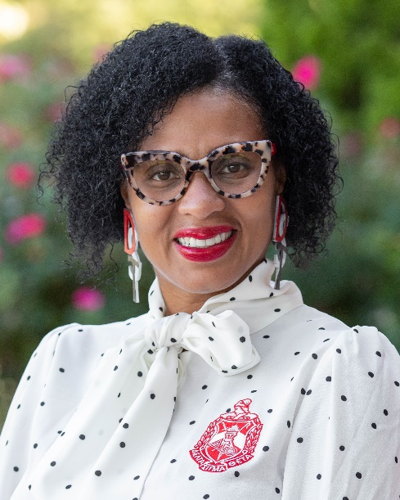

Dr. Sebrina Cooke-Davis
Executive Director Prevention & Education Programs

In her Executive Director role, Sebrina provides leadership in the development and implementation of systems and processes that support the delivery of quality programs for Prevention and Parent Education, leading the implementation and continuous improvement in these areas. She works with Finance to develop and manage program budgets and contracts, as well as manages financial decisions to ensure financial sustainability and health for each program.

Sebrina develops, cultivates, and maintains strong partnerships with organizations who may partner with or refer to prevention and educations programs, such as County DSSs, pediatric and obstetric providers, early childhood initiatives, and public health departments.

“I am committed to prevention and parent education. I take pride in the work of our highly motivated team and strive to inspire them to perform at the highest standards,” Sebrina shares.

Sebrina brings more than 20 years of experience working with and supervising prevention and parent education programs in settings such as substance abuse treatment facilities, hospitals, schools, and community-based organizations. Her previous professional experience includes Parent Educator, Parent Education Program Director, and Substance Abuse Prevention Consultant.

Always through the lens of preventive services, her work has focused on serving diverse populations with a common goal of increasing competence and confidence in parents and caregivers. Sebrina is trained in many parent education curriculum models and has multiple levels of credentials in the field, including North Carolina Certified Prevention Specialist

Sebrina has a passion for young people, particularly young women, where she has worked with over 2000 adolescent mothers since 2003. She is a Certified Birth Doula (Dona International) and has assisted in 10 deliveries. She remains in touch with many of the young women she has worked with, continuing to provide them with guidance and support throughout their lives.

Sebrina played a critical role in the development and launch of the SYNC program at CHS. SYNC (Sexual Health for Youth in Care) provides free sexual health education for both out-of-home teens and the professionals who work with them. With Health Education Trainers across the state, SYNC utilizes evidence-based approaches that have been proven to reduce the prevalence of teen pregnancy, unhealthy relationships, and STI/STDs, while increasing self-awareness and empowering decision making – all needs that are more prevalent with youth in care.

The first few years of a child’s life are critical to building a foundation for their future health and success. Sebrina is providing leadership and guidance for the development and expansion of several key prevention programs including HealthySteps, Community Navigation, and Child First.

HealthySteps partners our specialists with pediatric providers to offer information and support to parents during the first few years of their child’s life. Child First specialists partner with families to build strong, loving relationships with their young children, under age 6, to heal and protect them from life’s many stresses and challenges. Community Navigators connect parents with individualized information, local classes and groups, and support services to help address the social needs of parents and families right in their own health care providers’ offices.

Sebrina is a graduate of East Carolina University and holds a master’s degree in Adult Education and a doctorate in Educational Psychology. She is a member of the Adjunct Faculty at Southern New Hampshire University and the University of the Rockies, and a guest lecturer at NC A& T State University, teaching a wide array of classes on psychology and human development.

Sebrina’s civic and philanthropic leadership includes:

- First Baptist Church of Greensboro – speaker, volunteer parent educator
- Member of the American Psychological Association
- North Carolina Certified Parenting Educator
- Certified Doula-DONA International
- Member of Psi Chi National Honor Society for Psychology
- Member American Counseling Association Board
- Past Chair-Guilford Coalition on Adolescent Pregnancy Prevention (GCAPP)
- Cambridge Who’s Who
- Graduate of the Governor’s Academy for Prevention Professionals
- Trained Resiliency Specialist
- Loaned Executive with the United Way
- Certified Substance Prevention Consultant
- Delta Sigma Theta Sorority, Inc.
- Credentialing Committee Member-NC Parent Education Network
- Key Communicator with Guilford County Schools

