Pampa Metals Reports IP Chargeability Anomalies from the Cerro Chiquitin Target at Cerro Buenos Aires and Plans Further Drill Testing of Shallow & Deep Porphyry Targets
________________________________________________________________________
(CSE: PM) (FSE: FIRA) (OTCQX®: PMMCF) For Immediate Release
Vancouver – April 6, 2022 – Pampa Metals Corp. (“Pampa Metals” or the “Company”) (CSE: PM / FSE: FIRA / OTCQX®: PMMCF) is pleased to provide results from the pole-dipole induced polarisation (“IP”) survey completed at the Cerro Chiquitin target on its 100% owned, 7,600-hectare Cerro Buenos Aires project in northern Chile. Cerro Buenos Aires is located along the Paleocene or Central Mineral Belt of northern Chile, about 35 km southwest of the multi-million ounce El Peñon gold-silver mining district, and around 210 km south-southwest of the giant Spence and Sierra Gorda copper mining cluster.
Key takeaways:
- IP study results have improved the understanding of exploration results from 2021 and have clarified drill targets for further shallow and deep drilling near Cerro Chiquitin.
  - The covered area to the southeast of the tourmaline breccia body at Cerro Chiquitín is confirmed as a priority objective for follow-up drilling.
- The IP survey completed has provided reliable information up to 600 m below the surface, with interpretable results with respect to mapped geology, other geophysical studies, and wide-spaced reverse circulation drilling, all completed and reported in 2021.
  - Significant chargeability anomalies some 800 m to 1100 m wide (east-west) occur on at least four parallel lines covering an area about 1 km north-south, all of which remain open at depth.
A total of 18.8 linear km of pole-dipole IP were surveyed by Quantec Geoscience Chile Ltda. in January and February of 2022, distributed in six east-west lines each 2.6 km to 3.4 km in length, and with each line separated by 250 m, with readings every 200 m. The IP lines cover an area of approximately 3.5 km E-W by 1.5 km N-S, and were located to the south of the Cerro Chiquitín tourmaline breccia in areas covered by post-mineral gravels.
Cerro Chiquitin Target
Several chargeability anomalies are present in the data from the six lines surveyed, with a line-to-line continuous anomaly from line 7.274.850 in the south to line 7.275.850 in the north (1,000m). The most northerly line (7.276.100) appears to exit the principal chargeability feature, although a modest chargeable feature is still apparent that correlates well with the tourmaline breccia body mapped at surface at Cerro Chiquitin. The chargeable anomalies are open at depth beyond the limits of the survey, and several geophysical profiles show breaks across the profiles that may represent geological faults. Conductive features occur on all profiles, and tend to be sub-parallel to the surface, and may represent one of, or a combination of, water at the base of the gravel cover and clay alteration (intermediate argillic, to phyllic, to advanced argillic). Several chargeable features also correlate well with low-tenor, copper and molybdenum geochemical anomalies from historic soil sampling surveys carried out across the post-mineral “pampa” gravel cover.
The chargeability anomalies reflect the presence of sulphide minerals in the sub-surface that will almost certainly include pyrite (iron-sulphide), but also possibly other sulphide minerals such as chalcopyrite (copper-iron-sulphide – the most common copper mineral).
From south to north:
- Line 7.724.850: at the southern end of the IP study shows a high-intensity chargeability anomaly about 800 m wide in the mid-part of the line. The anomaly is relatively shallow, well defined below the 1500 m elevation, and open at depth beyond the limits of the IP survey. The zone of low chargeability to the east correlates with outcrops of volcanic rocks with intermediate argillic alteration and preserved primary magnetite. The western part of the chargeability anomaly corresponds to the along-strike projection of Pampa Metals’ RC drill hole CBA06 from 2021, and may represent a target of interest.
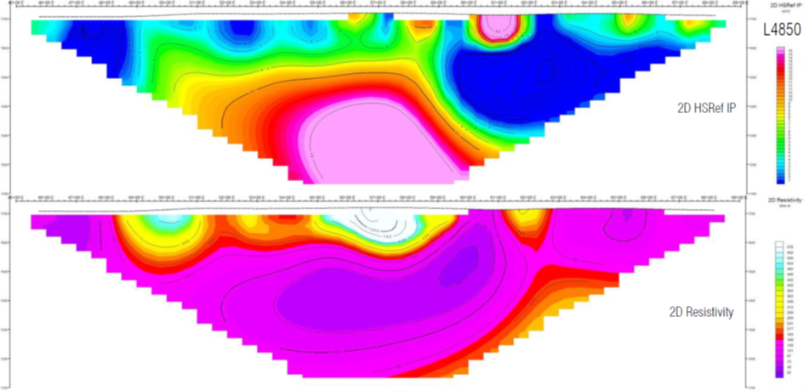
- Line 7.725.100: shows a moderate to high intensity chargeability anomaly, about 800 m wide and is open at depth. The western boundary of the anomaly may be fault controlled, and was drilled by Pampa Metals’ RC drill hole CBA06 from 2021 to relatively shallow depths, and with the best part of the anomaly further east and at greater depths. A steeply dipping resistive feature further east reaches the surface where a small, subdued outcrop of fragmental rhyolites affected by advanced argillic alteration, including silicification, penetrates the gravel cover and has been mapped at surface. The deep resistive anomaly may represent a target of interest.
- Line 7.275.350: shows a moderate to high intensity chargeability anomaly that is about 900 m wide, well delineated from the 1600 m elevation and open at depth below the 1100 m elevation. The eastern boundary may be fault controlled. The central part of this chargeability anomaly was tested by Pampa Metals’ RC drill hole CBA02 from 2021 (projected from 130 m north of the line). The deep resistive anomaly further east is considered of interest for drill testing. Again, this deep resistor corresponds to a small island hill with fragmentary rhyolitic rocks with advanced argillic alteration were observed.
- Line 7.275.600: like the previous line, a moderate to high intensity chargeability anomaly occurs and is about 1100 m wide, well defined from the 1600 m elevation and open at depth below the 1100 m elevation. The eastern margin appears to be limited by a high angled fault. The western part of the chargeability anomaly was tested by Pampa Metals’ RC drill hole CBA02 from 2021 (projected from 120 m south of the line), and the more intense are of chargeability to the east remains a target for further drill testing.
It should be noted that the drill holes CBA02 and CBA06, which coincide with some of the geophysical anomalies described above, were highly anomalous in zinc and lead that could be geochemical indicators of the periphery of a mineralised copper-porphyry system, together with lesser arsenic and antimony and minor sporadic, low-tenor gold, which could be indicative of an epithermal overprint.
Cerro Chiquitin Target – Conclusions
The pole-dipole IP survey to the south of Cerro Chiquitin has given positive results that confirm and validate previous results and interpretations from the area, whilst adding further detail and giving clear indicators of potential drill targets prospective for copper (and gold) at depth. The Company is now pursuing plans to carry out follow-up diamond drilling pater this year.
ABOUT PAMPA METALS
Pampa Metals is a Canadian company listed on the Canadian Stock Exchange (CSE: PM) as well as the Frankfurt (FSE: FIRA) and OTC (OTCQB®: PMMCF) exchanges. Pampa Metals owns a highly prospective, wholly owned, 62,000-hectare portfolio of eight projects for copper and gold located along proven mineral belts in Chile, one of the world's top mining jurisdictions. The Company is actively progressing four of its projects, including completed and planned drill tests, and has two additional projects optioned to Austral Gold Ltd., with Austral already drill testing its first target on Pampa Metals’ ground. The Company has also recently signed an agreement with VerAI Discoveries Inc. giving Pampa Metals access to the latest in artificial intelligence technology in relation to mineral exploration, as well as a further 18,700 hectares of highly prospective terrain in the core of the highly productive mineral belts of northern Chile.
The Company has a vision to create value for shareholders and all other stakeholders by making a major copper or gold discovery along the prime mineral belts of Chile, using the best geological and technological methods. For more information, please visit Pampa Metals’ website www.pampametals.com.
Qualified Person
Technical information in this news release has been approved by Mario Orrego G, Geologist and a Registered Member of the Chilean Mining Commission and a Qualified Person as defined by National Instrument 43-101. Mr. Orrego is a consultant to the Company.
Note: The reader is cautioned that Pampa Metals’ projects are early-stage exploration projects, and reference to existing mines and deposits, or mineralization hosted on adjacent or nearby properties, is not necessarily indicative of any mineralization on Pampa Metals’ properties.

ON BEHALF OF THE BOARD
Paul Gill | CEO & Director
www.pampametals.com

INVESTOR CONTACT
Ioannis (Yannis) Tsitos | Director
investors@pampametals.com

The CSE nor the Investment Industry Regulatory Organization of Canada accepts responsibility for the adequacy or accuracy of this release.
FORWARD-LOOKING STATEMENTS
This news release contains certain statements that may be deemed "forward-looking statements". All statements in this release, other than statements of historical fact, which address events or developments that Pampa Metals expects to occur, are forward-looking statements. Forward-looking statements are statements that are not historical facts and are generally, but not always, identified by the words "expects", "plans", "anticipates", "believes", "intends", "estimates", "projects", "potential", "indicate" and similar expressions, or that events or conditions "will", "would", "may", "could" or "should" occur. Although Pampa Metals believes the expectations expressed in such forward-looking statements are based on reasonable assumptions, such statements are not guaranteeing of future performance and actual results may differ materially from those in forward-looking statements.
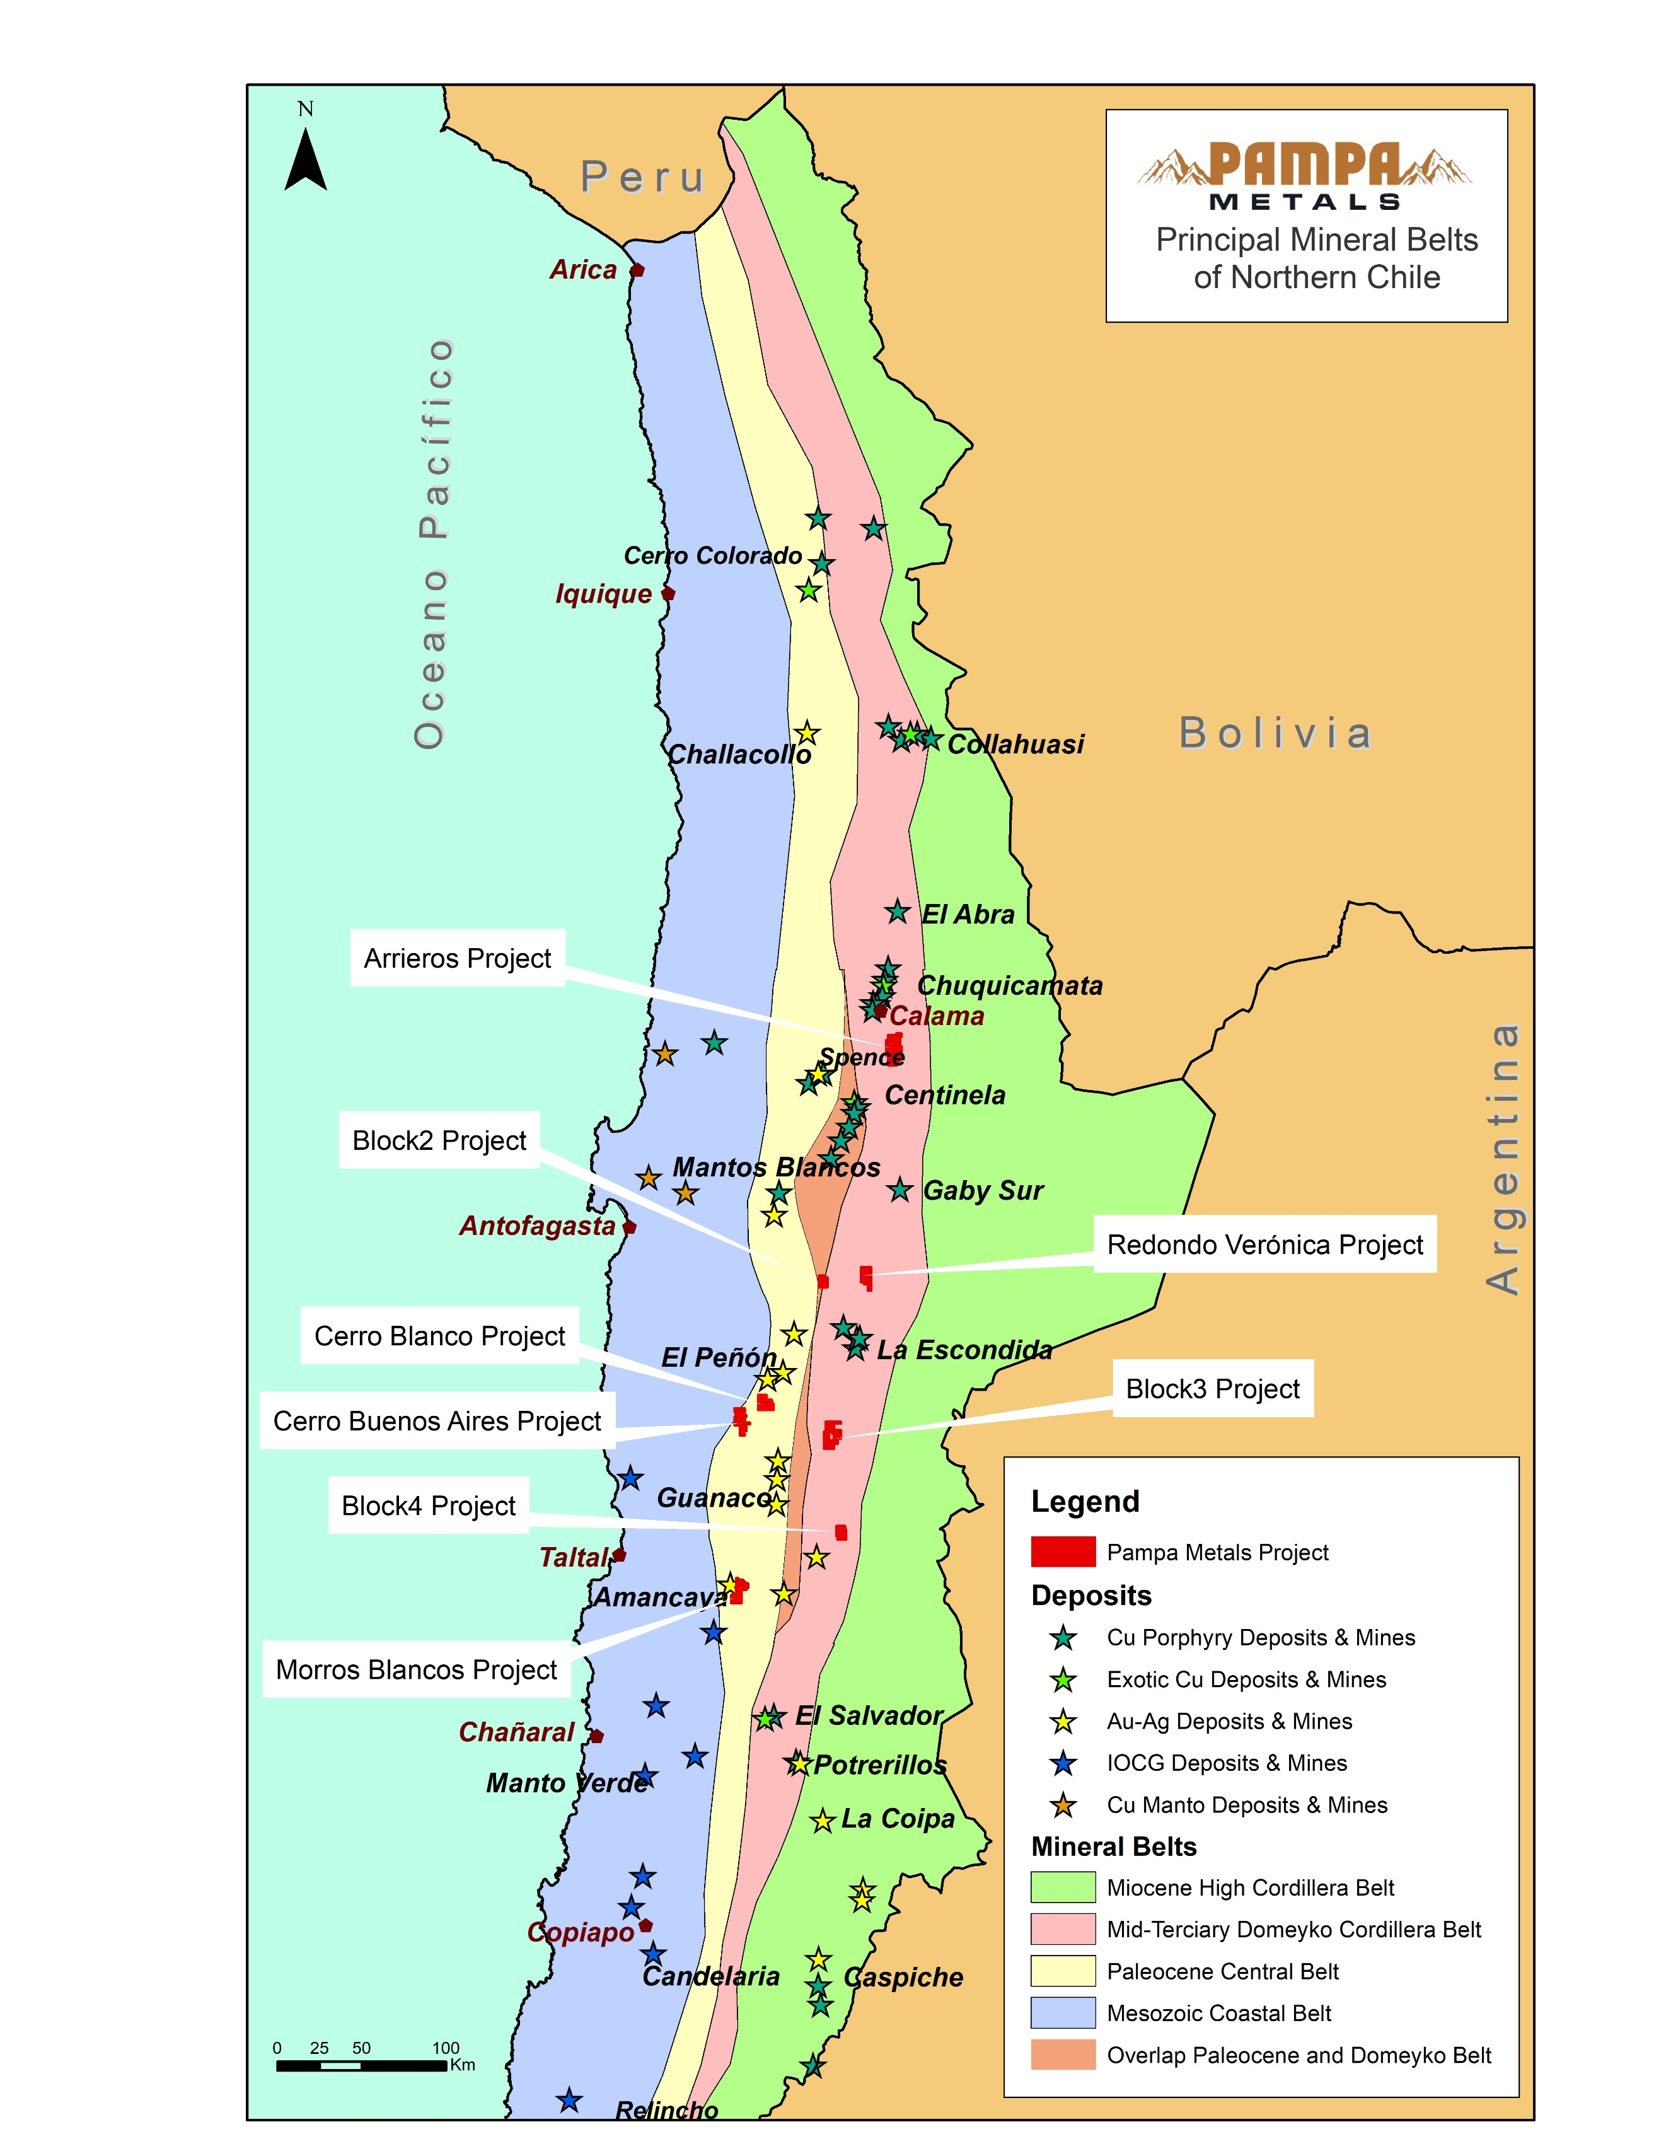
Pampa Metals – Project Locations & Major Mines of Northern Chile

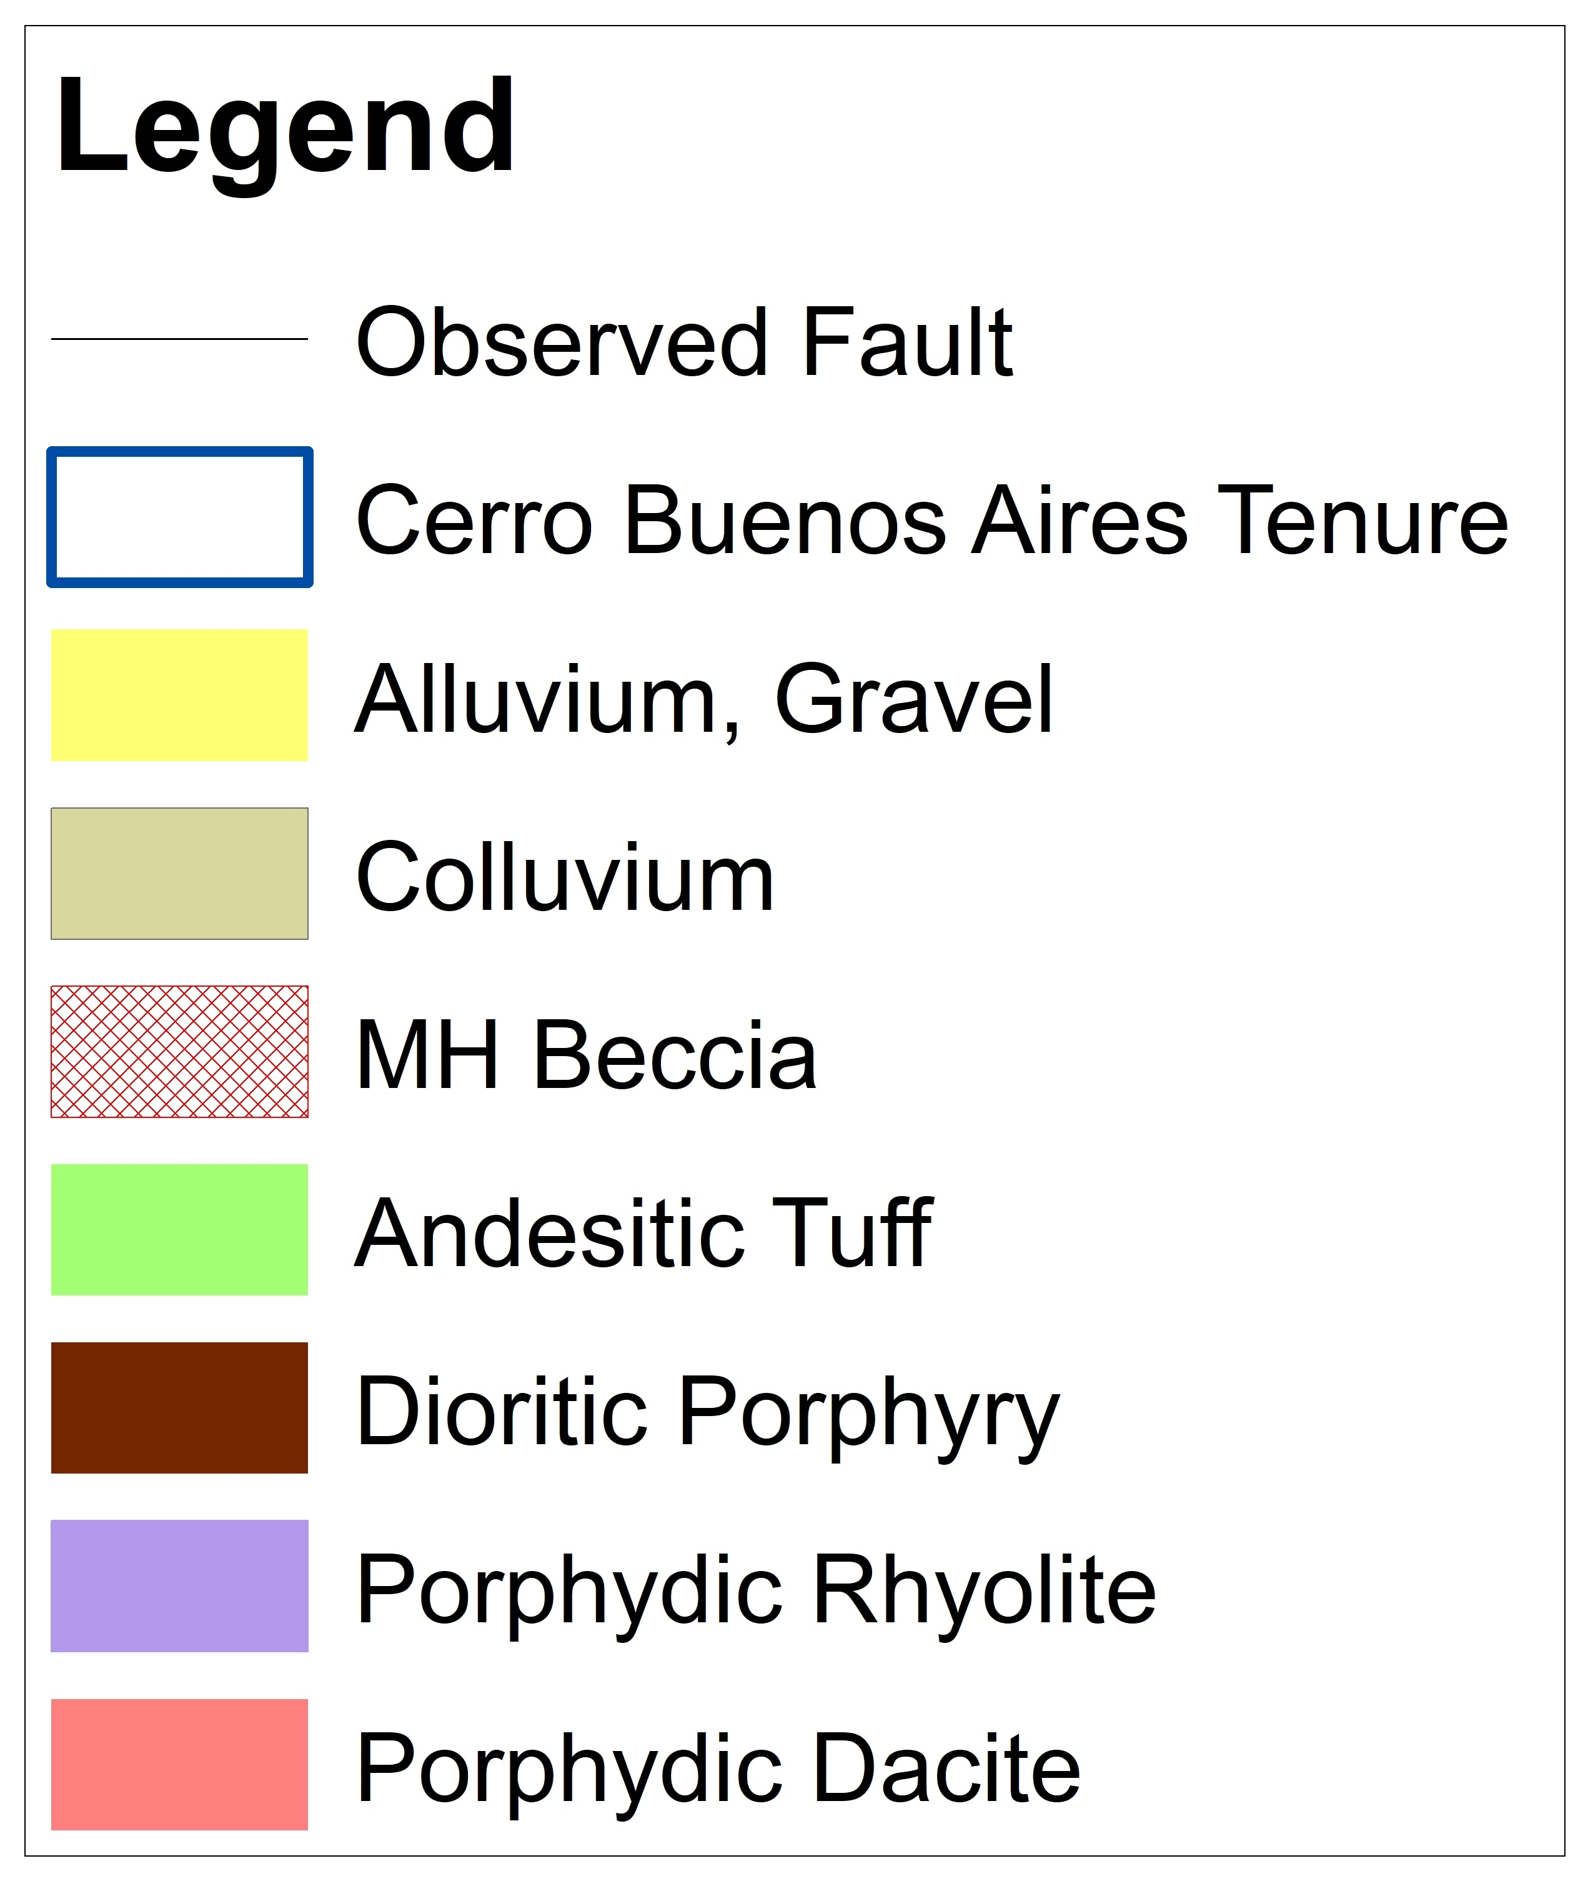
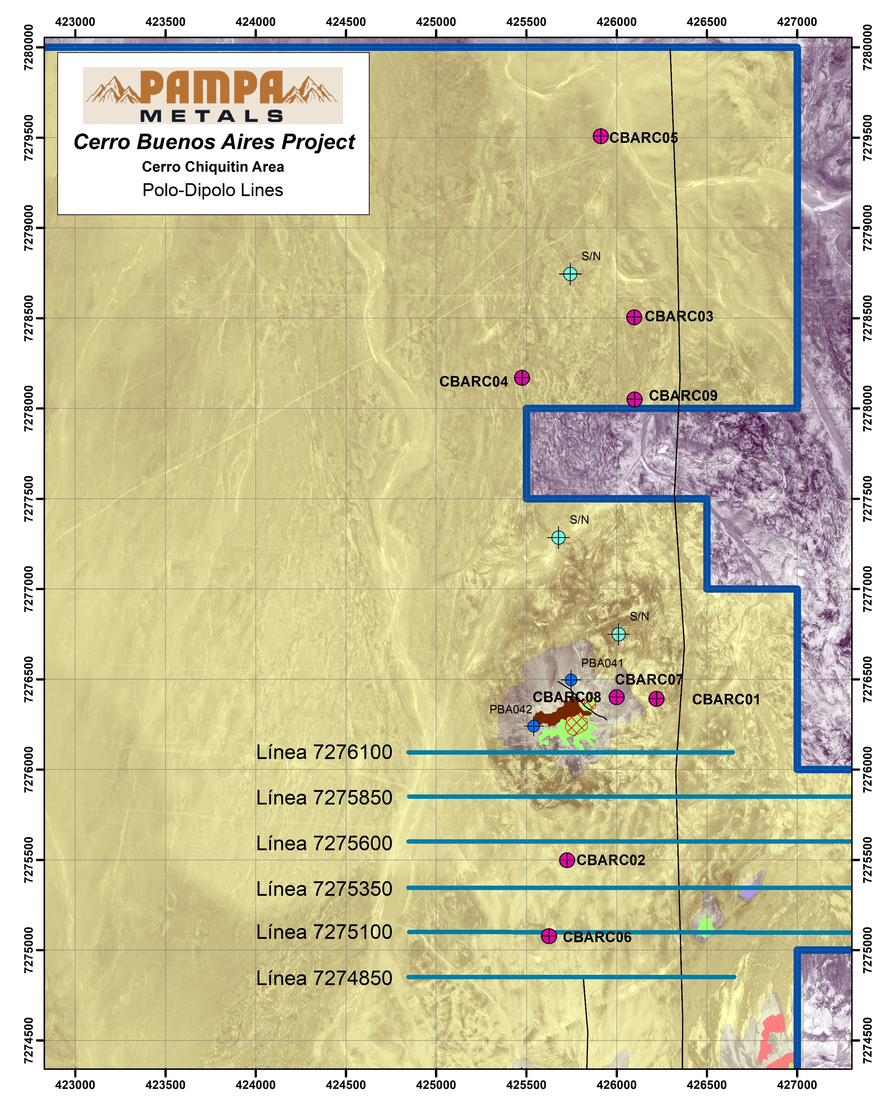
Cerro Chiquitin – Pole-Dipole IP Lines & Previous Drilling

