## MBDA Emblem - FINAL

## cid:image001.gif@01C69EC8.9B5BCB90UNITED STATES DEPARTMENT OF

### COMMERCE

### NEWS

**WASHINGTON, D.C. 20230**

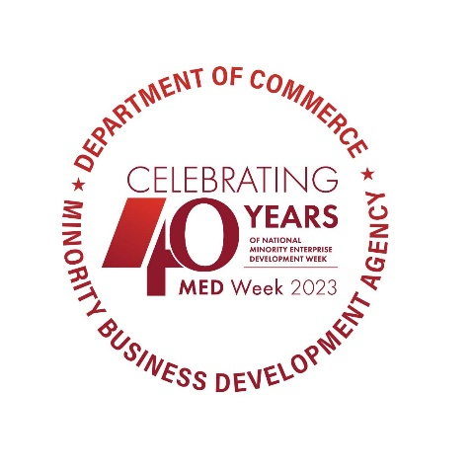**­­­**

**MBDA Media Contact Information:**

Mr. Gabriel Cushing, Public Affairs

Email Address: [mbdapublicaffairs@mbda.gov](mailto:mbdapublicaffairs@mbda.gov)

Website(s): <http://www.mbda.gov/>

**The Minority Business Development Agency Announces Winners of the 2023 National Minority Enterprise Development Week Awards**

WASHINGTON, DC – Today, the U.S. Department of Commerce, Minority Business Development Agency (MBDA) proudly announces recipients of the 2023 Minority Enterprise Development (MED) Week Awards. The National MED Week Awards are the highest level of national recognition that a U.S. minority business enterprise can receive from the Department of Commerce. These prestigious awards celebrate the outstanding achievements of minority entrepreneurs, as well as the individuals and organizations that have demonstrated their commitment to advancing minority business enterprises.

Forty years ago this week, the inaugural National MED Week was established and has since evolved into an iconic celebration and has been a catalyst for the creation of hundreds of local MED Week conferences across the Nation. These local and regional conferences have been enthusiastically sponsored by state and local governments, for-profit entities, and non-profit organizations. Today, the National MED Week brand and conference format is broadly accepted and synonymous with quality and support for the recognition and growth of minority business enterprises.

"Minority businesses have weathered the storm of the recent pandemic, and rallying behind them is not only the right thing to do, but it's also a strategic move for our nation's recovery," said Under Secretary for Minority Business Development Donald R. Cravins Jr. "With our newfound permanent federal agency status and an extended reach, now covering 131 program operators across the nation, we're thrilled to celebrate the entrepreneurial spirit within the minority business community. Bolstered by unwavering support from the White House and our partners at NMSDC, we are fully committed to elevating the revenues and capabilities of minority business enterprises, ensuring they are well-prepared to excel in our nation's economy and achieve equitable success."

The 2023 National MED Week Award recipients, by category, are:

**Minority Firms of the Year**

• **Minority Construction Firm of the Year Award:** Reytec Construction Resources (Houston, TX)

• **Minority Export Firm of the Year:** Combustion Associates, Inc. (Corona, CA)

• **Minority Manufacturing Firm of the Year:** Myers-Seth Pumps (Jacksonville, FL)

• **Minority Emerging Technology and Industries Firm of the Year Award:** Hydroplane Limited (Sherman Oaks, CA)

• **Minority** **Health Products and Service Firm of The Year Award:** Obatala Sciences (New Orleans, LA)

• **Minority** **Marketing and Communication Firm of the Year:** Social Driver (Washington, DC)

• **Minority** **E-Commerce Firm of the Year:** Storehouse in a Box (Farmington, MI)

• **Minority** **Veteran Owned Firm of the Year:** Arlo Solutions (Washington, DC)

• **Robert J. Brown Minority Business Enterprise of the Year Award:** Optus Bank (Columbia, SC)

**Champions of Minority Business Development**

• **Access to Capital Award:** Cuong Quy Huynh, Co-Founder, General Manager, and Treasurer, Rende Progress Capital (Sterling, VA)

• **Advocate of the Year Award:** Arian Simon, Co-Founder and CEO, Fearless Fund (Atlanta, GA)

• **Distinguished Supplier Diversity Award:** Siemens Corporation (Washington, DC)

**Individual Recognition**

• **Abe Venable Legacy Award for Lifetime Achievement Award:** David Steward (St. Louis, MO)

• **Ronald H. Brown Leadership Award:** Manuel Cidre Miranda (Arecibo, PR)

Award winners will be recognized at this year’s 40th National MED Week, sponsored by META, Amazon Global Procurement Organization, RTX, IBM, and Mastercard. 2023 National MED Week will be hosted in collaboration with the Annual Conference & Exchange by the National Minority Supplier Development Council (NMSDC), and will take place in Baltimore, Maryland from October 22-25. For more information on this year’s National MED Week, visit [www.mbda.gov](http://www.mbda.gov).

**About the U.S. Minority Business Development Agency (MBDA):**

The U.S. Department of Commerce, Minority Business Development Agency is the only Federal agency solely dedicated to the growth and global competitiveness of U.S. minority business enterprises (MBEs). For more than 50 years, MBDA’s programs and services have better equipped MBEs to create jobs, build scale and capacity, increase revenues, and expand regionally, nationally, and internationally.

###