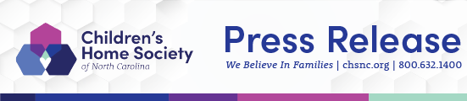
For Immediate Release
For more information, contact:
Children’s Home Society of NC
Dillard Spring
Director of Marketing & Communications
1.800.632.1400
dspring@chsnc.org

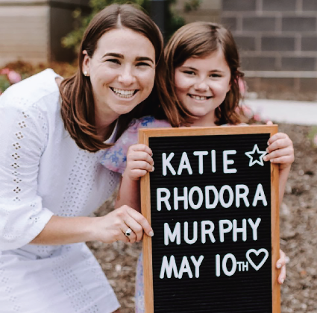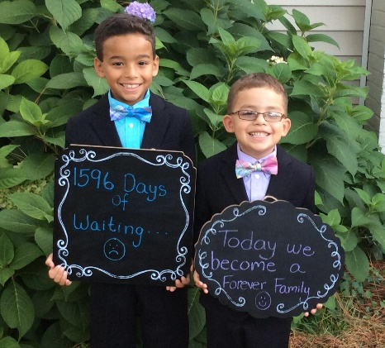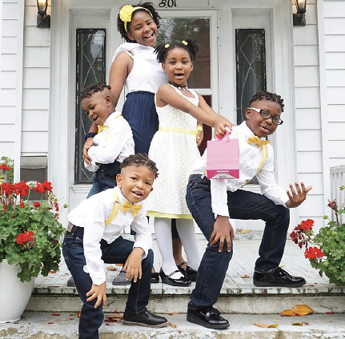

A sampling of Children’s Home Society adoption celebrations
See heartwarming adoption stories at https://www.chsnc.org/about/news/

Children’s Home Society of NC Celebrates
November as National Adoption Month

November 1, 2023 - Greensboro, NC – During November, Children’s Home Society of NC (CHS) and the broader community acknowledge those whose lives have been impacted by adoption and those who facilitate the process. This month helps spread awareness and encourages all to learn more about adoption.

National Adoption Month celebrates the families who have grown through adoption. It also recognizes the journey of the many children who are still waiting for their forever families. It further highlights the approximately 114,000 youth nationwide in need of adoption, and how easy it is to make a difference even if you cannot adopt.

“During National Adoption Month, we hope you will take the opportunity to spread the word about the more than 11,000 children in foster care here in North Carolina who so longingly hope for a permanent, safe, and loving family of their own, and offer them your support,” said Shannon Enoch, CHS Executive Director of Programs.

“Children’s Home Society strives for a permanent, safe, and loving family situation for children through reunification with their families of origin, and when that is not possible, through adoption. “We view adoption as a lifetime commitment, and we commit to our children and families to support them through the entirety of their adoption journey,” Enoch added.

Children’s Home Society has celebrated more than 16,000 adoptions since 1902. With over 11,000 children in foster care in our state, and 450-plus aging out each year, we continue to work tirelessly in our mission to promote the right of every child to a permanent, safe, and loving family. Today, CHS continues to create new families as well as to provide families with the support and resources they need to be healthy, stay together, grow stronger, and thrive.

For more information about Children’s Home Society, preserving family well-being, becoming a foster or adoptive parent, volunteering, or providing financial support, please call 800-632-1400 or visit www.chsnc.org.

About Children’s Home Society of North Carolina
Children’s Home Society offers a network of services and support throughout North Carolina to help establish and sustain healthy, loving relationships in every family. For 120 years, Children’s Home Society has provided a broad spectrum of programs and services including adoption, foster care, parenting education, family preservation, and teen responsibility. Children’s Home Society believes in the importance of family, not only in the life of a child but also in the foundation of a community. For more information, visit www.chsnc.org.

