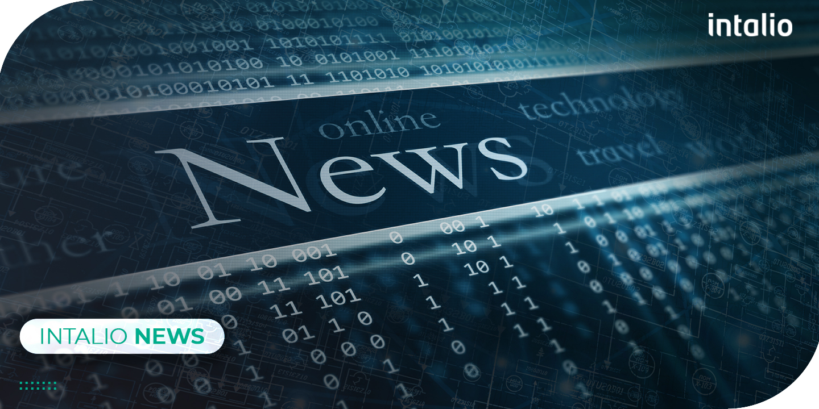
Intalio Announces the Appointment of Andy Scott as Senior Business Development Manager in the UK

July 2021 - Intalio appointed Andy Scott as the new Senior Business Development Manager in the UK to support the company’s global organizational strategy.
Since the late 1980s, Andy has had a great deal of experience with sales and marketing, and with implementing ERP projects, which makes him a key addition to helping Intalio reach new heights.

Not only does Scott have a solid background in ERP and business applications in general, but he has also gained considerable expertise in Odoo, a leading suite of applications dedicated to the innovation of enterprise business solutions and resource planning.

“Intalio through its acquisition of Ever Business Solution has been instrumental in Odoo's success, as well as being very well established in many other complementary solution areas. I am thrilled to be joining the team as I believe we can project that success onto the UK market. I am sure that we will be able to make a difference in the digital transformation field, as our customers will benefit from extensive solution knowledge, excellent implementation, and support resources from a growing UK-based team”, said Andy Scott.

Andy will be influential in further supporting our strategic expansion approach and our vision of becoming a leading organization outside of its present territories and industries. He will also play a key role in strengthening Intalio’s customer-centric marketing approach in various areas, as well as the alignment between Intalio’s Sales Organization and Marketing. Furthermore, Intalio will benefit from Scott’s widespread experience with product verticals packaging, marketing materials, and promotions, as well as the revision of product roadmap and priorities. This will help Intalio reinforce its product certifications and ensure that we deliver world-class products that meet the technological needs of every industry across the globe.

Intalio will continue to propose a diverse portfolio of products, solutions, and services, keeping its promise of providing the best solutions to enterprises of all sizes and industries while maintaining the level of excellence and professionalism that it has always delivered.

About Intalio
Intalio is a leading provider of Digital Transformation Solutions with over 30 years of countless innovations in Content Services, Process Services, and Data Governance. Initially founded in 1999, Intalio emerged as a leading provider for business process management solutions and distributed its services across North America, Europe, and Asia. Its main goal is to empower organizations of all sizes and from all sectors to design, deploy, and optimize the most complex business procedures.

