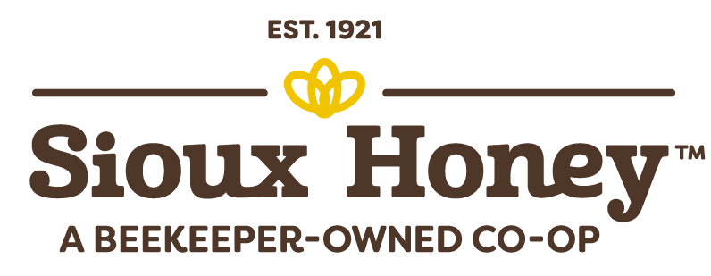

MEDIA RELEASE

RELEASE DATE: Thursday, January 25

CONTACT: Jim Minge
Public Relations Liaison
402-740-8188
jminge@bozell.com

Largest Honey Donation – Ever
‘Operation Honey Bear Hug’ delivers tens of thousands of bottles of premium honey to local food banks

Sioux City, Iowa – The Sioux Honey Co-op, a 103-year-old collective of U.S. beekeepers based in Sioux City, Iowa, donated 30,000 bear-shaped bottles of its premium SUE BEE® Clover Honey this week to food banks in five states.

The effort, affectionately known as “Operation Honey Bear Hug” by Sioux Honey team members, was carried out simultaneously in Sioux City at the Foodbank of the Heartland; in Meridian, Idaho, at the Idaho Foodbank; in Brooklyn Park, Minn., at Second Harvest Heartland in Fargo, N.D., at the Great Plains Foodbank; and in Irvine, Calif., at South County Outreach.

“It’s the most honey we have ever donated, and we believe it’s also the largest honey donation ever made by a U.S. honey co-op,” said Mark Mammen, President Emeritus at Sioux Honey.

“To visualize that much honey, consider this: If you stacked all 30,000 honey bears, head-to-toe, they would be taller than the peak of Mount Kilimanjaro,” Mammen added.

Many of Sioux Honey’s 150+ co-op of beekeepers live with their families in and around the communities where the honey bears are being donated.

“Our beekeepers are all about sharing sweetness, and so we decided to make this donation in their honor as a way to celebrate them and their families and all their hard work,” Mammen said.

Sioux Honey’s Grade A clover honey is an ideal product for food banks and pantries because of its versatility. It doesn’t need to be refrigerated; it can be used to help soothe a sore throat or tame a cough; it’s a great natural substitute for sugar in baking; and it has a substantial shelf life.

Indeed, honey is a superfood that lasts a long time. How long? They found a jar of honey in King Tut’s golden tomb that was still edible after 3,000 years. But the honey donated to the five community food banks will be eaten much faster than that, as condiments like honey are prized commodities at food banks.

“Honey – along with items like mustard, ketchup, seasonings, those kinds of things – is prized at food banks, which makes this donation highly coveted,” said Randy Ford, the CEO at The Idaho Foodbank, which provides food to 440 partners in Idaho, including food pantries, churches, schools and other community centers.

“For people who are struggling with food insecurity having access to shelf-stable items like honey is extremely helpful,” Ford added.

For Minnesota beekeeper Dan Bauer the donation represents the No. 1 reason the Bauers joined the Sioux Honey Co-op 50 years ago: Family.

“As a member of the Sioux Honey Co-op, we’re in the business together,” Bauer said. “If one of us does well, we all do well. It’s the Sioux Honey way. Same in our communities. If I can help my neighbor out, you can bet that I’m going to help.”

EDITOR’S NOTE: If you would like to interview a representative from one of the food banks or the Sioux Honey Co-op, please contact Jim Minge, PR liaison at 402-740-8188 or jminge@bozell.com.

PHOTOS: See attached photos and Photo ID document.

VIDEO available upon request via Jim Minge, PR liaison at 402-740-8188 or jminge@bozell.com.

ABOUT SIOUX HONEY CO-OP: In 1921, the Sioux Honey Co-op began as a small group of just five beekeepers. Located near Sioux City, Iowa, they shared equipment, marketing and processing facilities – all to help support one another. Today, Sioux Honey is still a co-op, but it has grown into 150+ beekeepers nationwide. Some have been members for decades – part of families who have passed down the trade for generations – and some have pioneered and started their own bee farms. But all of the members have a passion for producing a pure, quality product that customers can trust. And we’re proud to say we know each of our beekeepers by name, because we’ve learned that’s how you produce the best honey for more than a century.

ABOUT HONEY, from the National Honey Board: The story of honey is older than history itself. An 8,000-year-old cave painting in Spain depicts honey harvesting, and we know it's been used for food, medicine and more by cultures all over the world since. But honey isn't about humans. It's the natural product made by bees – one of our planet's most important animals. Honeybees visit millions of blossoms in their lifetimes, making pollination of plants possible and collecting nectar to bring back to the hive. Lucky for us, bees make more honey than their colony needs, and beekeepers remove the excess and bottle it. Just like they've been doing since the beginning of time.

