Henry J. Carter Specialty Hospital receives Enhanced Respiratory Care Standards of Care Accreditation

[DATE] – New York, NY

Henry J. Carter is the first long-term acute care hospital (LTACH) and Skilled Nursing Facility (SNF) in New York City to meet the new standard of respiratory care, championed by the Physician-Patient Alliance for Health & Safety.
The Physician-Patient Alliance for Health & Safety (PPAHS) is pleased to announce that Henry J. Carter (HJC) Specialty Hospital and Nursing Facility, a long-term care facility at NYC Health + Hospitals in New York, has met or exceeded the Enhanced Respiratory Care Standards of Care.

“At Henry J. Carter,” said the HJC CEO Floyd R. Long, “we strive to deliver the highest quality of both medical and rehabilitative care. As the only LTACH in New York City, we cannot ask less of ourselves. Weaning patients off medical support to enjoy their lives to the fullest has long been a priority: our facilities include a 14-bed weaning unit, and our Medical Ventilation weaning program boasts a 70% success rate exceeding both regional and national benchmarks. We are proud of the work we’ve done, and we appreciate the recognition from the Physician-Patient Alliance for Health & Safety (PPAHS). We’re looking forward to working closely with PPAHS in the future to ensure the best quality of care and quality of life for all of our patients.”
Until recently, there was no unified standard for service quality in Mechanical Ventilation (MV) facilities. This lack of standardization sometimes resulted in a lower quality of life for patients and their families, with problems including lung injuries, hypotension, and dependency on MV. Consequently, the facilities experienced inefficient resource use and increased liability insurance rates.
Enhanced Respiratory Care, endorsed by the American Association for Respiratory Care (AARC), is the first and only standard in the field. Developed and refined through years of practice in Tennessee, where it has been the standard for ventilation since 2003, this evidence-based approach includes advancements in weaning, patient care, and ventilator unit technology. It benefits everyone involved: patients and their families experience a higher quality of life and improved outcomes, while facilities gain a competitive edge through accreditation and optimize their resource utilization.
Henry J. Carter Special Hospital and Nursing Facility accreditation marks two firsts - the first LTACH in the country and the first SNF to join the PPAHS standard.
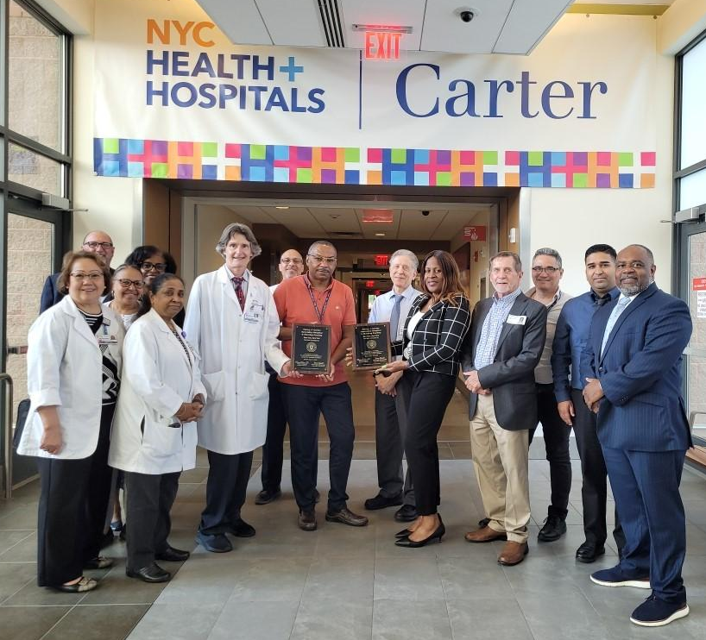
Caption – HJC CEO Floyd R. Long; Chief Medical Officer Dr. Michael Schuster; Chief Nursing Officer Meriam Pineda; LTACH Pulmonary Director Dr. William Dinan; Dr. Pappathi Anbalagan; Director of Respiratory Care Ms. Juliet Esan; and other members of the clinical and operations team.

Clyde Heflin MD, FACCP spoke about the need for recognized standards of care, “Previous to the Enhanced Respiratory Care Standards of Care, there were no established standards of care. Patients were sent to healthcare facilities based on other factors - bed availability, the smoothness of the marketing process, the look of the building, and so on. Enhanced Respiratory Care provides a standard of care that ensures that patients are receiving care based on an established standard and not on extraneous factors.” Dr. Heflin is also a member of the Enhanced Respiratory Care Standards Committee.

Michael Wong, JD (Executive Director, Physician-Patient Alliance for Health & Safety) emphasized the patient safety and quality of care that New York State communities will now enjoy, saying, “When families send their loved ones and friends to a healthcare facility, they want to make sure that they are receiving the best care possible. For communities in New York State, Henry J. Carter Specialty Hospital is such a facility.”

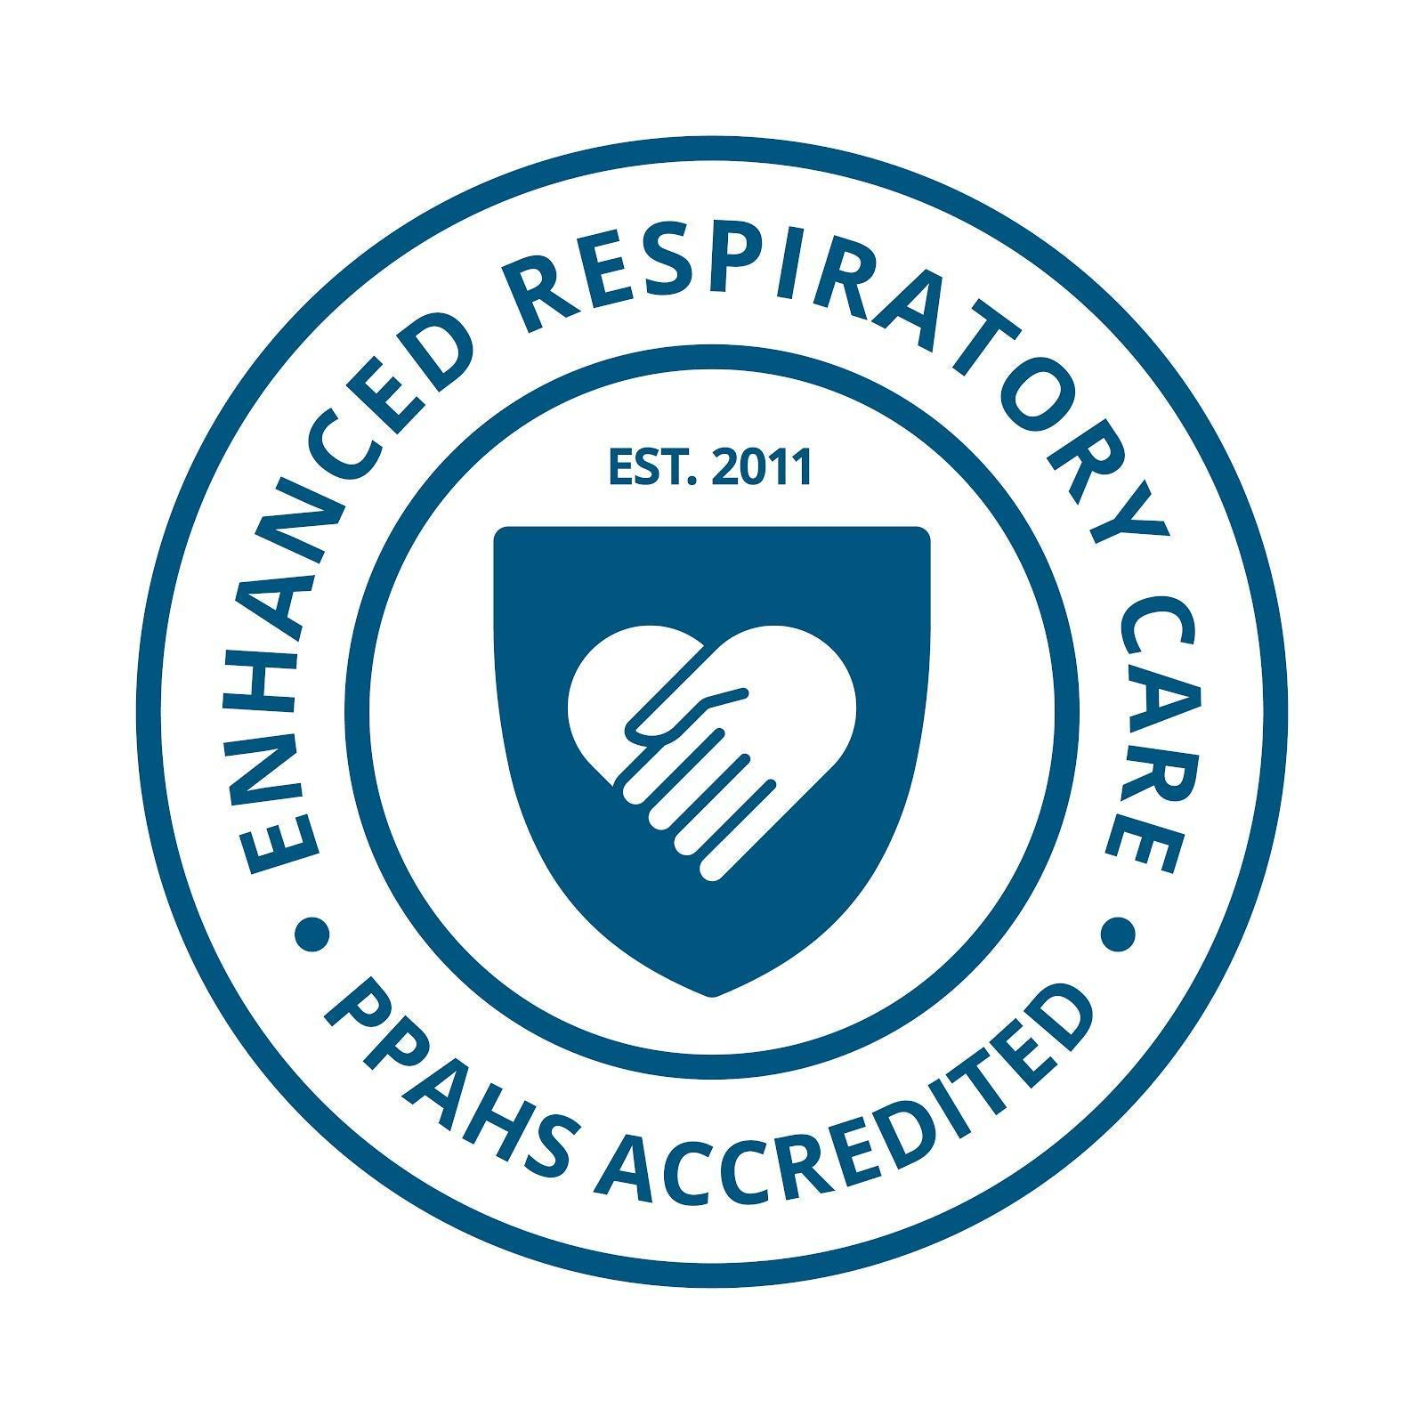
The Enhanced Respiratory Care Standards of Care are supported and endorsed by the American Association for Respiratory Care. Carl Hinkson, MS, RRT-NPS, ACCS, FAARC (President, American Association for Respiratory Care) writes:

“The American Association for Respiratory Care (AARC) would like to express our support and endorsement of your efforts in developing standards of care and facility accreditation for long-term mechanical ventilation in skilled nursing facilities. As the leading professional association for respiratory therapists in the United States, we recognize the importance of ensuring patients receive the highest quality care possible.”

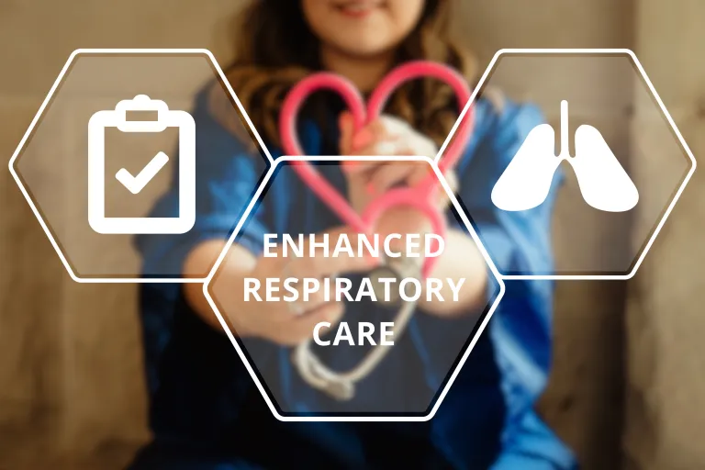

The Enhanced Respiratory Care Program is based on standards published by the American Association for Respiratory Care. Utilized in Tennessee, this Program has achieved liberation rates of 65% and has earned national recognition of excellence from the American College of Chest Physicians.

For more on the Enhanced Respiratory Care Accreditation, please visit
https://ppahs.org/accreditation-of-facilities/

To apply for Accreditation, please go to https://ppahs.org/apply-for-accreditation/

About NYC Health + Hospitals

NYC Health + Hospitals is the largest public health care system in the nation serving more than a million New Yorkers annually in more than 70 patient care locations across the city’s five boroughs. A robust network of outpatient, neighborhood-based primary and specialty care centers anchors care coordination with the system’s trauma centers, nursing homes, post-acute care centers, home care agency, and MetroPlus health plan—all supported by 11 essential hospitals. Its diverse workforce of more than 43,000 employees is uniquely focused on empowering New Yorkers, without exception, to live the healthiest life possible. For more information, visit www.nychealthandhospitals.org and stay connected on Facebook, Twitter, Instagram and LinkedIn.

About the Henry J. Carter Specialty Hospital and Nursing Facility

The Henry J. Carter Specialty Hospital and Nursing Facility at 1752 Park Avenue and 122nd Street in Manhattan features 365 beds for two distinct types of healthcare services: long-term acute care and skilled nursing care. Carter’s 201-bed Long-Term Acute Care Hospital (LTACH) provides specialized clinical support around the clock. This includes physicians on site at all times, and sub-specialty care that is always accessible, including pulmonologists, infectious disease specialists, cardiologists, and a full complement of clinical support services such as clinical labs, radiology, respiratory care and pharmacy. The long-term acute care hospital serves high acuity, medically fragile patients, many of whom require ventilator support, and patients with multiple chronic medical conditions that significantly impact life functioning, such as respiratory failure, congestive heart failure, uncontrolled diabetes, complex infections and complex wounds. Carter’s 164-bed Skilled Nursing Facility serves residents whose medical needs require management and care that cannot be provided at home. The facility features technologically advanced support equipment and a highly qualified on-site staff that are available 24/7. To learn more about the NYC Health + Hospitals/Carter – Long-term Acute Care Hospital and Nursing Facility or to schedule an appointment/tour, please call (646) 686-0000 or visit https://www.nychealthandhospitals.org/locations/carter-nursing-facility/. To take virtual tour of NYC Health + Hospitals/Carter, click here.

Henry J. Carter is also ranked #5 in Newsweek’s Best Nursing Homes in New York 2025; and received high-performance ratings in short-term rehabilitation from U.S. News and World Report’s Best Nursing Homes 2024.

About Physician-Patient Alliance for Health and Safety

Physician-Patient Alliance for Health & Safety is ranked internationally as a top-100 patient safety organization (Agilience Authority Index) and is a national advocacy force for addressing patient health and safety priorities shared by patients, physicians, regulators, and industry. PPAHS seeks to ensure that the best medications, medical inventions, and technology that can improve care and reduce costs are employed. PPAHS works to advance patient health and safety by developing and highlighting best practices and recommendations through better use and application of clinical practices and experiences, information technologies and checklists, and healthcare information. As a voice in support of ideas and innovation that can improve care, we encourage a health ecosystem that fosters a culture of patient safety. For more about PPAHS, please visit www.ppahs.org.

