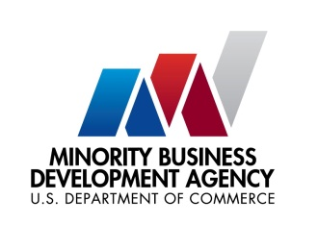

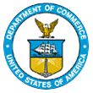
UNITED STATES DEPARTMENT OF

COMMERCE

NEWS
WASHINGTON, D.C. 20230

MBDA Media Contact Information:
Mr. Gabriel Cushing, Public Affairs
Email Address: gcushing@mbda.gov
Website(s): http://www.mbda.gov/

Today, the U.S. Department of Commerce’s Minority Business Development Agency (MBDA) officially announced Wendy D. Anderson as its permanent Chief of Staff.
Anderson previously served as Chief of Staff to Congresswoman Val Demings (FL-10) and Congresswoman Yvette Clarke (NY-9) where she counseled both members on critical legislation, oversaw all strategic policy implementation, managed staff, and facilitated leadership engagement across offices. An honors graduate from Florida A&M University, Anderson ushered MBDA through the launch of its Capital Readiness Program, a historic $125 million technical assistance program to help underserved entrepreneurs grow and scale their businesses. In August 2023, Vice President Harris joined MBDA in announcing the competition awardees for the Capital Readiness Program.
“Since joining MBDA, Wendy’s skillset and enthusiasm have garnered much admiration from our colleagues and across the Department of Commerce,” said Under Secretary of Commerce for Minority Business Development Donald R. Cravins Jr. “Deputy Under Secretary Cavazos and I look forward to working alongside Wendy in this permanent role as we continue to promote growth and global competitiveness for minority business enterprises across the country. Her intellect, leadership, instincts, and experience will be fundamental to that effort.”
MBDA’s new Chief of Staff joins over 25 other new staff members onboarded since January 2023 and reflects the agency’s mission to expand its current staff and capabilities. This growth is a key part of Under Secretary Cravin’s vision for a “new” MBDA, and of its codification in the Bipartisan Infrastructure Deal signed into law by the Biden-Harris Administration in November of 2021.
About the Minority Business Development Agency (MBDA)
The U.S. Department of Commerce, Minority Business Development Agency is the only Federal agency solely dedicated to the growth and global competitiveness of U.S. minority business enterprises (MBEs). For more than 50 years, MBDA’s programs and services have better equipped MBEs to create jobs, build scale and capacity, increase revenues, and expand regionally, nationally, and internationally.
###

