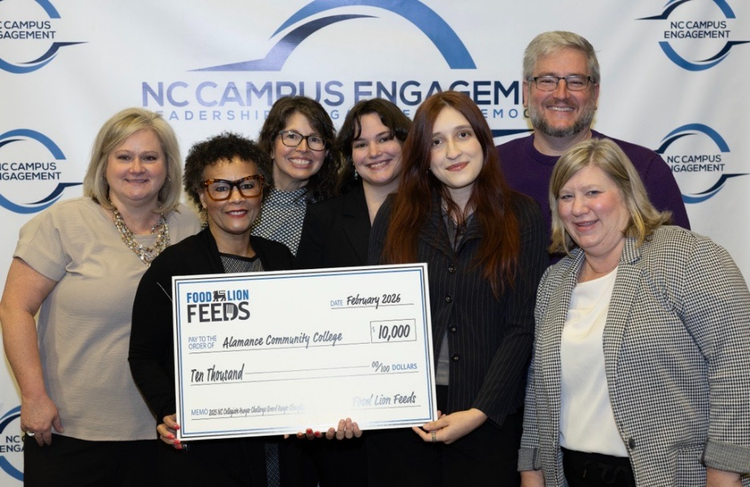

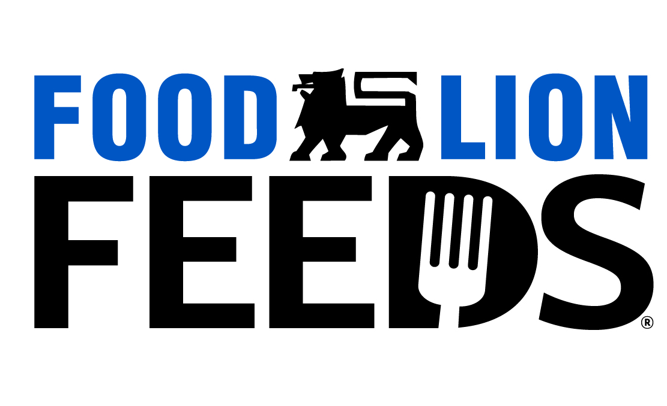

Feb. 16, 2026
FOR IMMEDIATE RELEASE

CONTACTS: Food Lion Media Relations
704-245-3317
publicrelationsteam@foodlion.com

Food Lion Feeds Announces North Carolina Collegiate Hunger Challenge Winners
Student leaders collect more than 66,000 pounds to promote nutritional access on campus

SALISBURY, N.C. – Food Lion Feeds, Food Lion’s hunger-relief platform, and North Carolina Campus Engagement have announced the winners of the North Carolina Collegiate Hunger Challenge, recognizing student-led efforts to address hunger on college campuses across the state. Together, the organizations awarded a total of $20,000 to the winning colleges for their standout volunteerism efforts.
From Sept. 8 to Dec. 19, 2025, 14 North Carolina colleges and universities competed to earn points by organizing events that raised awareness of food insecurity, nutritional education and wellness resources available in their communities.
Alamance Community College took home the title of the Grand Hunger Champion, securing the $10,000 grand prize. Catawba College was named the North Carolina Independent Colleges and Universities Private Sector Hunger Champion and North Carolina Central University won the UNC System Public Sector Hunger Champion. Each sector winner will receive $5,000.
Food Lion Feeds and North Carolina Campus Engagement will also award each of the winning colleges $1,600 to help supplement pantry levels during the spring semester.
Collectively, the 14 participating schools made a measurable impact by:
- Collecting more than 66,000 food items
- Hosting more than 120 awareness events
- Amplifying the cause with more than 300 social media posts
- Impacting more than 10,700 students, staff, faculty and community members
Dedicated MVP Student Hunger Ambassadors at each school led food drives, pantry renovations and educational activities designed to engage campus communities in innovative ways. Each participating school received $500 to host their hunger awareness events, while student ambassadors were paid stipends for their leadership.
“College students are stepping up in powerful ways to support one another and their communities,” said Kevin Durkee, Manager, Food Lion Feeds, Food Lion. “Through the N.C. Collegiate Hunger Challenge, we’re proud to partner with North Carolina Campus Engagement to support student-led solutions that help ensure students have access to the food they need to learn, grow and succeed.”
The award presentation took place Feb. 11 at North Carolina Campus Engagement’s annual Pathways to Achieving Civic Engagement Conference at Elon University in Elon, N.C.
“For eight years, the Hunger Challenge has empowered college students to raise awareness of food insecurity and take meaningful action to address it,” said Leslie Garvin, executive director, North Carolina Campus Engagement. “We are grateful for our partnership with Food Lion Feeds because this leadership-in-action model is more important than ever, as campuses report increased use of food pantries and recent survey data show that 30% of college students experience food insecurity.”
Fourteen Participating Schools:
University Partner | City
Alamance Community College | Graham
Catawba College | Salisbury
East Carolina University | Greenville
Elizabeth City State University | Elizabeth City
High Point University | High Point
Methodist University | Fayetteville
North Carolina Central University | Durham
North Carolina A&T State University | Greensboro
Piedmont Community College | Roxboro
Queens University of Charlotte | Charlotte
UNC Asheville | Asheville
UNC Pembroke | Pembroke
Warren Wilson College | Swannanoa
William Peace University | Raleigh
Since 2019, the North Carolina Collegiate Hunger Challenge has awarded more than $185,000, equivalent to more than 1.8 million meals*. Through Food Lion Feeds, Food Lion has helped provide more than 1.5 billion meals to individuals and families since 2014 and has committed to donating 3 billion meals by 2032. To learn more about Food Lion Feeds and its hunger relief efforts, visit foodlion.com/feeds.
*$1 helps provide at least 10 meals secured by Feeding America® on behalf of local partner food banks.
About Food Lion
Food Lion is an omnichannel grocery retailer committed to nourishing its neighbors. More than 82,000 associates across 1,100+ stores deliver an easy, fresh and affordable shopping experience throughout 10 Southeastern and Mid-Atlantic states. With a focus on hunger relief, Food Lion is a pioneer in food rescue. Since 2014, the company’s hunger relief platform Food Lion Feeds has donated more than 1.5 billion meals to those who are food insecure. The retailer has committed to donate 3 billion meals by 2032. Founded and based in Salisbury, N.C., since 1957, Food Lion is a company of Ahold Delhaize USA, the U.S. division of Zaandam-based Ahold Delhaize. For more information, visit foodlion.com.

About North Carolina Campus Engagement
North Carolina Campus Engagement is a collaborative network of colleges and universities committed to preparing students for civic and social responsibility, partnering with communities for positive change and strengthening democracy. Learn more at nccampusengagement.org.
# # #

