PRESS RELEASE

New AMO Speed Sensor Optimizes Main Spindle on Milling / Turning Machines

-Save money with the new WMK 3010S-

SCHAUMBURG, IL (March 2022) – The new WMK 3010S rotational speed sensor from AMO is now available, and provides users of milling and turning machines a better option for operation of their main spindle. Besides providing speed data, the WMK 3010S also supports the capturing of operating status data of that spindle thus optimizing many costs related to the operation of the machine.

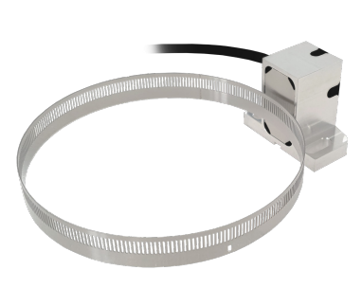
Available in North America through parent company HEIDENHAIN, this new AMO speed sensor includes a USB interface which allows the operating status of the spindle to output to the machine control. This enables the user to record rotational speed, operating time, temperature and more. Put these factors together, and overall performance and uptime expectations are optimized.

The rugged, inductive, incremental scanning head on the WMK 3010S is available with a 1Vpp interface. It has a minimalist modular design, allowing this IP67-rated product to be installed in existing customer designs without significant modifications. It is available in the common industry line count increments and can be operated up to a max of 50,000 rpm.

Many useful features are offered in the WMK 3010S including:
- Inductive Scanning
- IP67 protection
- Max speed of 50,000 rpm
- Integrated acquisition of operational data
- Offline output of data via USB
- Low Cost

Contact HEIDENHAIN to learn more!

About HEIDENHAIN
DR. JOHANNES HEIDENHAIN GmbH, headquartered in Traunreut, Germany, develops and supports motion control feedback solutions for the machine tool, semiconductor, electronics assembly and test, metrology, automation, medical, energy, biotechnology and other global markets. HEIDENHAIN employs approximately 6,000 people worldwide in its core business activities. The North American subsidiary is HEIDENHAIN CORPORATION, headquartered in Schaumburg, IL, and San Jose, CA, and has been serving the U.S. industry for over 50 years. Here nine company brands are represented. More information at: www.heidenhain.us/about-us

#

Image Available at: AMO_wmk_rotational_speed_sensor.jpg (1227×913) (heidenhain.us)

Media contact:
Kathleen Herrmann, K-Pro PR, Inc.
kherrmann@kpropr.com or 224-520-0665

Product contact:
Stuart Graham, Business Development Specialist
sgraham@heidenhain.com

