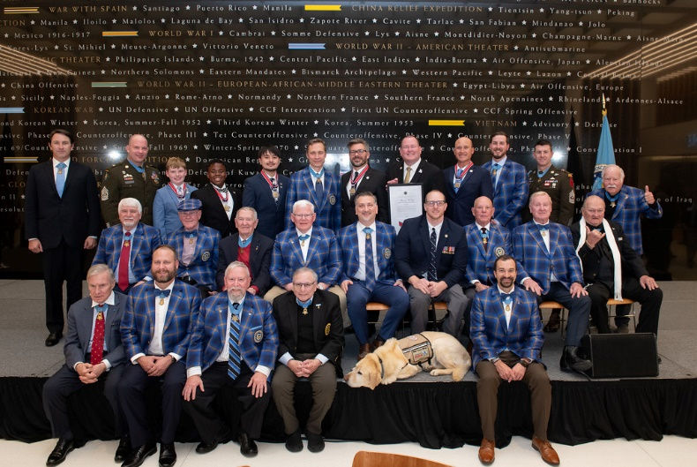
America's VetDogs Honored with Congressional Medal of Honor Society's 2024 Community Service Citizens Award
FOR IMMEDIATE RELEASE: March 27, 2024 (Smithtown, New York): America's VetDogs, a leading provider of assistance dogs to veterans and first responders with disabilities, is proud to announce it has been honored with the prestigious 2024 Community Service Citizens Award from the Congressional Medal of Honor Society. This esteemed recognition highlights America's VetDogs' unwavering commitment to serving those who have bravely served our nation.
Each year, the Congressional Medal of Honor Society acknowledges organizations and individuals who demonstrate outstanding dedication to their communities and exemplify the values of courage, sacrifice, and selflessness. The Community Service Citizens Award is particularly significant as it underscores the impact of organizations that go above and beyond to make a positive difference in the lives of others. Specifically, the award recognizes a community-based non-profit organization for its exceptional impact or mission in supporting our nation’s military service members and families.
"We are honored to receive the 2024 Community Service Citizens Award from the Congressional Medal of Honor Society," said John Miller, President, and CEO of America's VetDogs. "This recognition is a testament to the dedication of our staff, volunteers, and supporters who work tirelessly to fulfill our mission of enhancing the lives of veterans and first responders with disabilities. We are grateful for the opportunity to serve those who have sacrificed so much for our country. It was truly an honor to meet many of The Medal of Honor recipients and hear their stories of valor directly from them.”
America's VetDogs’ recognition by the Congressional Medal of Honor Society highlights the vital role of service dogs in aiding individuals with disabilities and the deep bond between humans and canines. The national nonprofit has placed more than 1,000 service dogs since 2003, supporting thousands of veterans, active-duty service members, and first responders as well as their families and loved ones. Through expertly trained service dogs and ongoing support, the organization makes a lasting impact which changes and saves lives. As it celebrates this recognition, America's VetDogs remains dedicated to serving veterans and first responders nationwide, upholding its legacy of empowerment and honoring their noble service.
For more information about America's VetDogs, please visit vetdogs.org. For images and produced video of the awards, click here.
For media inquiries, please contact: Allison Storck, 631-334-2615, Allison@VetDogs.org
About America's VetDogs:
For 20 years, America’s VetDogs (www.VetDogs.org) has trained and placed guide and service dogs to provide independence, enhanced mobility, and companionship to veterans with disabilities from all eras. In 2015, VetDogs opened its programs to first responders, including fire, police, and emergency medical personnel. America’s VetDogs is a 501(c)(3) not-for-profit organization founded by the Guide Dog Foundation and serves clients from across the United States. America’s VetDogs relies on contributions from generous individuals, corporations, service clubs, and foundations to fund its mission to help those who have served our country live with dignity and independence. It costs over $50,000 to breed, raise, train, and place one assistance dog, but America’s VetDogs provides its services completely free of charge to the individuals it serves. America’s VetDogs has been accredited by both the International Guide Dog Federation and Assistance Dogs International.

###

