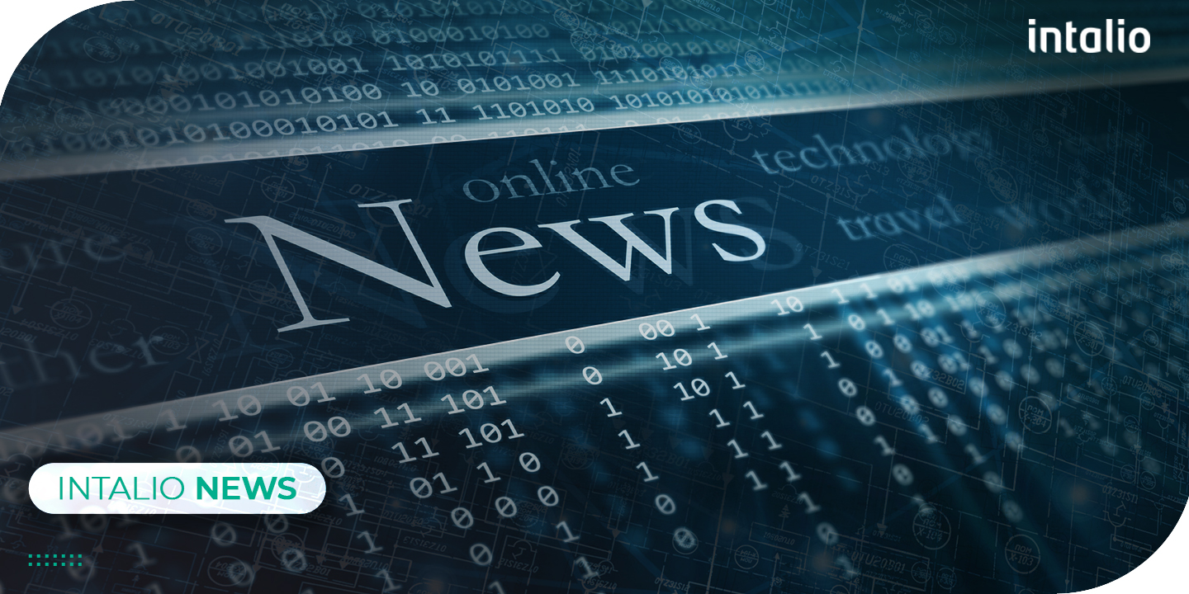
Intalio Announces the Appointment of Nicolas El Diri as Channels and Alliances Manager in North America

June 2021, Intalio appointed Nicolas El Diri as the new Channels and Alliances Manager to support the organizations' channel growth in the North American Market, establish connections with other stakeholders and partners, and solidify relationships to ensure long term benefits of the company.

Nicolas El Diri comes from a solid background of working with companies in various regions and across multiple sectors such as IT, banks, and postal services. Nicolas handled different roles throughout his career, some of which are Consultancy and Sales, Account Management, and Channels and Alliances Management. El Diri’s experience in understanding customer processes, launching and developing channel programs and partnerships, and building alliances with software vendors for revenue generations, makes him a key asset to the company to strategize and implement the sales and marketing plan for content services offerings for the coming years.

“I’m thrilled to be joining Intalio; a Niche Player in Gartner Magic Quadrant within Content Services space, where I will be utilizing 20 years of experience in Channel and Alliance Management to expand Intalio’s outreach and solutions offerings in North America”, said El Diri. “With a great deal of gratitude and respect, I’d like to thank the whole team for their professionalism and support throughout the recruitment process and the onboarding stage, where I sensed considerable synergy, which is an essential element for the success of any new venture. I couldn’t be more excited to start this next chapter in my journey and being part of the team.”

Nicolas El Diri has joined the team to help Intalio cater to its client base to add value on top of its solutions and get a look at the products that will be needed by channel partners. Nicolas’ main objective is to build and launch a channel business that covers North America and shows value to customers in order to promote Intalio products across the market. Building a channel program and partnership relationship with North America will enable Intalio to reinforce its existing identity in the market, as well as embark on new journeys in other markets.

Intalio has revamped the partnership and alliances strategy over the past year, which initially consists of a renewed channel program. El Diri will lead the initiative of connecting with partners and helping them by delivering solutions that support the digital transformation of customers in various industries and sectors.

This appointment comes at the forefront of several appointments to take place in the coming months to further continue offering the best solutions to businesses of all sizes and sectors while upholding its high standards of quality and professionalism.

About Intalio
Intalio is a leading provider of Digital Transformation Solutions with over 30 years of countless innovations in Content Services, Process Services, and Data Governance. Initially founded in 1999, Intalio emerged as a leading provider for business process management solutions and distributed its services across North America, Europe, and Asia. Its main goal is to empower organizations of all sizes and from all sectors to design, deploy, and optimize the most complex business procedures.

