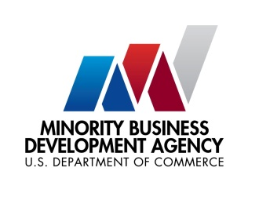

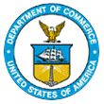
UNITED STATES DEPARTMENT OF

COMMERCE

NEWS
WASHINGTON, D.C. 20230

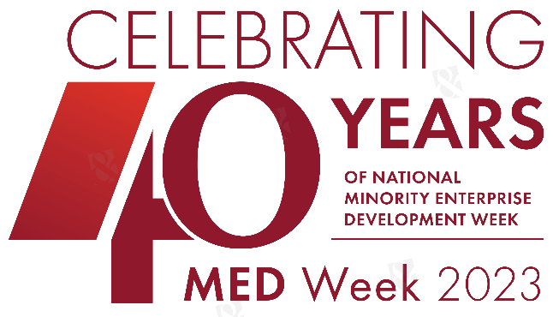
MBDA Media Contact Information:
Mr. Gabriel Cushing, Public Affairs
Email Address: mbdapublicaffairs@mbda.gov
Website(s): http://www.mbda.gov/

NMSDC and MBDA Work Together to Close Equity Gap for Minority Businesses at Annual Conference & Exchange
WASHINGTON, D.C., – As part of our efforts to accelerate minority business growth and advance economic equity the National Minority Supplier Development Council (NMSDC) and the Minority Business Development Agency (MBDA) are collaborating to bring this year’s NMSDC Annual Conference & Exchange and MBDA National Minority Enterprise Development (MED) Week to Baltimore October 22- 25. The conferences will be held in the same space to maximize attendance opportunities and will include MBDA-contributed federal government programming focused on creating greater opportunity for the minority business community.
This collaboration reflects the important role nonprofits, private corporations, and the federal government plays in promoting business diversity. It will enable NMSDC and MBDA to convene high-level federal partners to engage in important policy discussions focused on accelerating growth for minority businesses. It will also provide a more effective platform to educate companies and minority business enterprises (MBEs) on business development and contracting opportunities in emerging industries and federal programs/services that support business growth.
“This collaboration embodies NMSDC’s and MBDA’s shared goal of promoting minority business growth to create a more equitable economy that works for all. By fostering access to contracts, capital, and more diverse networks, we hope to close the equity gap and unlock infinite opportunities for NMSDC certified MBEs to soar past our goal of $1 trillion in annual revenue and build long lasting generational wealth for communities of color,” said NMSDC CEO and President Ying McGuire.
“The Minority Business Development Agency is excited to work with NMSDC to commemorate the 40th Annual National Minority Enterprise Development Week, a historic milestone for the minority business community,” said Donald R. Cravins, Jr., Under Secretary of Commerce for Minority Business Development. “MBDA and NMSDC share a mission to create an equitable business ecosystem in order to unlock our Nation’s economic potential. With historic investments across sectors and industries, the opportunity is here. MBDA and NMSDC have the tools and the reach to make this moment count by expanding access to capital, contracts, networks, and opportunities that every American entrepreneur deserves.”
This year marks MBDA’s 40th Anniversary of National MED Week, and this collaboration recognizes the desire to work more closely together as we embark upon the next 40 years of minority business development.
Interested in attending the 2023 NMSDC Annual Conference & Exchange? Visit https://www.nmsdcconference.org/2023/ to register today!
###

About the Minority Business Development Agency (MBDA)
The U.S. Department of Commerce, Minority Business Development Agency is the only Federal agency solely dedicated to the growth and global competitiveness of U.S. minority business enterprises (MBEs). For more than 50 years, MBDA’s programs and services have better equipped MBEs to create jobs, build scale and capacity, increase revenues, and expand regionally, nationally, and internationally.

