INSTANT COLOR CHEMISTRY EXPERT, BAMBU VAULT, IS DEVELOPING RAPID COVID-19 TEST KIT IN RESPONSE TO PRESIDENT TRUMP’S CALL TO ACTION

The company is uniquely positioned to develop an instant solution to identify pathogens and viruses in or on the body, quickly, accurately and in an easy-to-use consumer package

GREATER BOSTON, Mass., March 12, 2020 – Bambu Vault, a subsidiary of Bambu Global, today announces it has committed its rapid color-change chemistry library and unique expertise to continue to develop a fast, reliable, easy to use and accurate detection kit for the presence of the coronavirus.

The BlueAware™ diagnostic development program is being designed to be a very cost effective, simple and easy-to-use test kit. The results are rapid – in minutes – and highly accurate without the need to be administered by a healthcare provider, eliminating the concern and time-consuming processes of a laboratory test.

The simple test procedure requires an individual to provide a saliva sample into a vial. Should the sample be positive, their unique color change solution will visibly begin to change color in seconds. With additional funding, the company believes that this test can be mass produced and made available in just a few weeks.

The company is actively working with funding foundations, U.S. government agencies and interested investors to drive product development, testing and regulatory approvals, to share its life-saving technology with healthcare professionals and individuals as efficiently and as quickly as possible.

The team at Bambu Vault developed their expertise in advanced chemistry and color change as pioneers at Polaroid and have leveraged this know-how over the past 20 years with a dedicated team of 40 scientific innovators, Ph.D.’s and business professionals.

“Based on two decades of experience in advanced color change chemistry, we believe our BlueAware test kits will deliver a highly accurate and rapid color-change technology from a simple saliva sample,” said Saleem Miyan, President at Bambu Global. “We project it will deliver 95%+ sensitivity and 90%+ specificity in the presence of the COVID-19 virus.”

Miyan added, “Our development program advances our proven ability to detect unique chemicals from other pathogens and viruses. We are highly motivated and committed to focusing our team’s efforts to reduce the concerns and stress being felt globally due to the limited access to testing facilities and kits.”

The rapid test will be useful not only to process and screen those with symptomatic or asymptomatic concerns as a result of potential exposure to the virus but could also be used to monitor the ongoing effectiveness of treatments – all in just a matter of a few minutes.

The company welcomes any other interested parties to contact them directly.

About Bambu Vault
Bambu Vault is the IP development and licensing company of Bambu Global. Bambu Vault develops and protects four core technology platforms: self-powered lighting solutions; energy conversion; stimulus-triggered molecular change; and signature management. Each of these platforms is used to create multiple technologies for a variety of industries. Bambu Vault is entrusted with keeping these technologies protected through a robust and defendable patent portfolio, while also making them available to the world where they can realize their potential to enhance, improve and save lives. For more information, visit www.BambuVault.com.

About Bambu Global
Bambu Global, founded in 2001 and based in Lowell, Mass., develops and commercializes breakthrough technologies through a family of companies in the life sciences, lighting, renewable energy, safety, defense and tattoo industries. Combining the advanced sciences with unbridled imagination, Bambu Global is transforming electromagnetic energy in new ways to create unique color and light effects. Through its discoveries and more than 70 patents, Bambu Global is significantly improving lives, transforming industries and unlocking new areas of business value. For more information, visit www.BambuGlobal.com.

# # #

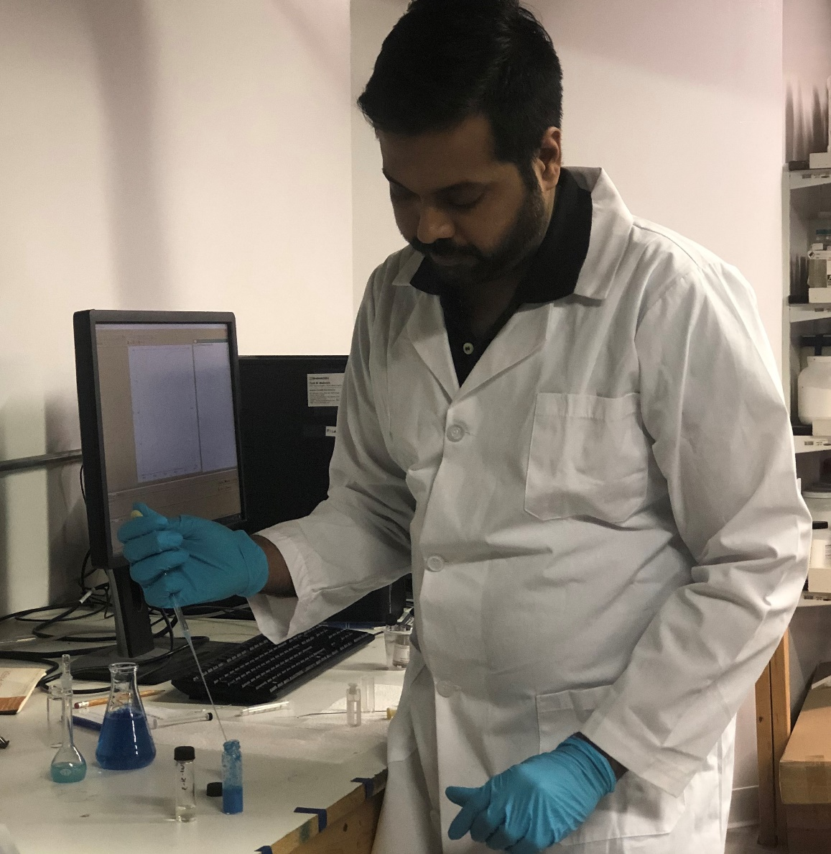
Bambu Vault’s Prakash Rai, Ph.D., Director of R&D, Biotechnology,leads development of the BlueAware Dx Test, a point-of-service diagnostic test in development to detect COVID-19 in minutes from saliva samples. The BlueAware test is intended to indicate the presence of the COVID-19 pathogen by turning blue, without the need to send the sample to a lab for processing.

Contact:
Edna Kaplan
Birnbach Communications for Bambu Global
ekaplan@birnbachcom.com
(781) 639-1910

