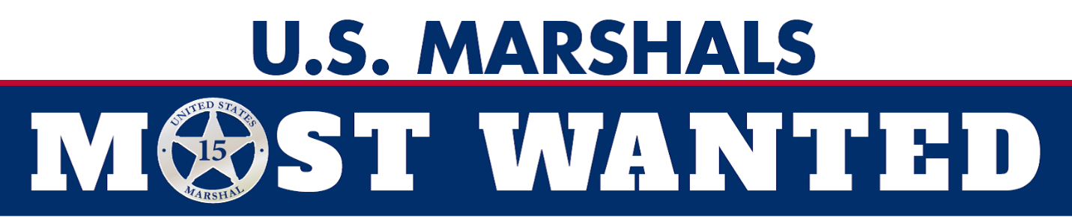

NEWS RELEASE
For Immediate Release  Dec. 7, 2023 | Contact:  U.S. Marshals Middle District of Louisiana  Chief Deputy U.S. Marshal Joshua Reich  (225)-921-8525  U.S. Marshals Office of Public Affairs  703-740-1699
US Marshals elevate East Baton Rouge man wanted for murder to Most Wanted List, offer up to $25K reward
WASHINGTON - The U.S. Marshals Service has elevated to its 15 Most Wanted Fugitive List a man wanted by the East Baton Rouge Parish Sheriff’s Office for first-degree murder and attempted murder.
The USMS is offering a reward of up to $25,000 for information leading to White’s arrest.
Leethel White aka “Lee Lee,” 46, is alleged to have shot two female associates at close range, killing one and severely injuring the other in a January 2016 incident in the Gardere area of Baton Rouge.
“Adding Leethel White to the U.S. Marshals Service’s 15 Most Wanted list illustrates our agency’s commitment to taking dangerous fugitives off the street and making communities safer,” said USMS Director Ronald L. Davis. “The men and women of the U.S. Marshals Service will be relentless in their endeavor to bring Mr. White to justice.”
White is 5 feet 10 inches tall, weighs approximately 215 pounds, and has black hair and brown eyes. He has tattoos on both arms, his chest and his back. He should be considered armed and dangerous.
Anyone with information regarding White’s whereabouts is urged to contact the U.S. Marshals 24-hour tip line at 1-877-WANTED2 or send information via the USMS Tips App.
Created in 1983, the USMS 15 Most Wanted fugitive program draws attention to some of the country’s most dangerous and high-profile fugitives. These fugitives tend to be career criminals with histories of violence who pose a significant threat to public safety. Generally, 15MW fugitives are considered the “worst of the worst” and can include murderers, sex offenders, major drug kingpins, organized crime figures and individuals wanted for high-profile financial crimes. Since the program began in 1983, more than 250 15MW fugitive cases have been closed.
The USMS has a long history of providing assistance and expertise to other federal, state, and local law enforcement agencies in support of their fugitive investigations. Working with authorities at the federal, state, tribal, and local levels, USMS-led fugitive task forces arrested more than 75,000 fugitives and cleared nearly 89,000 warrants in FY 2022.
For more information about the U.S. Marshals, please visit www.usmarshals.gov
# # #
America’s First Federal Law Enforcement Agency

