Hospital for Special Care first in Connecticut to achieve Enhanced Respiratory Care Accreditation

Progressive Medical Ventilation standard, backed by the Physician-Patient Alliance for Health & Safety, now present in healthcare facilities in 6 states across the U.S.

[DATE] – New Britain, CT

* Hospital for Special Care is the 4th largest, free-standing long-term acute care hospital in the U.S.
* Both medical centers and medical service companies can receive Enhanced Respiratory Care Accreditation implemented in Tennessee since 2013.

The Physician-Patient Alliance for Health & Safety (PPAHS) is pleased to announce that [Hospital for Special Care](https://hfsc.org/) (HFSC) in New Britain, CT has met or exceeded the Enhanced Respiratory Care Standards of Care.

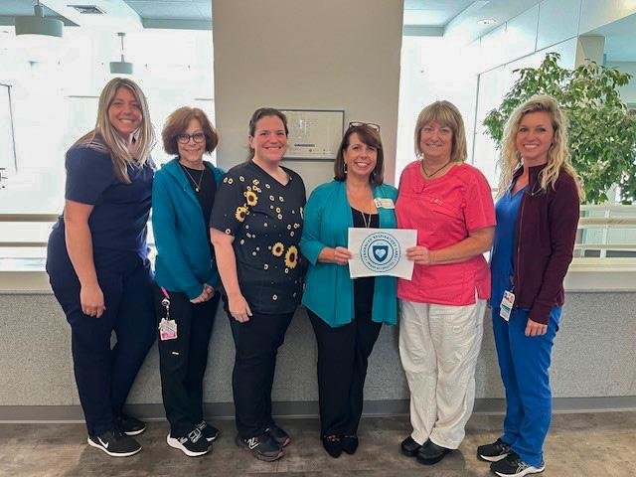

*From left to right: Lindsey Merli, Supervisor, Marilyn Tipaldi, Lead RT, Joline Farris, RRT, Kendra Mato, RRT representing PPAHS, Pamela Held, RRT, MEd, Respiratory Services Director, Samantha Sowik, RT Clinical Coordinator  
  
Not Pictured: Jen Andrulat, RRT, Nicole Morales, RRT, Laurie Miller, RRT, Carolyn Henry, Lead RRT*

“This accreditation,” said the hospital’s Respiratory Therapy Director Pamela Held, RRT, MEd., “is a testament to our hard work and our focus on delivering exceptional care that doesn’t just exceed our patients’ expectations, but also meets the most rigorous standards developed by the Physician-Patient Alliance for Health & Safety. Our team of dedicated professionals offers personalized support and guidance to ensure optimal outcomes for every patient.”

The HSFC President and CEO, Lynn Ricci, FACHE, stressed the hospital's leading role in rehabilitation practices: “We are at the forefront of rehabilitative healthcare, delivering exceptional cardiopulmonary care that is patient-centered and outcome-focused. Our Enhanced Respiratory Care Accreditation is a reflection of our commitment to providing the highest quality care.”

Until recently, there was no widely accepted service quality standard for Mechanical Ventilation (MV). Despite existing regulations, this led to numerous issues for both medical facilities and their patients. While the facilities had to deal with inefficient resource management and rising liability costs, the patients faced prolonged MV dependency, a variety of lung conditions and injuries, and an overall decline in quality of life.

Enhanced Respiratory Care is an evidence-based approach that has been endorsed by the [American Association for Respiratory Care](https://www.aarc.org/) (AARC). It is the first and only standard in the respiratory care field and was developed in Tennessee where it has been a ventilation standard since 2003. ERC includes advancements in weaning, patient care, and ventilator unit technology, offering numerous benefits. Patients and their families can enjoy a higher quality of life and improved outcomes, while accredited facilities have a competitive edge due to optimized resource utilization.

Clyde Heflin MD, FACCP spoke about the need for recognized standards of care, “Previous to the Enhanced Respiratory Care Standards of Care, there were no established standards of care. Patients were sent to healthcare facilities based on other factors - bed availability, the smoothness of the marketing process, the look of the building, and so on. Enhanced Respiratory Care provides a standard of care that ensures that patients are receiving care based on an established standard and not on extraneous factors.” Dr. Heflin is also a member of the Enhanced Respiratory Care Standards Committee.

Michael Wong, JD (Executive Director, Physician-Patient Alliance for Health & Safety) emphasized the patient safety and quality of care that Connecticut communities will now enjoy, saying, “ “When families send their loved ones and friends to a healthcare facility, they want to make sure that they are receiving the best care possible. For communities in Connecticut, Hospital for Special Care is such a facility.”

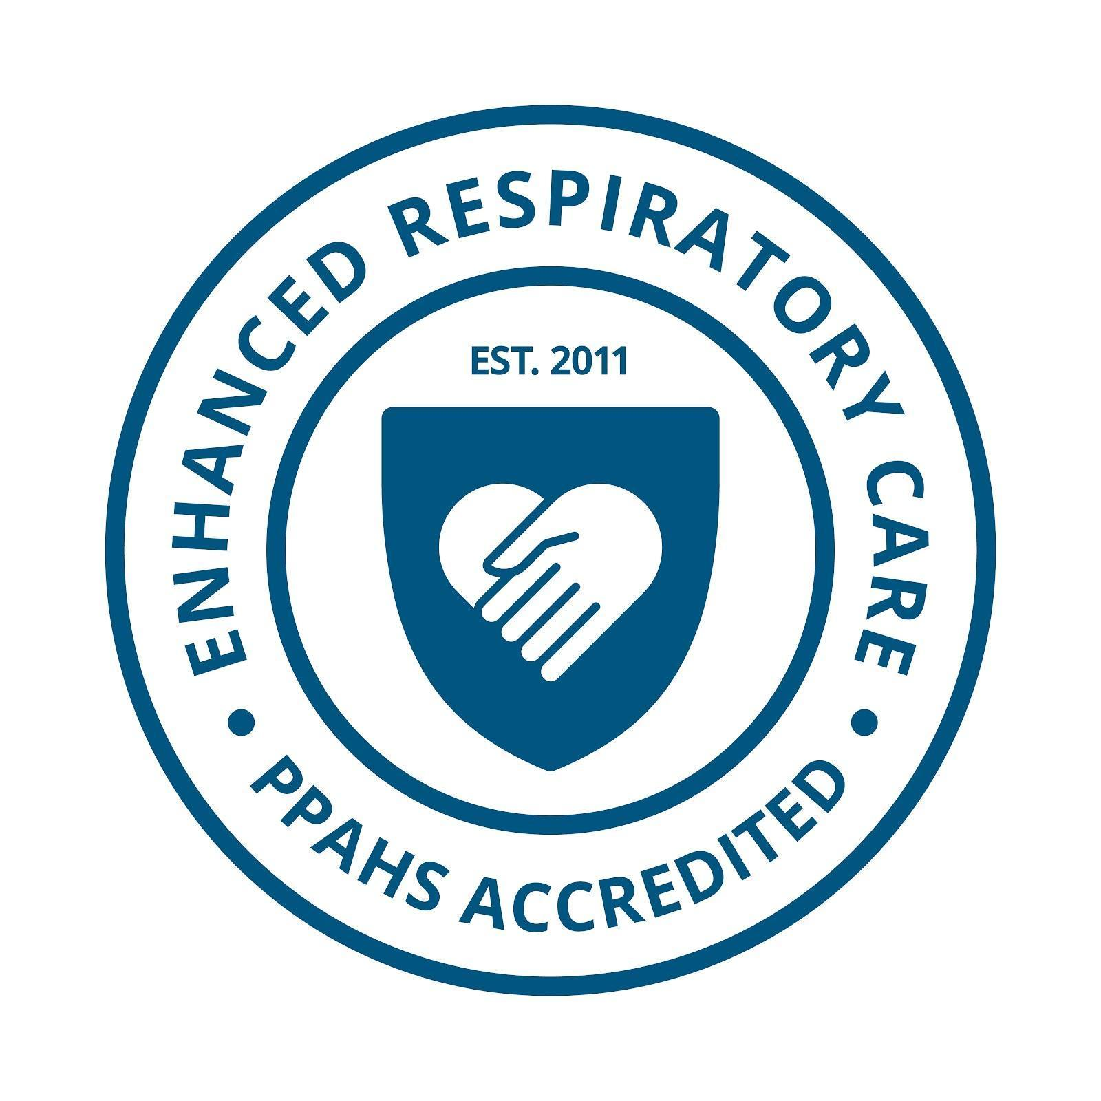

The Enhanced Respiratory Care Standards of Care are supported and endorsed by the American Association for Respiratory Care. Carl Hinkson, MS, RRT-NPS, ACCS, FAARC (President, American Association for Respiratory Care) [writes](https://ppahs.org/wp-content/uploads/2023/04/AARC-letter.pdf):

*“The American Association for Respiratory Care (AARC) would like to express our support and endorsement of your efforts in developing standards of care and facility accreditation for long-term mechanical ventilation in skilled nursing facilities. As the leading professional association for respiratory therapists in the United States, we recognize the importance of ensuring patients receive the highest quality care possible.”*

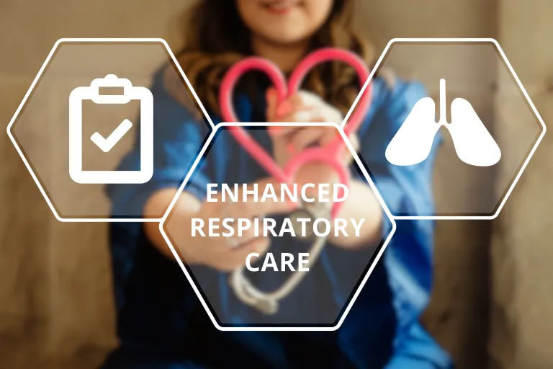

Gene Gantt RRT, FAARC, whose team has developed and managed the Enhanced Respiratory Care program in Tennessee since 2013, said, “The Enhanced Respiratory Care Program is based on standards published by the American Association for Respiratory Care. Utilized in Tennessee, this Program has achieved liberation rates of 65% and has earned national recognition of excellence from the [American College of Chest Physicians](https://www.chestnet.org/).”

For more on the Enhanced Respiratory Care Accreditation, please visit

<https://ppahs.org/accreditation-of-facilities/>

To apply for Accreditation, please go to <https://ppahs.org/apply-for-accreditation/>

**About Hospital for Special Care**

Hospital for Special Care (HFSC) is the fourth largest, free-standing long-term acute care hospital in the U.S. and one of only two in the nation serving both adults and children. Located in New Britain, CT, and Hartford, CT, it operates on a not-for-profit basis. HSFC is recognized for advanced care and rehabilitation in [pulmonary care](https://hfsc.org/specialties/pulmonary-rehabilitation/), [acquired brain injury](https://hfsc.org/specialties/brain-injury-care/acute-brain-injury-program/), [medically-complex pediatrics](https://hfsc.org/specialties/complex-pediatric-care/complex-pediatric-care/), [neuromuscular disorders](https://hfsc.org/specialties/neuromuscular-care/), [spinal cord injury](https://hfsc.org/specialties/spinal-cord-injury-care/spinal-cord-injury-care/), [comprehensive heart failure](https://hfsc.org/specialties/cardiac-rehabilitation/cardiac-care/), and comprehensive inpatient and outpatient treatment for children and adolescents with [autism spectrum disorder](https://hfsc.org/specialties/autism-center-at-hsc/).

The HSFC outpatient rehabilitation provides physical, occupational, and/or speech therapy services for patients with amputations, neurological conditions, orthopedic diagnoses, musculoskeletal diagnoses, multiple trauma, and complications from prolonged hospitalizations. Complex medical and rehabilitation care provide a wide range of services designed to maximize the outcomes of patients who no longer need invasive or acute diagnostic procedures, but who continue to require 24-hour nursing and medical care and/or monitoring.

HSFC is recognized for having the highest ventilator-weaning rate in Connecticut and consistently exceeds the national average. Services for the clinical management of patients with serious respiratory conditions are provided in three distinct units. HFSC’s 36-bed Laurie Coleman Puglisi respiratory care unit and the 38-bed respiratory step-down unit provide care for patients with multi-system problems and ventilator assistance.

***About Physician-Patient Alliance for Health and Safety***

*Physician-Patient Alliance for Health & Safety is ranked internationally as a top-100 patient safety organization (Agilience Authority Index) and is a national advocacy force for addressing patient health and safety priorities shared by patients, physicians, regulators, and industry. PPAHS seeks to ensure that the best medications, medical inventions, and technology that can improve care and reduce costs are employed. PPAHS works to advance patient health and safety by developing and highlighting best practices and recommendations through better use and application of clinical practices and experiences, information technologies and checklists, and healthcare information. As a voice in support of ideas and innovation that can improve care, we encourage a health ecosystem that fosters a culture of patient safety. For more about PPAHS, please visit* [*www.ppahs.org*](http://www.ppahs.org)*.*