Coulson Aviation Announces Wildfire Vehicle Restoration Contest* in Partnership with Chip Foose at the LA Auto Show

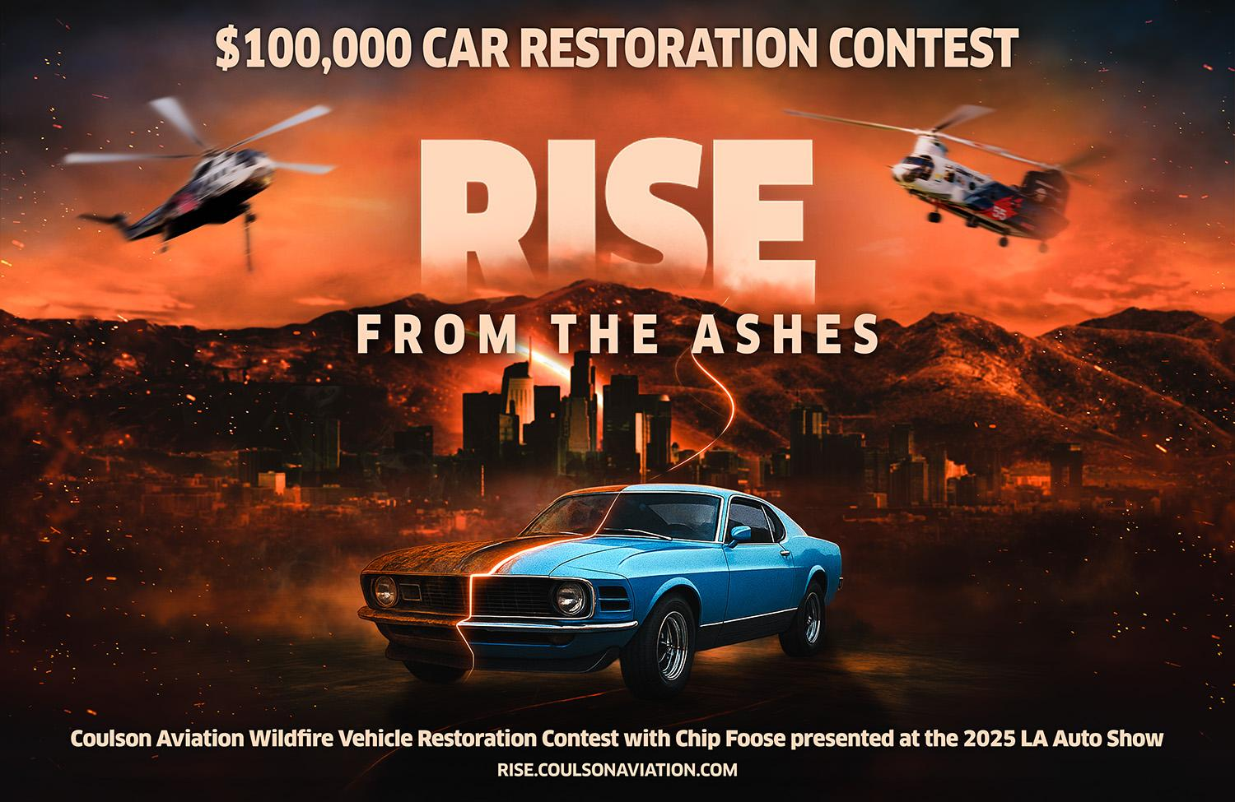

Los Angeles, USA

Honoring Southern California wildfire survivors with a one-of-a-kind vehicle restoration contest, celebrating LA’s iconic car culture, and showcasing Coulson’s continued leadership in aerial firefighting.
﻿

Los Angeles has long been the beating heart of American car culture – birthplace of custom hot rod design and a global epicenter of automotive creativity. It’s also a region repeatedly tested by devastating wildfires, including the 2024-2025 Eaton and Palisades fires, which shook Southern California communities earlier this year.
In those critical moments, Coulson Aviation – the world’s largest aerial firefighting company – once again served on the front lines, flying alongside Los Angeles area fire departments with its large rotary wing aircraft, pilots, and support crews. Coulson’s longstanding California presence, deep expertise, and world-leading innovations helped support the massive firefighting response that protected millions of residents and homes.
But Coulson’s connection to California goes beyond the skies. The Coulson team includes passionate automotive enthusiasts, mechanics, and builders – and nowhere is that spirit more alive than in Los Angeles. Inspired by the resilience of the communities affected by the fires and the city’s legendary car culture, Coulson Aviation and Coulson Autosports are launching the Coulson Aviation Wildfire Vehicle Restoration Contest*, honoring those who lost so much by giving one deserving resident the chance to rebuild a beloved vehicle.
And to make the project truly extraordinary, they’ve partnered with one of LA’s most iconic automotive figures: Chip Foose.

COULSON x CHIP FOOSE x LA AUTO SHOW:
A PARTNERSHIP ROOTED IN PASSION
The Coulson Aviation Wildfire Vehicle Restoration Contest will debut at the 2025 Los Angeles Auto Show; the nation’s premier celebration of automotive creativity, and a cultural legacy of Southern California’s car scene.
Legendary designer and builder Chip Foose – a California native and one of the most influential figures in custom car design – will join Coulson Aviation at the LA Auto Show to help launch the contest, meet potential entrants, and assist in selecting up to ten finalists. Foose will then personally provide input for the final design of the restoration and upgrade plan for the winning vehicle, working closely with Coulson Autosports throughout the build.
Whether it’s a family heirloom, a beloved daily driver, or a car deeply tied to personal memories that was damaged during the 2024-2025 wildfires, Coulson and Foose will work together to bring it back to life – culminating in the full reveal of the Foose-designed restoration during the 2026 LA Auto Show**.

WILDFIRE VEHICLE RESTORATION CONTEST
The Coulson Aviation Wildfire Vehicle Restoration Contest is open to California residents directly affected by the 2024-2025 wildfires. Entrants may submit photos, video, and a personal story describing what their vehicle means to them and the restoration vision they hope to bring to reality.
A judging panel will then submit up to ten finalist to a public vote, after which the winning vehicle will undergo a professional restoration and upgrade program at Coulson Autosports, to a value of up to $100,000 in parts and labor.
The successful owner will collaborate directly with the team at Coulson Autosports and legendary California designer Chip Foose, who will be at the 2025 LA Auto Show to help launch the contest and meet potential entrants. Foose will lead the design of the winning build – bringing his world-renowned creativity to the restoration program – and will return for the unveiling of the restored vehicle at the 2026 LA Auto Show.
The vehicle will be returned to its owner at the 2026 LA Auto Show**, celebrating the strength and resilience of wildfire-impacted communities in front of thousands of automotive fans.
Information about the Coulson Aviation Wildfire Vehicle Restoration Contest as well as the contest rules is available here: rise.coulsonaviation.com

COULSON ON DISPLAY AT THE 2025 LA AUTO SHOW
Visitors can experience Coulson’s aviation and automotive worlds coming together at the outdoor display on Gilbert Lindsay Plaza. Under the massive rotors of a Coulson Sikorsky S-61 helicopter – one of the very aircraft that fought the Eaton and Palisades fires – attendees will find:
- A custom-built Coulson Autosports 1953 International Harvester showcasing the team’s craftsmanship and passion
- Meet with LA-based Coulson fire-fighting helicopter flight crews
- Walk-through tours, photo opportunities, and behind-the-scenes insights into aerial firefighting
As part of its display, Coulson will debut its Philippine Mars US Navy Tribute Truck. Based on a 1953 International Harvester Cab Over, the custom build was inspired by the legendary Philippine Mars, which is one of the last surviving Martin Mars flying boats.
Originally built for the US Navy in the 1940s, the Philippine Mars spent decades serving as both a military transport aircraft and later as one of the world’s largest and most recognizable aerial firefighting water bombers. For Coulson Aviation, the Philippine Mars represents heritage, innovation, and a lifelong commitment to protecting communities from wildfire. And the Tribute Truck embodies that legacy in automotive form, honoring its Navy roots, firefighting service, and the deep pride the Coulson team has to be able to celebrate this extraordinary aircraft.
In addition to the static display, Coulson Aviation will also participate in a Chinook helicopter flyover during Media Day, underscoring LA’s role as both an innovation hub and a region deserving world-class wildfire protection.
“Los Angeles is where innovation, culture, and community come together. It’s where the world learned to love cars – and where so many families are now rebuilding after the devastating fires. We wanted to give something back in a way that reflects both who we are and what LA represents. Restoring a vehicle isn’t just about metal and paint; it’s about restoring memories, reviving hope, and celebrating a community that has always inspired us.” – Britton Coulson, President & COO, Coulson Aviation (USA).

CONTEST ENTRY INFORMATION
- Contest Launch: November 20, 2025 at the LA Auto Show
- Final Entry Deadline: January 20, 2026
- Up to ten finalists will be selected and notified around January 29, 2026
- Public Voting Period for Finalists: February 1-15, 2026
- Winner Notification: March 1, 2026
- Vehicle Reveal: LA Auto Show 2026** (or shortly thereafter)
- Entrants can review the official rules and submit entries via the contest website: rise.coulsonaviation.com
*NO PURCHASE NECESSARY TO ENTER OR WIN. A PURCHASE WILL NOT INCREASE YOUR CHANCES OF WINNING. Void outside of California where prohibited by law. Contest open only to individuals who are at the time and date of entry: (i) legal residents of and physically located in the State of California; (ii) at least eighteen (18) years of age or older; (iii) a victim of the 2024-2025 California wildfires; and (iv) owns (i.e., can show proof of title) and maintains physical possession of a vehicle (i.e., an insurance company doesn’t own or otherwise have a legal right to possess the vehicle) that sustained significant damage as a result of the 2024-2025 California wildfires. Contest begins at 12:00 p.m. PT on 11/20/25; ends at 12:00 p.m. PT on 1/20/26. Entries will be judged based on the following judging criteria: 33.3%: originality; 33.4%: creativity; and 33.3%: represents a worthwhile reason for restoration for the vehicle that can be accomplished within the set budgetary constraints. ARV of prize: up to $100,000. Subject to full Official Rules, available at rise.coulsonaviation.com. Sponsor: Coulson Aviation, 56850 Higgins Drive, Thermal, CA, 92274.
**The vehicle return date may vary, depending on parts availability and other factors outside the control of Coulson Autosports. However, all efforts will be made to complete and return the vehicle at the 2026 LA Auto Show or shortly thereafter.

ABOUT COULSON AVIATION
Coulson Aviation (USA) Inc., part of the Coulson Group, is the world’s largest aerial firefighting company and a global leader in aviation innovation. For decades, Coulson has pioneered major advancements in aerial operations—including large-aircraft wildfire suppression, night-vision firefighting, and next-generation aviation safety systems. Today, Coulson protects communities across North America, South America, Australia, and beyond with the world’s most capable fleet of fixed- and rotary-wing firefighting aircraft. coulsonaviation.com

MEDIA CONTACT
Jennifer Lord, Marketing Manager, Coulson Aviation: jennifer.lord@coulsonaviation.com

Contact
Greg Emmerson
greg@theidagency.com

