Wolf Haldenstein Adler Freeman & Herz LLP announces that it is investigating Huntington Ingalls Industries, Inc. for potential violations of securities laws
PLEASE CLICK HERE TO PROVIDE YOUR CONTACT INFORMATION

NEW YORK, NY– November 15, 2024 - Wolf Haldenstein Adler Freeman & Herz LLP ("Wolf Haldenstein"), a preeminent national shareholder rights litigation firm, announces that it is investigating claims on behalf of investors of Huntington Ingalls Industries, Inc. (NYSE: HII) (“Huntington” or the “Company”).
The investigation concerns whether Huntington Ingalls Industries, Inc. and certain of its officers and/or directors have engaged in securities fraud.

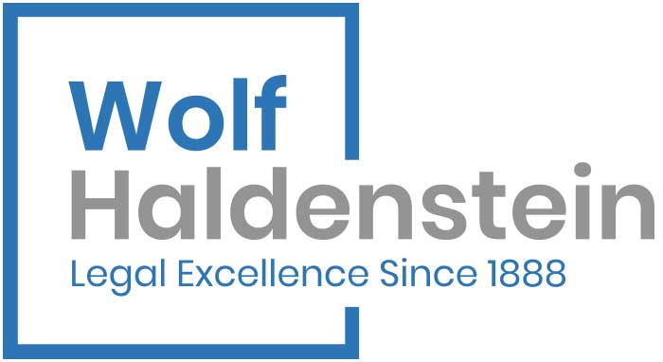

PLEASE CLICK HERE TO PROVIDE YOUR CONTACT INFORMATION

On October 31, Huntington a military shipbuilder based in Newport News, VA, cut its 2024 shipbuilding revenue (the majority of its revenue) to $8.8 billion from $9.1 billion. It had expected to reach an agreement with the U.S. Navy for Virginia-class Block V and Block VI and Columbia-class submarines in the second half of 2024, but this has not happened. In addition, for the third quarter, Huntington’s per-share profit was $2.56, down from $3.70, a year ago. Revenue also declined 2.4% to $2.7 billion. Stock fell from $250.49 to $184.96, or a little over 26%.

“Two issues have impacted our results and guidance for the year... our assumptions of performance improvement and risk reduction have not been achieved, due to late critical material deliveries from the supply chain and reduced experience levels within our teams, both in production touch labor and supervision,” said Chris Kastner, Huntington’s president and CEO.
Wolf Haldenstein has experience in the prosecution of securities class actions and derivative litigation in state and federal trial and appellate courts across the country. The firm has attorneys in various practice areas, and offices in New York, Chicago, Nashville and San Diego. The reputation and expertise of this firm in shareholder and other class litigation has been repeatedly lauded by the courts, which have appointed it to major positions in complex securities, multi-district and consolidated litigation.

If you wish to discuss this investigation or have any questions regarding your rights and interests, please immediately contact Wolf Haldenstein by telephone at (800) 575-0735 or via e-mail at classmember@whafh.com.

Contact:

Wolf Haldenstein Adler Freeman & Herz LLP
Gregory Stone, Director of Case and Financial Analysis
Email: gstone@whafh.com or classmember@whafh.com
Tel: (800) 575-0735 or (212) 545-4774

This press release may be considered Attorney Advertising in some jurisdictions under the applicable law and ethical rules.

