Rivalz Network Secures $9 Million to Advance AI Intel Infrastructure

Bali, Indonesia

Leading Investors Include Delphi Ventures, D1 Ventures, Gate.io, Magnus Capital, and Cogitent Ventures.
Rivalz Network, aims to transform the AI landscape by introducing the first AI Intel Layer, has raised $9 million in recent funding rounds. This funding marks a pivotal moment for Rivalz as it continues to innovate in AI data and decentralized infrastructure.
In addition to its leading investors, Rivalz has garnered support from a diverse group of backers, including Zee Prime, Caballeros, Formless Capital, Dweb3, Mask.io, BitsCrunch, SL2, Momentum6, 4RC, Stakewithus, NewTribe, Autonomy Capital, Optic, Emoote, BlockBuilders, OIG, The Rollup, IBC, DWF Labs, GSR, Rana, CFG Labs, Basics Capital, Blocktheory, Pragma, X21, Kyros, iAngels and Wise3 Capital. Additional investors in Rivalz include angels from 0g Labs, Clique, Metaking Studios (Blocklords), and Vader Research
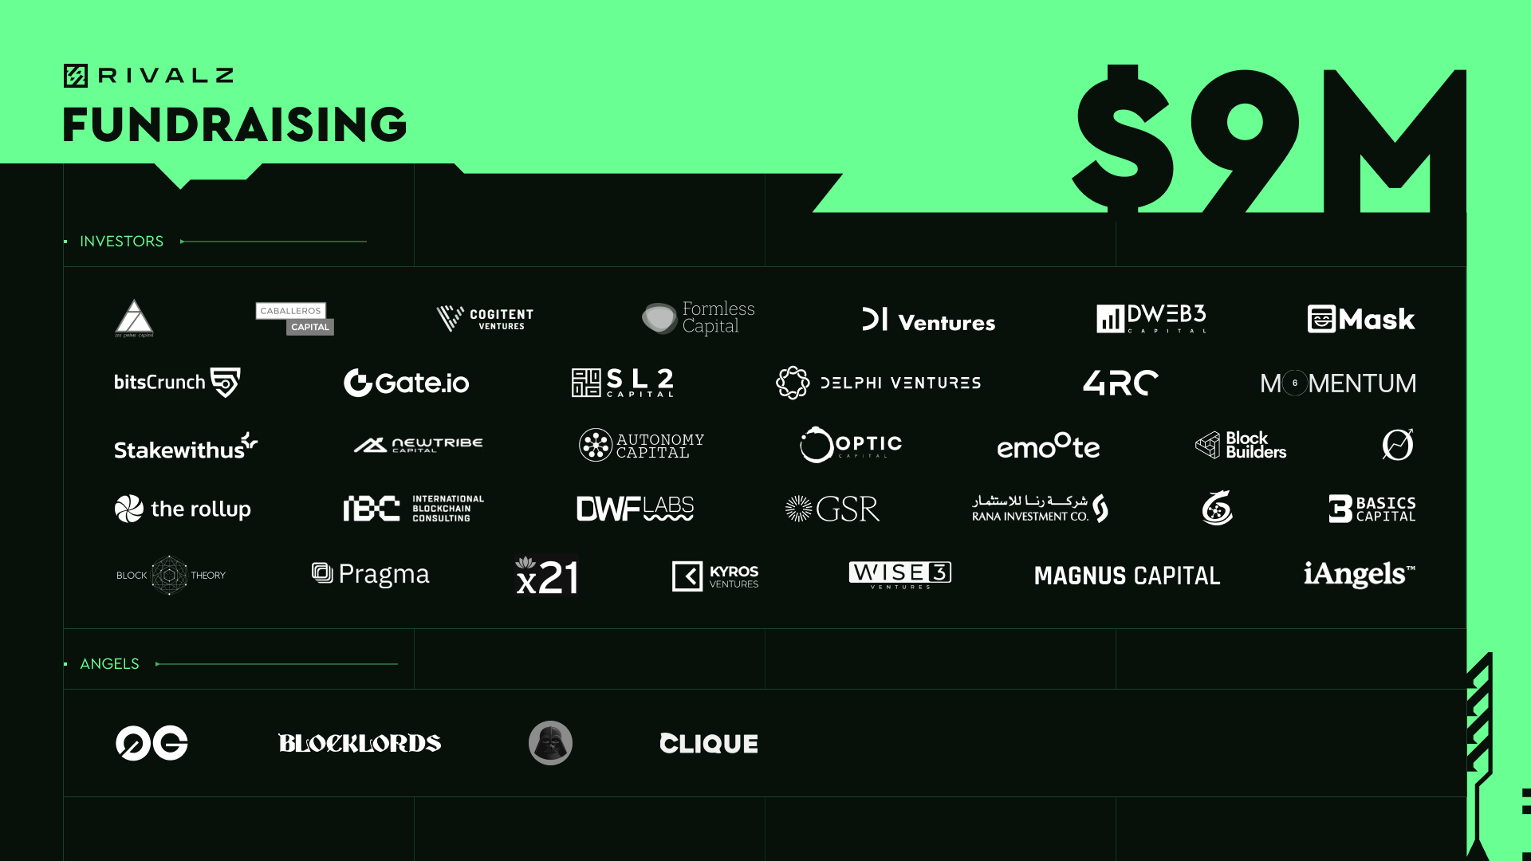

Enabling the Agentic Economy
Rivalz is addressing a critical bottleneck in AI development—the need for AI-ready, proven, verified, and private data. Built on Dymension and Arbitrum, Rivalz’s DePIN dual-chain infrastructure is set to revolutionize the AI landscape. By offering a hybrid and novel approach to decentralized storage and connectivity networks, Rivalz aims to unlock the next stage of AI development, fostering an agentic future.
Rivalz’s AI Intel Layer consists of three essential components:
- Decentralized Data Provenance Protocol: Ensuring the accuracy, origin, and immutability of AI data.
- Secure, FHE-Enabled, Scalable Data Storage: Providing decentralized storage and collaboration with AI-grade latency, confidential computing, and pre-processing pipelines.
- Agentic Data Coordination Service (ADCS): A decentralized real-time data infrastructure creating a competitive marketplace for AI agents, ensuring data quality and reliability through trust and reputation systems.
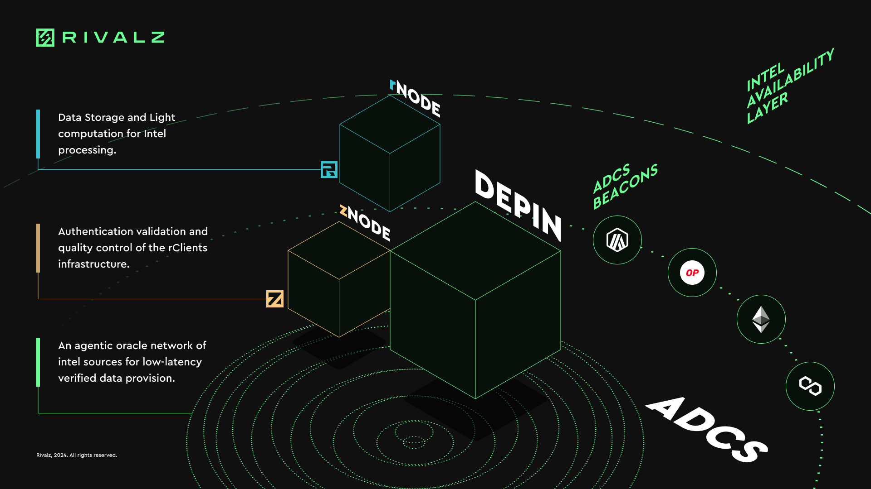
Rivalz is laying the groundwork for a new paradigm in AI development. This infrastructure supports high-quality, secure, and accessible intel, paving the way for the next generation of autonomous systems and unlocking a new era of value creation in agentic economies.
Since the Rivalz Testnet launch in June 2024, the project attracted over 180,000 participants, 50,000 active storage client runners and 14 million transactions and gathered a combined social audience of half a million. There are currently 8 projects developing with Rivalz infrastructure in different areas like personalized AI in gaming, AI orchestration, AI automation, etc. Rivalz also secured strategic partnerships with some of the leaders in the space such as Dymension, Chainlink, Mon Protocol, Aethir, and Puffer Finance among others.
With the new capital, Rivalz plans to accelerate its development efforts, expand its infrastructure capabilities, and enhance its ecosystem. The funding will be strategically used to drive innovation, strengthen partnerships, and scale the project’s product offerings to meet the growing demand for decentralized, high-quality AI data solutions.
For More Details:
Web: https://rivalz.ai/
Twitter: https://x.com/Rivalz_AI
Telegram: https://t.me/RivalzAI_Ann
Discord: https://discord.com/invite/rivalzai
zNode Sale Announcement: https://blog.rivalz.ai/validator-znode-sale/

Contact:
Venky
venky@rivalz.ai

Disclaimer: This content is provided by Rivalz Network.. The statements, views and opinions expressed in this column are solely those of the content provider.The information provided in this press release is not a solicitation for investment, nor is it intended as investment advice, financial advice, or trading advice. It is strongly recommended you practice due diligence, including consultation with a professional financial advisor, before investing in or trading cryptocurrency and securities.

