NAVEX Expands AI Capabilities Across NAVEX One, Accelerating the Future of Connected Intelligence

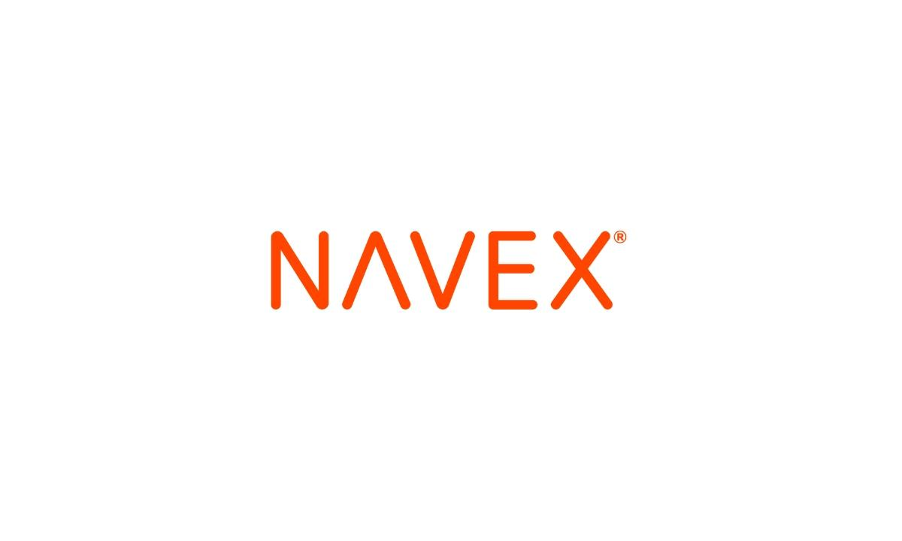

Lake Oswego, OR, United States, December 15th, 2025, NewsDirect

NAVEX, the global leader in integrated risk and compliance management, today announced a major expansion of its artificial intelligence capabilities across its flagship NAVEX One platform. Building on more than a decade of industry-leading data, NAVEX continues to weave AI into the core of its products, empowering compliance, risk, and HR teams to work smarter, act faster, and uncover insights that previously went unseen.

Over the past year, NAVEX has rolled out a series of AI-driven enhancements, including the NAVEX One Compliance Assistant (NCA), machine translations, integrated microlearning, and an AI training content library. Each is designed to help customers strengthen speak-up culture, streamline case management and investigative quality, ensure policy alignment, improve third-party due diligence, and identify emerging patterns of misconduct before they become systemic issues.

Today’s announcement marks the next chapter: a platform-wide expansion of AI services that brings connected intelligence to every corner of the user experience. Within Whistleblowing and Incident & Case Management, new AI features introduce intelligent automation that helps compliance teams work faster, document more consistently, and uncover risk trends earlier.

These capabilities support both reporters and investigators with flexible intake options, smart case summarizations and data field standardization, guided decision prompts, and multilingual access, always with human oversight at the center. Designed for speed, scale, and ethical integrity, these innovations help organizations move every case toward a clearer, smarter, more confident resolution.

“AI is no longer an add-on. It’s part of how modern organizations run their compliance programs,” said Kevin Haugh, Chief Product Officer at NAVEX. “Because NAVEX One is fueled by the industry’s richest data set, we’re uniquely positioned to deliver AI that is responsible, pragmatic, and deeply effective. Our current capabilities already accelerate customer outcomes, and the next phase of our roadmap pushes even further. We’re investing heavily in AI-driven predictions, proactive risk signals, and automated guidance that will help customers stay ahead of issues, not simply react to them. This is the future of compliance, and NAVEX is building it.”

NAVEX is committed to responsible AI development rooted in transparency, governance, and customer trust. Each new feature is rigorously monitored for quality and accuracy, reflecting the company’s long-standing commitment to ethical innovation and compliance excellence.
With today’s expansion, NAVEX continues to build an increasingly intelligent, unified experience within NAVEX One, where every insight is clearer, every workflow is faster, and every team is empowered to protect their people and their business.

About NAVEX

Trusted by 13,000 organizations, including 75 percent of Fortune 100 and 500 companies, NAVEX is the global leader in risk and compliance solutions. Its NAVEX One platform strengthens risk and compliance programs, empowering organizations with unparalleled industry benchmark data and insights. NAVEX One provides a 360-degree view of enterprise, third party and ecosystem risk for enhanced regulatory compliance and proactive risk management. Based in Lake Oswego, OR, with a global presence, NAVEX continues to shape the future of governance, risk and compliance. Visit our blog or follow us on LinkedIn, Facebook, and YouTube.

Contact
Senior Public Relations Manager
Scott Levesque
NAVEX
scott.levesque@navex.com

