BUSINESS NEWS PRESS RELEASE

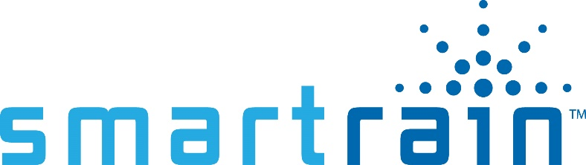
CONTACT INFORMATION:
Smart Rain
Rudy Larsen
801-554-5843
Rudy@SmartRain.net

FOR IMMEDIATE RELEASE

Smart Rain Announces Acquisition of Weather Reach technology from Irrisoft,
a Campbell Scientific Company
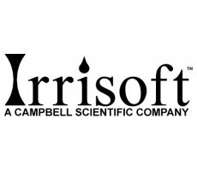

Salt Lake City January 13, 2020– Smart Rain has announced the acquisition of Irrisoft and Weather Reach brands from Campbell Scientific Inc. Smart Rain has purchased all assets as well as assuming all customer support and services.

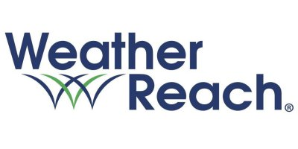
Steven Moore, President and founder of Irrisoft, and the Irrisoft team are pioneers in the smart landscape irrigation control, business; starting their business in 2001 and have proven the ability to use weather conditions to automate landscape irrigation better than anyone else in the industry. Their most successful product was the Rain Bird ET Manager, which was private labeled for Rain Bird and sold by Rain Bird for almost a decade. Irrisoft took what they learned and further advanced their product with the Weather Reach Controller Link. For this reason, Smart Rain found great value in everything they have built from weather station network management, weather responsive irrigation automation, as well as the process behind water schedule creation. Smart Rain also sees this much larger than an acquisition of Irrisoft but a partnership with Campbell Scientific which as deep roots in weather stations and sensor technology. Steven Moore has said, “I am impressed with the simplicity and reliability of the Smart Rain system and look forward to the integration of Weather Reach technology to further improve efficient water use and sustain beautiful landscapes.”

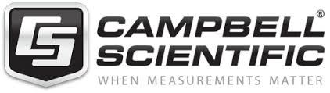
Dan Hymas President of Smart Rain said “We have watched and loved what Irrisoft has done over the years. It was naturally a perfect fit to take all they have built and integrate into our software and smart watering system. We believe both Irrisoft and Smart Rain customers will love even more what is yet to come from Smart Rain”

Larry Shirk Vice President of Campbell Scientific also said “This is naturally a great fit for Campbell Scientific as well. We have enjoyed working with Smart Rain and look forward to a long-standing relationship for years to come”

About Smart Rain
Smart Rain was started in 2012 with one goal in mind. Add Value. From the very beginning the mission to help our customers save water, save money and save time has been at the core of our business. Starting out as a water management company our company has a rich and in-depth understanding of irrigation management and all that goes into those services. Today the company is truly a tech company with roots deep in the water management service business. Our customers whether it be property ownership, property manager, water manager or landscape manager have come to love the ‘Value Add’ mentality that our company has fostered. Helping to save our customers over 1 billion in fresh water, $2 million on water bills, and over 100 thousand hours, these stats stand as a living testament to our ethos – Add Value!
About Irrisoft a Campbell Scientific Company
In 2001 Irrisoft was an early pioneer in smart irrigation control technology. Campbell Scientific, the world’s leader in weather stations, joined with Irrisoft; green industry software developers. The synergy between the two companies continues to produce effective innovative solutions to improve automated water management.
Irrisoft’s first product, the WR-7 Weather Reach Receiver, proved the innovative system effectively automated water management. In 2005 Rain Bird partnered with Irrisoft. The next generation WR-7 became Rain Bird’s ET Manager. In a joint development project the ET Manager Cartridge for the LXM controllers was produced. Rain Bird turned to Irrisoft because Weather Reach technology is a sustainable solution built on reliable high-quality Campbell Scientific weather stations.
Irrisoft’s continued efforts resulted in the Controller Link. With Wi-Fi on board this Internet based smart irrigation control device also offers remote web monitoring. Controller Link converts existing controllers to smart, climate-based automation. To improve water use efficiency and tracking flow sensing comes standard.
Steven Moore and Travis Barney are the founders of Irrisoft. They have over 50 years of combined green industry experience that includes automated irrigation control, software development, weather station network management landscape architecture, irrigation design, landscape construction, irrigation consulting and wholesale irrigation sales and distribution. This diverse strong background enables them to provide effective technology for the landscape industry.

