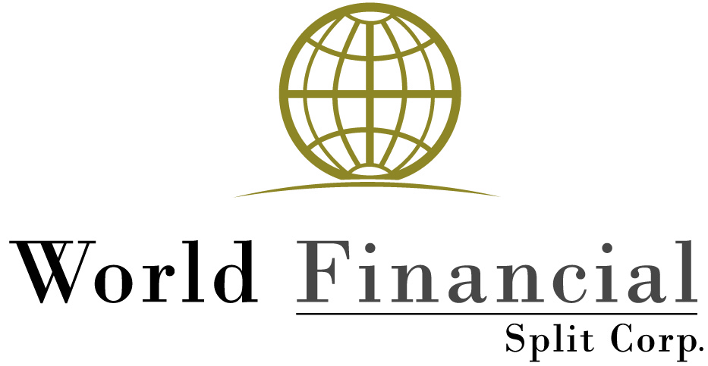

ANNOUNCES SEMI-ANNUAL RESULTS

**Toronto, Ontario, August 28, 2019 – (TSX: WFS; WFS.PR.A)** World Financial Split Corp. announces results of operations for the six months ended June 30, 2019. Increase in net assets attributable to holders of Class A shares amounted to $0.26 million or $0.22 per Class A share. Net assets attributable to holders of Class A shares as at June 30, 2019 were $3.27 million or $2.93 per Class A share. Cash distributions of $0.26 per Preferred share were paid during the period.

The Fund is a mutual fund corporation which invests in a portfolio that includes common equity securities selected from the ten largest financial services companies by market capitalization in each of Canada, the United States and the Rest of the World (the “Portfolio Universe”). The issuers of securities in the Portfolio, other than Canadian issuers, must have a minimum credit rating of “A” from Standard & Poor’s Rating Services or a comparable rating from an equivalent rating agency.

In addition, up to 25% of the Net Asset Value of the Fund may be invested in common equity securities of Financial Services companies not included in the Portfolio Universe as long as such companies have a market capitalization at the time of investment of at least US$10 billion and for non-Canadian issuers, a minimum credit rating of “A-” from Standard & Poors Rating Services or a comparable rating from an equivalent rating agency.

The Fund employs a proprietary investment strategy, Strathbridge Selective Overwriting (“SSO”), to enhance the income generated by the portfolio and to reduce volatility. In addition, the Fund may write cash covered put options in respect of securities in which it is permitted to invest.

The Fund’s investment portfolio is managed by its investment manager, Strathbridge Asset Management Inc. The Fund’s Class A and Preferred shares are listed on Toronto Stock Exchange under the symbols WFS and WFS.PR.A respectively.

**Selected Financial Information: ($ Millions)**

***Statement of Comprehensive Income***

***For the six months ended June 30, 2019***

***(Unaudited)***

Income (including Net Gain on Investments) $ 0.84

Expenses (0.27)

Operating Profit 0.57

Preferred Share Distributions (0.31)

Increase in Net Assets Attributable

to Holders of Class A Shares **$ 0.26**

For further information, please contact Investor Relations at 416.681.3966, toll free at 1.800.725.7172 or visit [www.strathbridge.com](http://www.strathbridge.com).

|  |  |
| --- | --- |
| John Germain, Senior Vice-President & CFO | **Strathbridge Asset Management Inc.**  121 King Street West  Suite 2600  Toronto, Ontario, M5H 3T9  416.681.3966; 1.800.725.7172  [www.strathbridge.com](http://www.strathbridge.com)  [info@strathbridge.com](mailto:info@strathbridge.com) |