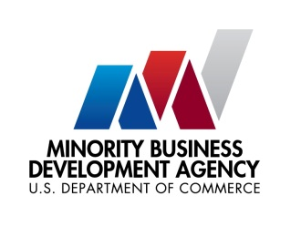

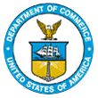
UNITED STATES DEPARTMENT OF

COMMERCE NEWS

WASHINGTON, D.C. 20230

MBDA Media Contact Information:
Mr. Gabriel Cushing, Public Affairs
Email Address: mbdapublicaffairs@mbda.gov
Website(s): http://www.mbda.gov/

The National Minority Enterprise Development Week (MED Week) Deadline for Nominations Fast Approaching on August 15, 2024

The U.S. Minority Business Development Agency Celebrates Businesses, Organizations, and Advocates with 41st Annual National MED Week Awards
WASHINGTON, D.C. (August 6, 2024) – The Minority Business Development Agency (MBDA) invites nominations for the 41st Annual National Minority Enterprise Development (MED) Week Awards. These awards honor the exceptional achievements of entrepreneurs, businesses and organizations that are advancing business enterprises within underrepresented communities.
For more than fifty years, the U.S. Department of Commerce’s Minority Business Development Agency has played a pivotal role in nurturing the expansion and global competitiveness of the nation's minority business enterprises. MBDA has been a trailblazer in honoring the achievements and economic contributions made by these businesses, which now number more than 10 million.
“The National MED Week Awards are a testament to the resilience and ingenuity of business leaders and trailblazers that are driving progress and inspiring future generations,” said Eric Morrissette, MBDA Acting Under Secretary.
Since its establishment in 1983, MED Week has celebrated the outstanding accomplishments of entrepreneurs from various backgrounds. With more than 300 awards presented, these accolades pay tribute to the exceptional achievements and unwavering commitment of individuals and organizations dedicated to fostering business growth.
Award Categories:
- Firms of the Year: Celebrating minority business enterprise excellence across nine industry-specific categories

- Champions of Business Development: Honoring individuals and organizations that have made outstanding contributions to business growth.

- Individual Recognition:
  - Abe Venable Legacy Award for Lifetime Achievement: For those whose lifelong efforts have significantly advanced business development.

  - Ronald H. Brown Leadership Award: Recognizing visionary leaders who have championed diversity and expanded opportunities for underrepresented business leaders.
National MED Week will take place October 20-26, 2024. This year’s conference will bring together entrepreneurs, business leaders, and public sector representatives to celebrate the growth and successes of minority business enterprises across the country.
How to Nominate: Detailed information on award categories, eligibility criteria, and nomination procedures is available on the MBDA’s website at http://www.mbda.gov. Nominations must be submitted by August 15, 2024, to ensure consideration.
About the U.S. Minority Business Development Agency (MBDA):
The U.S. Department of Commerce, Minority Business Development Agency is the only Federal agency dedicated to the growth and global competitiveness of U.S. minority business enterprises (MBEs). For more than 50 years, MBDA’s programs and services have better equipped MBEs to create jobs, build scale and capacity, increase revenues, and expand regionally, nationally, and internationally.

###

