NEWS RELEASE
For Immediate Release  Aug 1, 2024 | Contact:  Deputy U.S. Marshal Kris Garcia  Southern District of Florida  Phone: (786) 412-9547  Deputy U.S. Marshal Michael Barron  USMS Office of International Operations  Phone: (802) 999-1854
US Marshals add Canadian man to 15 Most Wanted fugitive list; offer up to $25K reward for info leading to capture
Wanted for May 2023 murder in Florida, January 2022 kidnapping in Canada

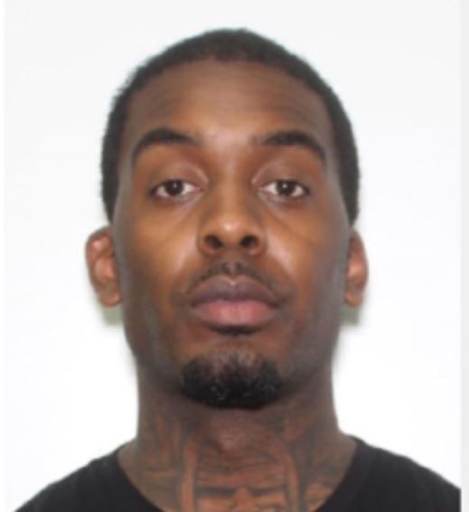
WASHINGTON – The U.S. Marshals Service elevated Deshawn “Thorobread” Davis, 36, to its 15 Most Wanted Fugitives list for a May 2023 murder in Florida and by Ontario authorities for his role in a January 2022 kidnapping and murder of a woman.
Davis, a Canadian man, is wanted for a brutal murder that occurred May 7, 2023, during which he is alleged to have opened fire during a party at the GALA, a Miami Beach nightclub, shooting to death Lowell “Lo” Grissom, a Miami rapper and talent scout for Chris Brown Entertainment, and injuring two women.
Law enforcement in Florida believe the murder was a targeted attack with a gang nexus.
Davis was already a fugitive in Canada when the Florida murder took place.
In February 2023 the Ontario Provincial Police charged Davis and two others with the January 2022 kidnapping and murder of Elnaz Hajtamiri. Authorities believe Hajtamiri’s ex-boyfriend Mohamad Lilo (currently in jail in Canada) orchestrated the murder with Davis and another accomplice by posing as police officers and forcibly dragging the woman from a relative's house in Wasaga Beach, Ontario, on the night of Jan. 12, 2022, to an SUV before disappearing. Hajtamiri is presumed dead. Her body has not been recovered. The Canada Crown attorney charged Lilo with murder by way of direct indictment.
“Deshawn Davis on the U.S. Marshals Service 15 Most Wanted list reflects the heinous nature of his alleged crimes and shows our resolve to bring him to justice” said U.S. Marshals Service Director Ronald L. Davis.
The U.S. Marshals are offering a reward of up $25,000 for information that leads to Davis’s capture. The USMS in the Southern District of Florida and the USMS Florida/Caribbean Regional Fugitive Task Force have adopted the Miami Beach Police murder warrant and are collaborating with the USMS Investigative Operations Division Office of Canadian Affairs to locate Davis, who is believed to be in the U.S.
Davis has been featured on Canada’s 25 Most Wanted for his involvement in the Ontario kidnapping and murder. A $100,000 joint OPP and York Regional Police reward is available for anyone with information about Hajtamiri's whereabouts.
Canadian authorities are asking anyone with information about Davis to contact the OPP or the dedicated TipLine at 1-833-728-3415.
Davis is a black man of average build, standing 6 feet 1 inch and weighing approximately 175 pounds. He has brown eyes and black hair. He has tattoos on his neck, forearms and chest.
Anyone with information on Davis’s current location is urged to contact the U.S. Marshals Service at 1-877-WANTED-2. Tips may be submitted via the USMS Tips App. Your information will be taken in strict confidence. Your anonymity is guaranteed.
Created in 1983, the USMS 15 Most Wanted fugitive program draws attention to some of the country’s most dangerous and high-profile fugitives. These fugitives tend to be career criminals with histories of violence who pose a significant threat to public safety. Generally, 15MW fugitives are considered the “worst of the worst” and can include murderers, sex offenders, major drug kingpins, organized crime figures and individuals wanted for high-profile financial crimes. Since the program began in 1983, more than 250 15MW fugitive cases have been closed.
The USMS has a long history of providing assistance and expertise to other federal, state, and local law enforcement agencies in support of their fugitive investigations. Working with authorities at the federal, state, tribal, and local levels, USMS-led fugitive task forces arrested more than 73,000 fugitives and cleared nearly 86,000 warrants in FY 2023.
The Florida/Caribbean Regional Fugitive Task Force began operations in July 2008 following the Presidential Threat Protection Act of 2000. With partnership agreements with more than 90 federal, state or local agencies and 11 fully operational offices, the FCRFTF has apprehended more than 64,600 fugitives since inception. The FCRFTF, in cooperation with its partners, has made an extraordinary impact on the apprehension of the region’s most dangerous and violent fugitives, making communities and citizens safer.
For additional information about the U.S. Marshals Service please visit https://www.usmarshals.gov

# # #
America’s First Federal Law Enforcement Agency

