Contact:
Barbara Golden, Communications Manager
904-669-8142 (cell)
BGolden@FloridasHistoricCoast.com

Florida’s Historic Coast Honors Cultural History with an Array of Events
Ceremonies, lectures, and festivals recognize and celebrate the heritage of Florida’s Historic Coast
St. Augustine, Fla. (November 9, 2023) – Many populations have called the sandy beaches, marsh hammocks, and hardwood forests of Florida’s Historic Coast home. From the land’s very first native people to Spanish colonists to freed slaves, these shores celebrate the beauty of cultures past and present. Join St. Augustine, Ponte Vedra and The Beaches to recognize and celebrate these vibrant cultures.
The National Park Service will host free events, Wednesday, Nov. 15 through Thursday, Nov. 16, at the Castillo de San Marcos National Monument to commemorate Native American Heritage Month.
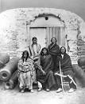
Known as Fort Marion in the 19th century, the fort served as a military prison for Native Americans during three separate periods: the Seminole in 1837, warriors of five Plains tribes from 1875-1878, and Apache from 1886-1887.
The Castillo is honored to feature representatives from the Cheyenne and Arapaho Tribes, the Kiowa Tribe, the Comanche Nation, and the Caddo Nation to lead educational sessions on art, history, and the legacy of the 1870s imprisonments and its impact today. The educational sessions will be held Wednesday, Nov. 15, from 9am to 12pm, and Thursday, Nov. 16 from 9am to 3pm at Flagler College’s Ringhaver Student Center. The event concludes Thursday with a 3:45 p.m. with a memorial ceremony at Castillo de San Marcos.
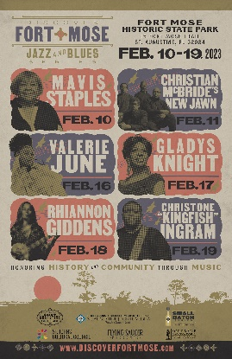
The settlement of Garcia Real de Santa Theresa de Mose, referred to as Fort Mose Historic State Park, was established in 1738 as the first legally-sanctioned free Black settlement in the United States. Fort Mose's inhabitants were slaves of West African origin who escaped from the British colonies of South Carolina and Georgia to Spanish Florida. Today, Fort Mose Historic State Park is a historical and cultural destination managed by the Florida State Parks Service. The park features a museum and visitor’s center. A groundbreaking to build a replica of the original wooden fort at the nation's first free Black settlement is scheduled for January 2024.
One of their major fundraising efforts for the reconstruction project is the popular Discover Fort Most Jazz and Blues Series, where history, community, and music come together. Spread over two weekends from Feb. 8 through Feb. 17, 2024, the 3rd Annual Series features performances by big-name acts like rapper Common, New Orleans-based Preservation Hall Jazz Band, legendary Jazz at Lincoln Center Orchestra with Wynton Marsalis, Christone “Kingfish” Ingram with special guest Taj Farrant, and roots musician Keb’ Mo’. Tickets go on sale on Friday, November 10, 2023.
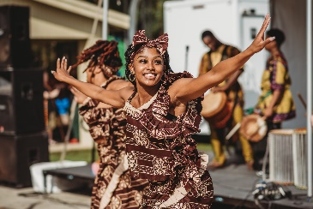
The Gullah Geechee Heritage Festival is a unique experience, celebrating 450 years of West African Culture. On Saturday, Dec. 2nd, Armstrong Park in Elkton, Florida will echo with the sounds of traditional music, dance, food, and crafts to celebrate this vibrant culture. The Gullah Geechee are descendants of Africans who were enslaved on the rice, indigo, and cotton plantations of the lower Atlantic coast. They have traditionally resided in the coastal areas and the sea islands of North Carolina, South Carolina, Georgia, and Florida.
Also taking place on December 2, the Colonial Quarter in St. Augustine will host the annual Colonial Night Watch is evidence of the indelible influence British occupation had on the city of St. Augustine from 1764-1784 (Spain later regained Florida). During the day, there will be an encampment at the Colonial Quarter with Historic Florida Militia depicting 18th century Spanish, British, French, colonial militia and Native American military arts, culture and lifestyles. In the evening, the Colonial Night Watch procession from the Castillo de San Marcos National Monument along St. George St. to the Governor’s House Cultural Center & Museum starts at 7 p.m.
When Don Pedro Menendez de Aviles landed on the shores of St. Augustine in September of 1565, his mission’s priest, Father Francisco López de Mendoza Grajales, conducted what was to be the first parish mass in the New World. This holy site is where the new Spanish settlers would begin devotion to Our Lady of La Leche. Today, a small mission chapel stands in honor of Our Lady of La Leche. “Noches de Navidad” and Las Posadas will take place 3-9 p.m. on December 16, 2023. The event features a live Nativity, Eucharistic Adoration, cookies, hot cocoa, and a 16th-century Spanish procession of “Las Posadas” (the Inns). Admission is free, but reservations are required.
With the landing of Don Pedro Menendez de Aviles in St. Augustine in 1565, Spanish influence and heritage can be found throughout Florida’s Historic Coast. The St. Augustine Spanish Food & Wine Festival celebrates the food, wine, and culture of Spain with a multi-day festival. Foodies, history buffs, and xenophiles can explore Spanish history and traditions while enjoying Spanish wine, tapas, and spirits. The festival takes place on the Flagler College Campus the last weekend in February.
Many local events celebrate the traditions of the European settlement, including the annual Sept. 9 commemoration of Pedro Menendez de Aviles landing and even St. Augustine’s famous Night of Lights. It is firmly rooted in the Spanish tradition of displaying white candles in their windows during the holiday season. For images to accompany postings click here.
Located midway between Daytona Beach and Jacksonville, Florida’s Historic Coast includes historic St. Augustine, the outstanding golf and seaside elegance of Ponte Vedra Beach, and 42 miles of pristine Atlantic beaches. For more information, call 1.800.653.2489 or go to the Visitors and Convention Bureau website at www.FloridasHistoricCoast.com.
Check us out on social media Instagram @FloridasHistoricCoast ViajaStAugustine,
Facebook.com/OfficialStAugustine and Facebook.com/ViajaStAugustine and Twitter @FlHistoricCoast

# # #

