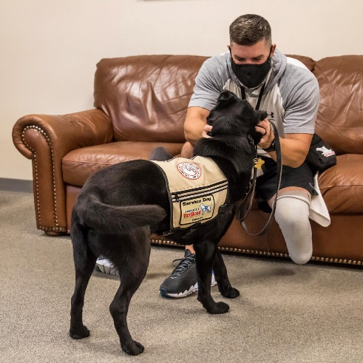
Media Contact:
Jamie Shrewsbury
Jamie.shrewsbury@guidedog.org
C: 304-839-2551

America’s VetDogs collaborates with BAE Systems
to enhance the lives of veterans with disabilities
America’s VetDogs joins BAE Systems’ Tech Power: Innovating for Impact program to bring together veterans and leading engineering programs at colleges and universities across the United States.

FOR IMMEDIATE RELEASE: SMITHTOWN, N.Y., FEBRUARY 22, 2022 - America’s VetDogs, a national nonprofit that provides specially trained guide and service dogs to veterans and first responders with disabilities, announces its collaboration with BAE Systems, Inc., a leading aerospace and defense technology company. America’s VetDogs joins BAE Systems’ Tech Power: Innovating for Impact program to bring together veterans, leading engineering programs at colleges and universities, and the company’s mentors. America’s VetDogs matches candidates from its program with an engineering student team to create innovative, custom-designed devices to aid the veteran in their everyday life.

Five colleges and universities across the country are participating in the program, which spans the 2021-2022 academic year. Each school will complete up to two projects for veterans in their region. Projects will be completed in a group setting with four to six students supported by three industry mentors. For most colleges and universities, student teams spent the first semester developing a design before transitioning into the building phase in the second semester. The completed technologies will be presented to the local veterans in May 2022.

“America’s VetDogs is thrilled to collaborate with BAE Systems and innovative, engineering students who have a passion to give back to our nation’s heroes,” said John Miller, president and CEO of America’s VetDogs. “It is so impactful to see our graduates receive individualized support, work with the next-generation to bring awareness to veterans with disabilities, and further increase their independence through the America’s VetDogs program.”

Colleges and universities participating in the Tech Power: Innovating for Impact program include:
- Binghamton University, NY
- Prairie View A&M University, TX
- University of San Diego, CA
- Trine University, IN
- Kirkwood Community College, IA

“We’re proud to work with America’s VetDogs to advance our shared mission of improving the lives of veterans through innovative technologies,” said Melissa Bernard, head of the Tech Power: Innovating for Impact program at BAE Systems Electronic Systems sector. “It is remarkable to see the connection between our employee volunteers and these talented engineering students, as they create unique and meaningful solutions for our veteran community.”

To learn more about America’s VetDogs and their mission, please visit VetDogs.org. For more information regarding BAE Systems’ Tech Power: Innovating for Impact program, visit BAESystems.com.

About America’s VetDogs
Since 2003, America’s VetDogs (www.VetDogs.org) has trained and placed guide and service dogs to provide independence, enhanced mobility, and companionship to veterans with disabilities from all eras. In 2015, VetDogs opened its programs to first responders, including fire, police, and emergency medical personnel. America’s VetDogs is a 501(c)(3) not-for-profit organization founded by the Guide Dog Foundation and serves clients from across the United States. VetDogs relies on contributions from generous individuals, corporations, service clubs, and foundations to fund its mission to help those who have served our country live with dignity and independence. It costs over $50,000 to breed, raise, train, and place one assistance dog, but America’s VetDogs provides its services completely free of charge to the individual. America’s VetDogs has been accredited by both the International Guide Dog Federation and Assistance Dogs International.

About BAE Systems
BAE Systems, Inc. and its 35,000 people are part of a global defense, aerospace and security company with 89,600 employees worldwide. We deliver products and services for air, land, sea and space, as well as advanced electronics, intelligence, security, and IT solutions and support services. Our dedication shows in everything we design, produce and deliver— to protect those who protect us in a high-performance, innovative culture. We push the limits of possibility to provide a critical advantage to our customers where it counts.

###

