NCCAOM Announces
Mina Larson, M.S., MBA, CAE
as Incoming CEO
FOR IMMEDIATE RELEASE: 07/22/2019

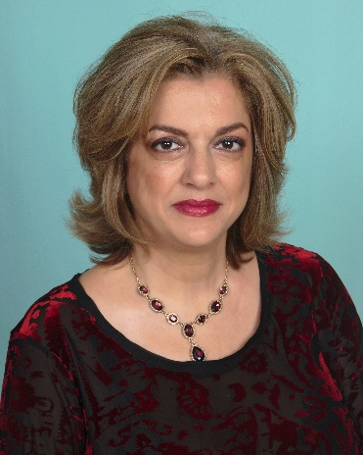
Washington, D.C., (July 22, 2019) – The National Certification Commission for Acupuncture and Oriental Medicine (NCCAOM)® Board of Commissioners is pleased to announce that they have selected Mina M. Larson, NCCAOM’s former Deputy Executive Director from a wide list of nationwide candidates, as its new CEO, effective July 22, 2019. Former CEO, Dr. Kory Ward-Cook, will stay on through December 2019 to assist with the leadership transition.
Ms. Larson has devoted the past 16 years to the NCCAOM overseeing various aspects of the organization, such as operations, development, regulatory affairs, advocacy, media relations, communications and marketing. She has played an instrumental role in helping restructure the organization to better serve NCCAOM National Board-Certified Acupuncturists™, as well as the broader AOM community. She has been the primary contact for many state associations, regulatory boards, legislators, and members of the media. “With her long history of association leadership, credentialing supervision, government relations and her desire to advance the AOM profession, we are looking forward to her inspiring leadership. We are fortunate to have someone of Mina Larson’s caliber and experience to lead NCCAOM.,” said NCCAOM Board Chair Afua Bromley. “She is well-respected by other AOM leaders. Our profession is at a critical moment and Mina’s business expertise, political savvy and leadership skills make her an exciting leader for the next phase of the NCCAOM’s development.”

Prior to arriving at the NCCAOM, Larson served as a director to former California Governor Pete Wilson's Executive Office and Communications Office and handled media relations for the California State Assembly. Ms. Larson is a Certified Association Executive from the ASAE. She holds dual Bachelors’ degrees in Journalism and Government from
California State University, Sacramento, a Master of Science in Non-Profit Association Management from University of Maryland University College and an MBA from University of Maryland. She has taught various training workshops throughout the country on improving media relations, marketing and advocacy and authored numerous articles on association management topics such as ethics, advocacy and public relations.
“I am grateful to the NCCAOM Board of Commissioners to have provided me with the opportunity to lead this exceptional organization at such a pivotal time for our profession”, stated Larson. I look forward to working with our dedicated Board and staff to make positive and meaningful impact on areas identified by our valued NCCAOM Board-Certified Acupuncturists such as public education, advancing NCCAOM certification in the federal arena, and improving professional development.”
About NCCAOM
The National Certification Commission for Acupuncture and Oriental Medicine (NCCAOM)® is a non-profit 501(c)(6) organization established in 1982. NCCAOM is the only national organization that validates entry-level competency in the practice of acupuncture and Oriental medicine (AOM) through professional certification. NCCAOM certification or a passing score on the NCCAOM certification examinations are documentation of competency for licensure as an acupuncturist by 46 states plus the District of Columbia which represents 98 percent of the states that regulate acupuncture. All NCCAOM certification programs are currently accredited by the National Commission for Certification Agencies (NCCA). To learn more about the NCCAOM, or about acupuncture and national board certification visit www.nccaom.org. To find an NCCAOM National Board-Certified Acupuncturist™ in your area, click on Find A Practitioner at www.nccaom.org.
###

