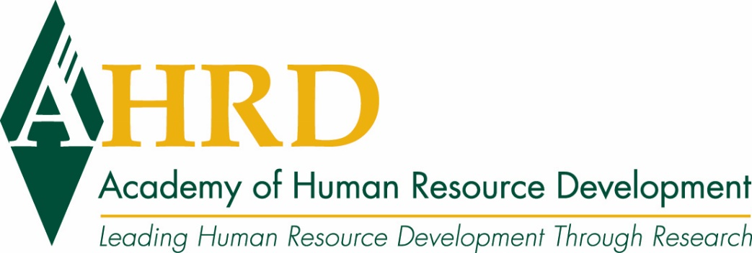

AHRD Launches 2020 Conference with special event highlighting Hiring and Retaining Military Veterans

January 2020 – Academy of Human Resource Development launched a brand-new special event set to take place prior to the 2020 AHRD International Research Conference in the Americas focused solely on the hiring and retaining of military veterans in the workplace. The event, titled “Hiring and Retaining Military Veterans: Integrating Research and Best-Practices to Improve Veteran Outcomes” will be a part of the pre-conference workshops on Wednesday, February 26, 2020, though attendees will not have to register for the full conference to attend this event.

Since federal hiring initiatives were launched, hundreds of employers have formalized military veteran hiring programs and thousands more have informally prioritized, to at least some extent, the employment of those who have served in the armed forces. However, once employed, veterans leave their first non-military job at alarming rates (50% within one year; nearly 65% within two years). The dramatic turnover is particularly concerning as employers are investing significant resources in finding veterans for hire. Whereas veterans are currently perceived as assets and possibly social responsibilities, prolonged high turnover rates may reduce the likelihood of employers continuing to invest resources in finding veterans for hire.

Focused on human resource practitioners who are interested in learning about and developing a plan to formalize their veteran hiring and support, the preconference event will explore recognized challenges to veteran employment, including reasons employers struggle to hire and retain veterans. The session will also lead into a discussion about the challenges veterans experience veterans during the career transition and through the employment life cycle. Those who attend the event can expect to work with the facilitators through a comprehensive veteran employment and retention framework that utilizes research-informed current best practices in hiring and retaining veterans.

The session will be facilitated by Michael Kirchner, Ph.D., Sarah Minnis, Ph.D., and Christopher Goehner, M.A.

To learn more about the workshop and to register, please visit: https://www.ahrd.org/page/2020-precon.

About AHRD

Founded in 1993, the Academy of Human Resource Development (AHRD) is a global organization made up of, governed by, and created for the Human Resource Development (HRD) scholarly community of academics and reflective practitioners. Join today as we lead human resource development through research. AHRD sponsors four refereed research Journals: Advances in Developing Human Resources, Human Resource Development International, Human Resource Development Quarterly and Human Resource Development Review. AHRD’s conference is in Atlanta February 26-29th. More information here: https://www.ahrd.org/page/Annual-Conference .

AHRD Media Contact:
Kathie Pugaczewski, Executive Director
651-265-7859

