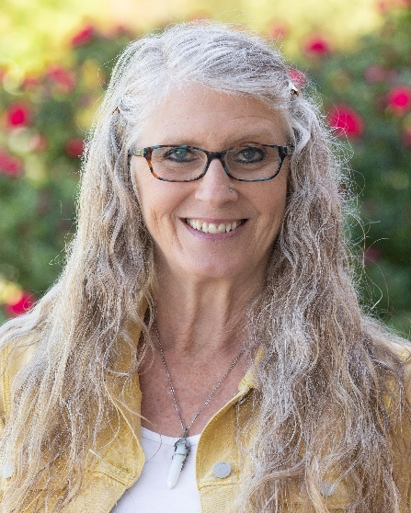

**Donna Henderson**

**Executive Director of Permanency Support & Education**

Donna’s responsibilities as Executive Director include leading the statewide Child-focused Recruitment, Homebuilders, and Permanency Support & Education programs according to best practices and in the spirit of CHS leadership. She is committed to incorporating data into program development to support successful services for children and families to create opportunities to elevate families to care for children in their homes. She supports program implementation according to defined fidelity measures to ensure consistent implementation and outcomes for children and families.

Donna has more than 30 years of experience including: Executive Director of the Broward Healthy Start Coalition in Broward County Florida, Director of Healthy Families Broward, Certified Teaching Parent - Outreach Broward, where she lived with her family, two dogs, and seven youth who were transitioning back to their community and families after completing treatment at a psychiatric facility.

Joining CHS through a merger 18 years ago, Donna has been a Foster Care Supervisor, served as Director of Family Finding in all 100 North Carolina counties, established the first Resource Team for foster care referrals, expanded the Wendy’s Wonderful Kids model to a statewide program, and overseen the implementation of the Kinship Navigation recourse, support, and licensure program.

“My career has been focused on providing a safe and loving home for children,” Donna says. “Even in my early years, I worked with children who were stepping down from psychiatric placements to reintegrate them to families and provide tools to them so they could be successful in their journey to permanency.”

“From mental health, maternal and child health, to child welfare, I have never lost focus on what matters – equipping individuals with the best tools and knowledge available to be successful in their journey with their families.”

Throughout her career, Donna has led change. From the Family Finding implementation at CHS – connecting youth in foster care to lifelong family members – to expanding Wendy’s Wonderful Kids/Child-Focused Recruitment (CFR) services to fidelity throughout the state. The Family Finding focus on relative search and engagement was incorporated into the CFR model where the longest waiting children in foster care are three times more likely to be adopted. Taking lessons learned and strengthening focus on areas that show impact on achieving permanency, she remains steadfast in supporting youth and families in a variety of capacities one family, one youth at a time to help build skills for success.

Donna holds a BA from Jacksonville State University and an MSW from Florida International University.

As for her extracurricular activities, Donna says, “I enjoy being in my community, and I look for new experiences, attend cultural events, and try to be in situations to learn from others about art, traditions, views, and perspectives – and of course cuisine. I enjoy spending my free time in nature, exploring the waterfalls of western North Carolina, and traveling.”

Originally from Northern California, she married her high school sweetheart, raised two beautiful children and has been blessed with three grandchildren.