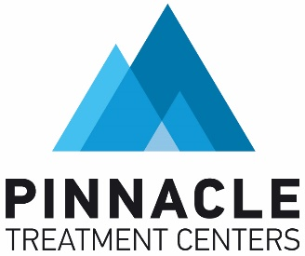

**FOR IMMEDIATE RELEASE**

Media Contacts:

Alex Muller, [alex.muller@pinnacletreatment.com](mailto:malex.muller@pinnacletreatment.com)

**Pinnacle Treatment Centers Announces Telehealth Intakes for Methadone Treatment for Opioid Use Disorder**

***Reduced Barriers to Medication-Assisted Treatment: Hope for New Patients***

*California, U.S. – 10/14/2024*

[Pinnacle Treatment Centers (PTC)](https://pinnacletreatment.com/), a leading provider of comprehensive treatment for opioid use disorder (OUD), is thrilled to announce a new development in OUD treatment in California: the approval of telehealth induction for medication-assisted treatment with methadone.

This is an important step in the fight against opioid addiction, removing a significant barrier to care for people with OUD who don’t have easy access to treatment. The Substance Abuse and Mental Health Services Administration (SAMHSA) and the Department of Health and Human Services (HHS) announced the new rule change in April, with compliance required by October 2nd of this year.

Aegis, acquired by Pinnacle in 2020 and part of the Pinnacle Family of Companies, has received statewide approval, granted by the Department of Health Care Services (DHCS), to implement key components of the recent federal rule changes as California updates its regulations.

This exception approval allows Aegis to:

* Offer same-day admissions for faster access to lifesaving methadone treatment programs.
* Provide walk-in support without appointments, Monday through Friday, and on weekends in Stanislaus and San Joaquin counties.
* Deliver more convenient and flexible services to help individuals begin their recovery journey.

This approval marks a significant step forward in addressing opioid use disorder (OUD) across California, ensuring that individuals can access the care they need when they need it most.

*“The opioid epidemic has taken a huge toll throughout the state. Treatment is needed now more than ever. Pinnacle is committed to offering the gold-standard of care for opioid use disorder in a safe, timely, and effective manner. Expanding access to methadone by allowing patients to initiate treatment via telehealth is a critical step forward in reducing harm caused by the opioid crisis in California.”*

* *Holly Broce, President, OTP Division at Pinnacle Treatment Centers*

**About Pinnacle Treatment Centers**

Pinnacle Treatment Centers is a leading provider of comprehensive substance abuse treatment services across multiple states. Established with a commitment to accessible and affordable care, Pinnacle offers a full range addiction treatment services including medically supervised detox, inpatient and outpatient treatment, sober living with PHP, medication-supported recovery, and other recovery support services. The organization integrates evidence-based practices and personalized care plans to address the unique needs of each individual. Pinnacle Treatment Centers is dedicated to helping patients achieve lasting recovery and improve their quality of life through compassionate and professional support. For more information, visit www.pinnacletreatment.com.