## cid:image001.gif@01C69EC8.9B5BCB90UNITED STATES DEPARTMENT OF

### COMMERCE

### NEWS

**WASHINGTON, D.C. 20230**

**­­­**

**MBDA Media Contact Information:**

Mr. Gabriel Cushing, Public Affairs: gcushing@mbda.gov

Website(s): <http://www.mbda.gov/>

**U.S. Minority Business Development Agency Celebrates Capital Readiness Program Successes with NASDAQ Tower Display**

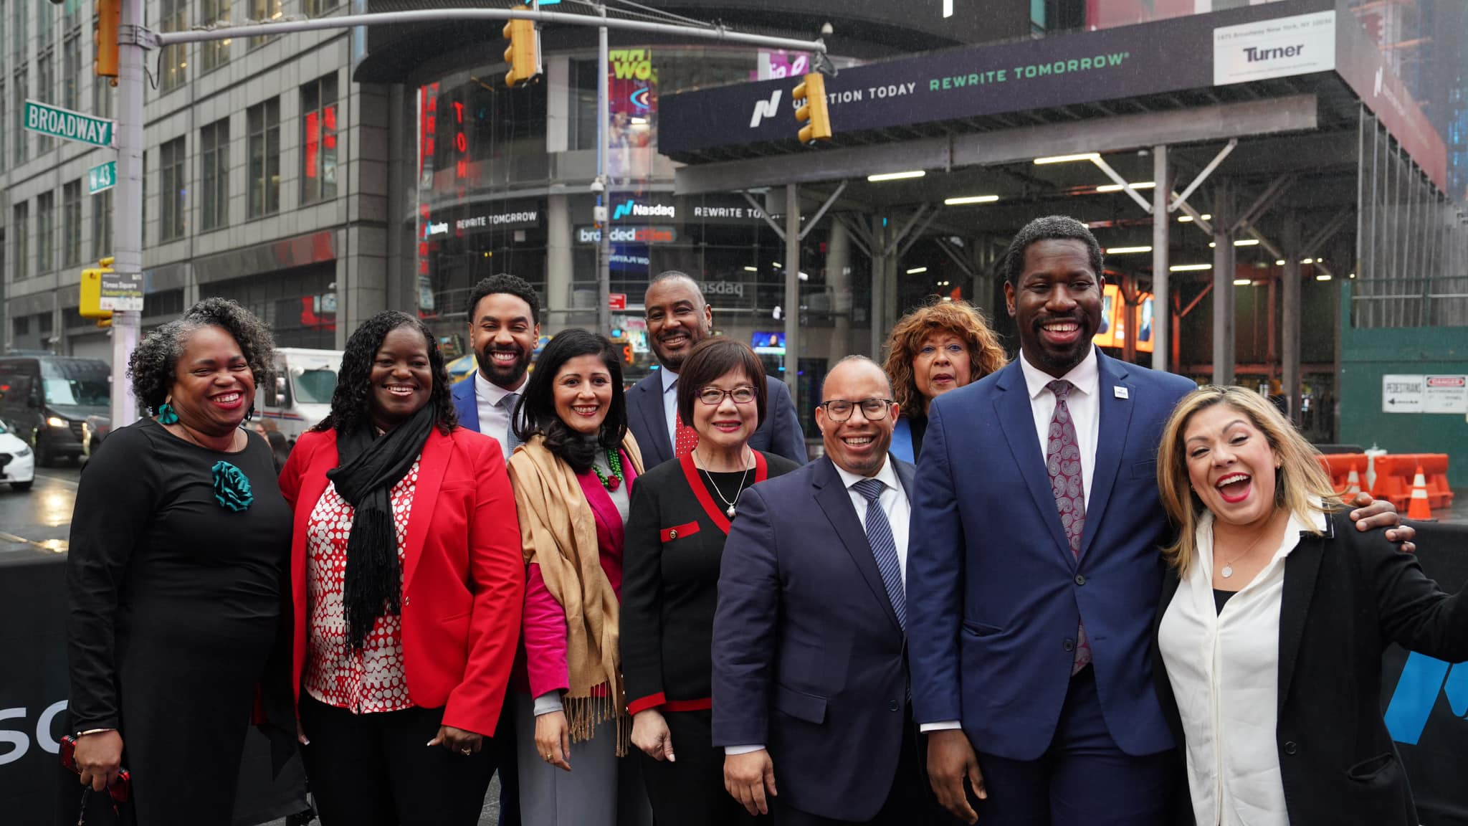

NEW YORK CITY – On Thursday, November 21, 2024, the Minority Business Development Agency (MBDA) celebrated the achievements of the historic Capital Readiness Program (CRP) at the NASDAQ Tower in Times Square. Deputy Under Secretary of Commerce for Minority Business Development Eric Morrissette joined Capital Readiness Program awardees as they uplift underserved entrepreneurs across the nation.

“One of the greatest obstacles facing underserved entrepreneurs is access to capital, which is why the CRP is so essential. With this landmark program, MBDA is working to address the root problem of that issue by supporting businesses and communities that have been historically overlooked or left behind,” said **Deputy Under Secretary Eric Morrissette**. “The CRP has and will continue to open doors for entrepreneurs looking to start and scale their businesses.”

Since its inception in 2023, CRP awardees, incubators, and accelerators have already served 6,326 entrepreneurs and helped raise $263 million in capital, form 2,636 new businesses, develop 1,726 business pitches, and host 2,486 networking events for diverse business owners and entrepreneurs across America.

Awardees in attendance included The U.S. Black Chambers, Inc., U.S. Hispanic Chamber of Commerce, Ventures, the Community Development Venture Capital Alliance, the National Minority Supplier Development Council, the National Urban League, the National Asian/Pacific Islander Chamber of Commerce, and the Eastern Shore Entrepreneurship Center.

“The Capital Readiness Program has empowered the United States Hispanic Chamber of Commerce to unlock critical capital opportunities, driving growth for businesses and reshaping regional economies,” said **USHCC Educational Fund Senior Vice President Evelyn Barahona, one of the awardees present at NASDAQ**. “Through the program, we've catalyzed expansion and new ventures for small business owners, strengthening not only the Hispanic community but the nation's economy. Looking ahead to 2025 and beyond, the USHCC is excited to collaborate with the MBDA and partners to further elevate the possibilities for businesses across the country.”

These centers have unique expertise to assist, and train underserved entrepreneurs seeking resources, tools, and technical assistance to start or scale their businesses in high-growth industries such as healthcare, climate resilient technology, asset management, infrastructure, and more.

For more information on active Minority Business Development Agency initiatives, visit [www.mbda.gov](http://www.mbda.gov).

***About the Minority Business Development Agency (MBDA)***

The U.S. Department of Commerce, Minority Business Development Agency is the only Federal agency dedicated to the growth and global competitiveness of U.S. minority business enterprises (MBEs). For more than 50 years, MBDA’s programs and services have better equipped MBEs to create jobs, build scale and capacity, increase revenues, and expand regionally, nationally, and internationally.

###