PRESS RELEASE
May 1, 2023

DAS Health Names New CEO to Continue Company’s Exponential Growth

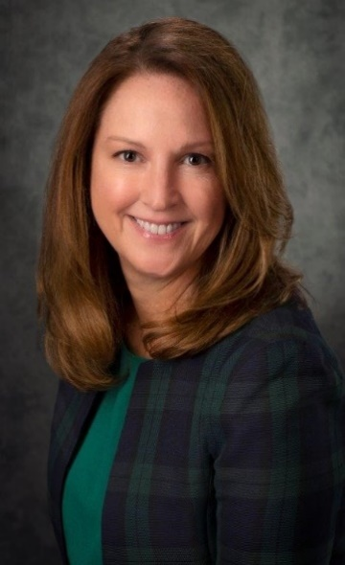
[TAMPA, FL] - DAS Health, a leading national provider of health IT and management solutions, is pleased to announce the promotion of Michelle Jaeger to the position of President & Chief Executive Officer, effective immediately.
Mrs. Jaeger has been an instrumental part of DAS Health since joining the company as Chief Operating Officer in 2021 and subsequently being promoted to President. With over 20 years of experience in healthcare and technology, Jaeger has brought a wealth of knowledge to DAS Health, helping to drive organic enterprise sales, complete and integrate multiple acquisitions, and develop effective strategies that have led to increased revenue and market share. Her previous experience in various leadership roles provides her with unique expertise that will be a crucial part in continuing DAS Health’s impressive growth trajectory.
"I am thrilled to be taking on this new role and am grateful to the DAS Health team for their support and trust in me," said Jaeger. "Our company has achieved great success in recent years, and I am committed to building on that momentum and driving continued growth for DAS Health and our clients."
As CEO, Jaeger will continue to oversee the company's operations and strategic initiatives, working closely with the leadership team to further advance DAS Health's mission of providing innovative and effective healthcare solutions to clients across the United States.
"To say that I am excited to have Michelle officially take the helm of DAS Health is an understatement," said David Schlaifer, who will step into the role of Executive Chairman. "It is rare that you can find someone who you know will not only protect a legacy, but substantially improve upon it. Michelle is that rare individual. Her leadership, expertise, and commitment to our team and clients make her the perfect fit for this role, and I look forward to seeing the company thrive under her leadership."
About DAS Health
DAS Health, a Sheridan Capital Partners portfolio company, has been a leading provider of Health IT and business solutions and a trusted consultant to independent and enterprise physician groups, hospitals and healthcare systems across North America since 2003, and has been recognized as an Inc 5000 fastest growing company for a record ten times. Headquartered in Tampa, FL with a regional presence in over 30 states, DAS delivers superior Information Technology, MSP managed IT, cloud hosting, RCM medical billing, value-based care, patient engagement, compliance, and practice management solutions for tens of thousands of users impacting over 15 million patients nationwide. It includes representation and support of dozens of various Practice Management and EHR platforms, including as a NextGen® Premier Partner and the largest channel partner for CGM Aprima® and e-MDs® solutions, and as a Microsoft® Solutions Partner, Datto® Diamond Partner, and industry leading partner of Dell®, ConnectWise®, Sophos®, Kaseya® and a number of other key affiliations.
NextGen® is a registered trademarks of QSI Management, LLC.; Aprima® is a registered trademark of Aprima Medical Software, Inc., a CompuGroup Medical, Inc. Company; eMDs® is a trademark of eMDs, Inc.; Microsoft® is a registered trademark of Microsoft Corporation; Datto® is a registered trademark of DATTO, Inc.; Dell® is a registered trademark of DELL, Inc.; ConnectWise® is a registered trademark of ConnectWise, Inc.; Sophos® is a registered trademark of Sophos Limited; Kaseya® is a registered trademark of Kaseya International Limited
For more information about DAS Health and its solutions, visit https://dashealth.com.
Media Contact
Libby Schlaifer, Marketing Manager
Libby.Schlaifer@dashealth.com | 813-774-9800 ext. 410

