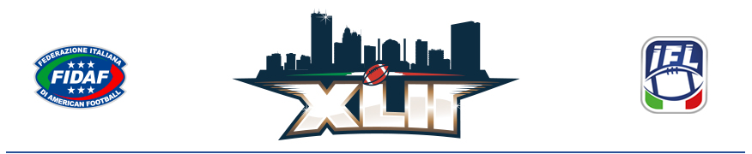

MEDIA RELEASE
THE XLII ITALIAN BOWL FINALISTS ARE SET:
PARMA AND FLORENCE look for storybook Season endings in Toledo, Ohio July 1st
The “Spaghetti Bowl”, the first American football game played in Italy, took place on January 1, 1945 in Florence, and featured the United States Fifth Army and Twelfth Air Force. Nearly eight decades later, a group of American businesspeople and football fans are bringing the best Italian teams to the birthplace of the game for a first of its kind championship event.
June 26, 2023 – Saturday, July 1, 2023, will be a historic day for Italian and European American football, as Guelfi Firenze and the Parma Panthers face off in the XLII Italian Bowl at the University of Toledo’s Glass Bowl. In addition to providing a crowning moment for one of these two teams, the game will also serve as the climax of a 14-day celebration of Italian culture, sport, and international camaraderie.
For the teams, the XLII Italian Bowl will offer total immersion in the unique atmosphere only the United States can create around championship football. Participants, mostly Italian locals, will be welcomed to the US with a dinner at the Glass Bowl stadium, travel to the Pro Football Hall of Fame in nearby Canton, OH, and play in the state-of-the-art 26,000 seat facility on gameday.
“Taking the IFL final to Toledo in the United States, where the game originated, has the hallmarks of an epic adventure for Italian American football,” said FIDAF Deputy Vice President Fabio Tortosa. “We are grateful to have this extraordinary opportunity for growth as it will positively impact the entire Federation as well as the two teams in the final.”
The Parma Panthers and Guelfi Firenze both finished the IFL regular season with 7-1 records. While Guelfi leads the teams’ all-time matchup 9 wins to 3, the Panthers delivered Firenze their sole loss during the 2023 season.
The Panthers, who boasted the #1 defense this season, are tied for the most IFL championship wins all-time at 5 and lifted the Gionni Colombo trophy as recently as 2021. Local product Tommaso Mondardi led their offense in 2023 with 15 touchdown passes and just 1 interception. John Grisham, who will be in attendance this Saturday, famously featured the Parma Panthers in his novel, Playing for Pizza.
Guelfi Firenze are looking to repeat as champions after their 2022 Italian Bowl victory over the Seamen of Milan. The dynamic quarterback product out of Dartmouth, Jared Gerbino, leads Guelfi Firenze, rushing for 13 touchdowns and adding 9 more through the air during their 2023 campaign.
The XLII Italian Bowl will offer fans so much more than the game itself. Celebrations already kicked off with the “Passport to the Taste of Italy”, a week-long showcase of Italian cuisine at nearly 40 different restaurants in the Toledo region. Mayors from several cities across the region competed in a football skills competition with the winner awarded the inaugural Mayors’ Cup during halftime of the big game. NFL players and alumni are hosting a youth football camp on June 30th and local businesses will have a chance to network with Italian companies at The Italian Bowl Business Forum, which will promote the Toledo/Italy trade and investment pipeline.
“The IFL final, and all that comes with it, will facilitate more exchanges and greater understanding between different cultures, further cooperation, and more positive interactions for thousands of people.” said Kapsukiewicz.
Fans can visit local and Italian artisans and vendors at a special edition of the Toledo Night Market that will start at 4PM in the Flatlands next to the Glass Bowl on game day. After the new IFL champions are crowned, the crowd will head to the Toledo riverfront to watch the city’s July 4th fireworks presentation.
Buy Your Tickets Today while supplies last. General Admission seating is just $15 and reserved seating is $30. International fans traveling to this momentous event can contact Central Travel for help with accommodations and logistics.
For more information on the 42nd IFL championship game, please visit www.ItalianBowlUSA.com or follow along on social media:

- Twitter: https://twitter.com/italianbowlusa
- Instagram: https://www.instagram.com/italianbowlusa/
- Facebook: https://www.facebook.com/ItalianBowlusa

###

Contact:
Barbara Allaria, Press & Communication Officer, FIDAF - Federazione Italiana di American Football
+39 0331 770343 – 338 6541305 (mobile)
press@fidaf.org

