Tearlach Commences Mapping at Georgina Stairs, Jellicoe, Ontario

VANCOUVER, BRITISH COLUMBIA, June 27, 2023, Tearlach Resources Limited (TSXV: TEA) (OTC: TELHF) (FRANKFURT: V44) (“Tearlach” or the “Company”) is pleased to announce that it has started mapping and sampling on our Georgina Stairs Lithium Project in the Georgia Lake pegmatite field, Jellicoe, Ontario. Mapping targets are being generated daily and followed up by Tearlach’s geology team. The Project is located 9 km east of Rock Tech Lithium’s Georgia Lake Project and is being explored for lithium mineralization hosted in spodumene pegmatites.

Highlights:

- Data compilation on the Project area, including topography, geology and geophysics data, was completed in the spring of 2023 and used to identify specific exploration targets in the Project area.
- Satellite images were used to identify outcrops, access roads and logged areas.
- 172 sample locations were described in the month of May.
- 76 samples have been submitted to the lab for assays.
- 20 granite outcrops were discovered and sampled.
- Tearlach signed an MOU with four local First Nation communities.

Tearlach’s geology team has discovered 20 granite outcrops hosted by biotite metasedimentary rocks on the Georgina Stairs claim block, whereas previously Ontario Regional Geology Map (MRD126) indicated that there was no granite on the claim block (Figure 1). The medium- to coarse-grained biotite granite outcrops occur in the southern part of the claim block. The mapping results have been interpreted and indicate three (3) exploration target areas for additional mapping. The discovery of granite is important because pegmatite dykes are derived from granite. For example, Rock Tech’s spodumene pegmatites are hosted by metasedimentary rocks in close proximity to granites.
A total of 172 sample locations were described in the month of May, of which 76 samples were submitted to Actlabs, Geraldton location for assay. Results are pending. The samples include granite to examine their rare-element content and metasediments to examine rare-element metasomatism as an indicator of blind pegmatites. Diabase was also sampled to distinguish between different generations of sills and dykes to see if one generation is associated with pegmatites. The Li, Rb, Cs, Nb, Ta and Be content of the granite will be plotted on a map to determine in which direction these rare-elements are increasing. This will be the direction to look for the possible presence of pegmatites.
Prospecting is ongoing and has been facilitated by access from the Peck Lake Road, which passes north to south through the middle of the property, and there are many logging trails on the Property (Figure 1). The geology team has been able to park the truck next to the outcrops.
The Project is underexplored in part because it is located outside E.G. Pye’s Georgia Lake Area map (Ontario Geological Survey, M2056, 1964), which has guided lithium pegmatite exploration in the area for many decades. The majority of the Property has had no historical exploration on it despite being so close to the Trans Canada Highway. The limited historical exploration on the Property consists of drilling in 1972 and 1973 in search of sulphides and prospecting in 2009 and 2011 also for sulphides.
The Property’s geology is similar to Rock Tech Lithium’s Georgia Lake Project and is 9 km east of Rock Tech’s spodumene pegmatites. The geology is also similar to Balkan Mining and Minerals Limited’s Gorge Lithium Project and is located 4.7 km north of their spodumene pegmatites.
Dr. Selway, VP of Exploration for Tearlach, commented, “I am pleased to finally get into the field to look at the rocks on the Georgina Stairs Property. Tearlach staked the property in February 2023. The discovery of granite on the property is a good first step to finding pegmatites.”
Tearlach welcomes Aboriginal Consultation and has met with four First Nation communities (Animbiigoo Zaagi’igan Anishinaabek, Bingwi Neyaashi Anishinaabek, Biinjitiwaabik Zaaging Anishinaabek and the Red Rock Indian Band) with traditional territories on Georgina Stairs Property face-to-face on April 20 and 21, 2023. These meetings led to the signing of a Memorandum of Understanding (“MOU”) dated May 9, 2023, with all four communities. Tearlach has also hired a member of the First Nation communities as a geological assistant to join our geology team, as he has excellent knowledge of and experience hunting and fishing in our project area.

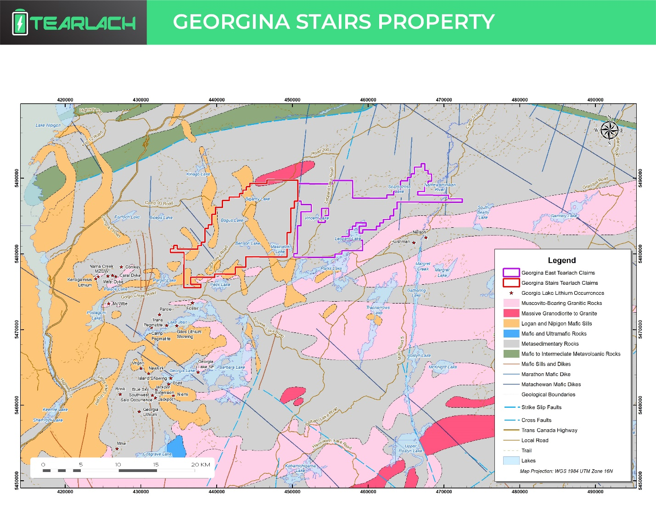
Figure 1. Geology map for Georgina Stairs Project, Jellicoe, NW Ontario.

Qualified Person:

Julie Selway, Ph.D., P.Geo. supervised the preparation of the scientific and technical information that formed the basis for the written disclosure in this news release. Dr. Selway is the VP of Exploration for Tearlach Resources and the Qualified Person ("QP") as defined by National Instrument 43-101.

About Tearlach:

Tearlach, a member of the TSX Venture 50, is a Canadian exploration company engaged in acquiring, exploring, and developing lithium projects. Tearlach is focused on advancing its flagship Gabriel Project in Tonopah, Nevada, bordering American Lithium's TLC Deposit, and has completed 11 drill holes on the Gabriel Property. Tearlach has three lithium assets in Ontario: Final Frontier, Georgina Stairs, and New Frontier. Final Frontier is located adjacent to and near Frontier Lithium’s PAK lithium deposit north of Red Lake. Georgina Stairs is located northeast of Rock Tech Lithium’s Georgia Lake deposit near Beardmore. Tearlach has two lithium assets in Quebec: Rose-Fliszar-Muscovite Project in the James Bay area and Shelby Project adjacent to and near Patriot Battery Metals’ Corvette lithium project and Winsome Resources’ Cancet and Adina lithium projects. Tearlach also has the Savant Property, an exploration stage Gold-Silver-Copper Property, in Northwestern Ontario. Tearlach's primary objective is to position itself as North America's leading lithium exploration and development company. For more information, please get in touch with the Company at info@tearlach.ca or visit our website at www.tearlach.ca for project updates and related background information.

ON BEHALF OF THE BOARD OF DIRECTORS,
TEARLACH RESOURCES LIMITED

Charles Ross
Chief Executive Officer
Suite 610 - 700 W. Pender Street
Vancouver, BC, Canada V6C 1G8
Tel: 604-688-5007

Follow us on Facebook, Twitter, and LinkedIn.

Forward-looking statements

This press release contains forward-looking statements and forward-looking information within the meaning of Canadian securities laws (collectively, “forward-looking statements”). Statements and information that are not historical facts are forward-looking statements. Forward-looking statements are frequently, but not always, identified by words such as “expects”, “anticipates”, “believes”, “intends”, “estimates”, “potential”, “possible” and similar expressions or statements that events, conditions or results “will”, “may”, “could” or “should” occur or be achieved. Forward-looking statements and the assumptions made in respect thereof involve known and unknown risks, uncertainties, and other factors beyond the Company’s control. Forward-looking statements in this press release include statements regarding beliefs, plans, expectations or intentions of the Company. Mineral exploration is highly speculative and characterized by several significant risks, which even a combination of careful evaluation, experience and knowledge may not eliminate. Forward-looking statements in this press release are made as of the date herein. Although the Company believes that the assumptions and factors used in preparing the forward-looking statements in this press release are reasonable, undue reliance should not be placed on such statements. The Company undertakes no obligation to update publicly or otherwise revise any forward-looking statements, whether as a result of new information or future events or otherwise, except as may be required by law.

Neither the TSX Venture Exchange nor its Regulation Service provided (as that term is defined in the policies of the TSX Venture Exchange) accepts responsibility for the adequacy or accuracy of this release.

