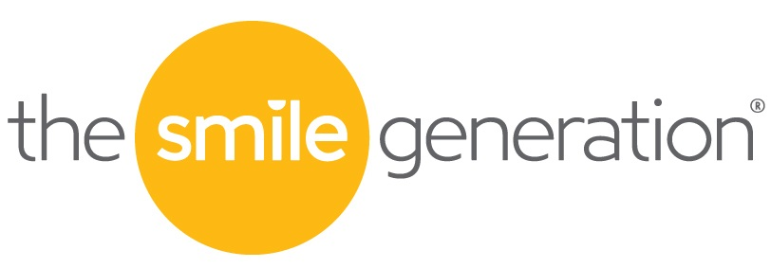

FOR IMMEDIATE RELEASE

Date: April 1, 2019
Contact: Wendy Belleville: Director, Communications and Public Relations
wendy.belleville@pacden.com│714-845-8250

Smile Generation®-Trusted Dental Practices Launch Charity: Water Campaign:
“Give Time. Give Water. Give Hope”
Campaign expected to raise $500,000 for clean drinking water for those in need
IRVINE, CALIF. April 1, 2019 – The Smile Generation, the referral service that connects prospective patients with trusted local dentists in their communities, announces a new campaign to support charity: water, a non-profit organization that brings clean, safe drinking water to people in developing countries. Smile Generation-trusted dental practices throughout the United States have launched a nationwide fundraising campaign to provide clean drinking water to more than 16,000 Ethiopians in need. 100% of donations benefit charity: water. Since 2009, The Smile Generation has brought clean drinking water to over 150,000 people by raising over $3.5 million in eight countries.
“For many developing countries, access to clean water changes everything,” said Kyle Guerin, Director, Foundation and Corporate Responsibility. “We’re passionate about charity: water’s mission to provide clean drinking water for people around the globe. The Smile Generation has been partnering with charity: water for 10 years and we look forward to supporting this important mission for many decades to come.”

According to statistics, 663 million people in the world live without clean water, nearly one in 10 people worldwide. The majority live in isolated rural areas and spend hours every day walking to collect water for their family. As charity: water notes, not only does the time walking for clean water keep children out of school or take up time that parents could be using to earn money, the water often carries diseases. According to the World Health Organization, contaminated water can transmit diseases such cholera, dysentery, typhoid, and polio. In addition, by 2025 half of the world’s population will be living in water-stressed areas. Access to clean water, however, means education, income and health - especially for women and children.

charity: water, which began in 2007, has funded water programs in 27 countries around the globe - in Africa, Asia, Central and South America. To find a Smile Generation-trusted dental practice participating in the charity: water campaign, click HERE.

About The Smile Generation®
The Smile Generation is a referral service that connects patients with trusted dentists and financial options that helps patients afford the care they want and need. The Smile Generation network is made up of more than 700 dental offices throughout Arizona, California, Colorado, Florida, Georgia, Idaho, Kansas, Louisiana, Massachusetts, Minnesota, Missouri, Tennessee, South Carolina, New Mexico, Nevada, Oregon, Texas, Utah, Virginia, and Washington. Smile Generation-trusted offices are supported by Pacific Dental Services®.
For more information, visit us at http://www.smilegeneration.com
Facebook: http://www.facebook.com/smilegen
Instagram: https://www.instagram.com/smilegeneration/
Twitter: http://twitter.com/smilegen
YouTube: https://www.youtube.com/user/SmileGenerationTV

