PRESS RELEASE

ETEL’s New TBS Linear Axis Provides Precision and Stability to Semiconductor Manufacturing Equipment
-An ISO 2 cleanroom product -

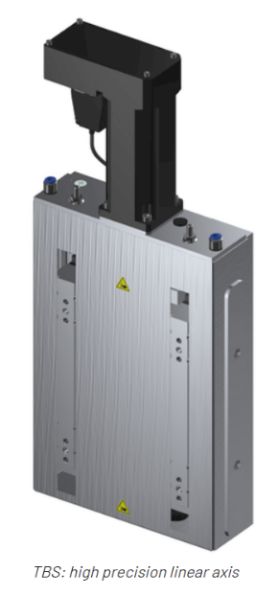
SAN JOSE, CA (June 2022) – With the new TBS Linear Axis offering from ETEL, semiconductor equipment manufacturers can now integrate a high precision linear axis enabling outstanding performance in term of accuracy and precision in its category of one-Degree-Of-Freedom (1-DOF) systems. With its ISO 2 rating for cleanrooms and incorporated HEIDENHAIN Group encoder technologies, the TBS provides high cleanliness and accuracy for any application needing to carry up to 45 kg of payload with high precision and stability of macro and micro motion.
The TBS 1-DOF mechanical bearing is based on an indirect drive linear axis that is controlled by a high-performance, low cogging servomotor using a dual encoder feedback control scheme. This is combined with specific design characteristics and options such as thermal decoupling of heat sources, high stiffness and a micrometric hard stop to ensure that its performance is maintained over a long operating lifetime, improving the end users’ ROI.
As part of ETEL’s commitment to providing high quality motion systems to the semiconductor market, the TBS is especially suitable for Wafer Process Control applications such as Overlay Metrology, Critical Dimension and Thin film Metrology, as well as photonics. Any customer who has adapted an alternate solution can receive a hands-on evaluation in order to prove the TBS’s superior performance.
Main Specifications:
- Acceleration up to 0.5 g
- Payload up to 45 kg
- Position stability: down to ± 10 nm
- Bidirectional repeatability: ± 0.3 um
- Max. speed: up to 30 mm/s
- Max. Acceleration: up to 5 m/s2
- ISO 2 cleanliness (ISO 1 Optional)

ETEL S.A. is based in Switzerland with exclusive North American distribution through HEIDENHAIN CORPORATION in San Jose, CA and Schaumburg, IL (www.heidenhain.us). As a leading international supplier of direct drive and motion control components and integrated systems, ETEL supports high tech industry with linear motors, torque motors, positioning stages, and motion controllers/systems.
More ETEL information can be found at: https://www.heidenhain.us/product/direct-drive-motors-and-motion-systems/
#
High-resolution digital image available:
https://www.heidenhain.us/addl-materials/pr/2022/ETEL_TBS_Linear_Axis.JPG

Product contact:
Brian Zlotorzycki, Business Development Specialist, ETEL
bzlotorzycki@heidenhain.com or 847-755-5569

Media contact:
Kathleen Herrmann
kherrmann@kpropr.com or 224-520-0665

