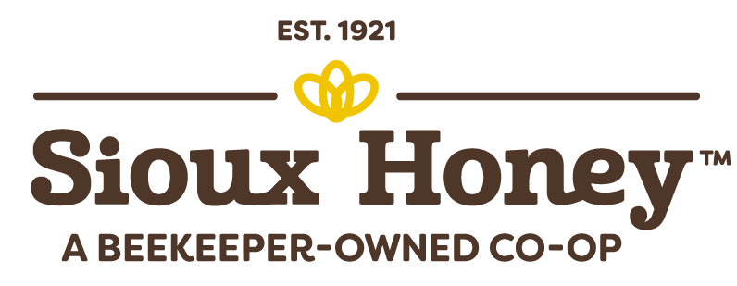

MEDIA ALERT CONTACT:
Jim Minge
Public Relations Liaison
402-740-8188 – jminge@bozell.com

Sioux Honey Photo IDs:

Sioux Honey Photo 1 (honey on shelf) – A few of the 6,000 bear-shaped bottles of SUE BEE Honey that were donated to the South County Outreach food pantry in Irvine on Wednesday, Jan. 24, by the Sioux Honey Co-op.

Sioux Honey Photo 2 (pallet, forklift) – A member of the South County Outreach food panty in Irvine unloads some of the 6,000 bear-shaped bottles of SUE BEE Honey that were donated to the food pantry by the Sioux Honey Co-op on Wednesday, Jan. 24.

Sioux Honey Photo 3 (three people outside) – From left: LaVal Brewer, President and CEO of South County Outreach in Ivine; Teresa Flores, office administrator at Sioux Honey Co-op; and Ron Astrada, shipping supervisor at Sioux Honey Co-op’s Anaheim distribution center, pose next to some of the 6,000 bear-shaped bottles of SUE BEE Honey that were donated to the food panty by Sioux Honey on Wednesday, Jan. 24.

Sioux Honey Photo 4 (family shopping) – The DePover Family of Ashley Park, Minn., shops at a local food pantry, thanks to food supplied by Second Harvest Heartland food bank in Brooklyn Park, Minn., where the Sioux Honey Co-op donated 6,000 bear-shaped bottles of SUE BEE Honey on Wednesday, Jan. 24.

Sioux Honey Photo 5 (Sioux Honey beekeeper in field) – One of the Sioux Honey Co-op’s 150+ member beekeepers tends to some of his hives.

