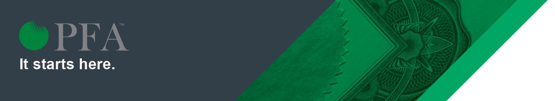
Frequently Asked Questions:
Professional Financial Advisor (PFA™) Designation
- Is the PFA designation right for me?
The PFA is a designation geared towards financial advisors who don’t already hold a professional credential. With a focus on practice development, technical knowledge, and compliance and ethics, the PFA program helps newer advisors get a successful head start while empowering existing advisors to fine-tune the primary building blocks of their business.
- How does the PFA differ from the CLU, CFP, or CHS?
The PFA designation is unique and distinct from the CLU®, CFP® and CHS. Designed to bridge the theory provided in licensing to real-world practices within a regulatory and ethical framework, the PFA program offers a strong foundation for the working advisor. PFA designation holders also receive advanced standing for nine of the 12 core curriculum modules within the Advocis Core Curriculum Program for CFP® Certification and the CLU® designation program.
- What is the estimated timeframe to complete the PFA program?
Created with working professionals in mind, the four-semester PFA curriculum enables program completion and business-readiness in 24 months, while balancing the responsibilities of full-time work.
- What are there eligibility requirements to apply for the PFA program? Are there any pre-requisites?
To be eligible for admission, applicants are required to hold initial industry licensing, such as MFDA, IIROC or Life License Qualification Program (LLQP).
- How is the program structured?
The PFA program covers the fundamental technical knowledge required to assess the best solutions for clients and essential practice-management skills to build and grow a successful financial advisory practice. Throughout the program a strong emphasis is placed on compliance and ethical practices, ranging from the legal and regulatory framework to professional standards and conduct.
The program is delivered over four semesters:
- Semester 1 – Business Elements
- Semester 2 – Client Engagement & Discovery
- Semester 3 – Building Client Value
- Semester 4 – Fine Tuning Your Practice & The Value of Advice

- Is the program delivered in classroom or online?
All program segments, including assessments, will be delivered online.
- How are candidates assessed? Is there a final examination to earn the designation?
Candidates will be assessed through a series of exams within each semester. Following the successful completion of all four semesters, a Final Comprehensive Exam must be challenged and passed to receive the designation.
- When and how frequently will the PFA program be offered?
The PFA program will be offered on an annual basis, with new admissions in the spring and fall. In 2020, spring admissions open on February 18 with courses beginning April 1.
- What is the cost for the PFA program?
For Advocis members, the cost of the PFA program is $900 (not including GST/HST) with a separate examination fee of $150 (not including GST/HST). For non-members, the cost is $1,360 (not including GST/HST) with a separate examination fee of $350 (not including GST/HST).
- Where can I find more information about the PFA program and how to apply?
For more information about the PFA program, including how to apply online, email PFA@advocis.ca or call 1-844-282-2510 to speak with a program representative.

