MEDIA RELEASE

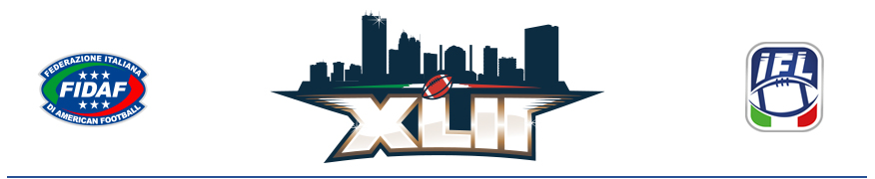

THE CITY OF TOLEDO WILL HOST THE 42nd ITALIAN BOWL ON
JULY 1, 2023 IN THE GLASS BOWL

First-ever Italian Football League Championship Held Outside of Europe;
Italian-themed Events Will Take Place Throughout the Weekend

Toledo, Ohio – September 30, 2022 – Today with the Toledo skyline in the background, a large group of Italian Bowl organizers and partners – including Italian Federation of American Football (FIDAF) Deputy Vice President Fabio Tortosa, and FIDAF Board Member and General Manager of the reigning Italian champions Guelfi Firenze Edoardo Cammi) – announced the 42nd Italian Bowl is coming to Toledo’s Glass Bowl Stadium on Saturday, July 1, 2023. The game will mark the first time in Italian Football League (IFL) history that Italy’s national championship will be played outside of Europe.

“With the organizational machine up and running, the chance to work side by side with experienced, dedicated professionals to hold the Italian Bowl in the birthplace of American football is an irresistible challenge and an exceptional opportunity for growth,” said Tortosa. “Taking the IFL final to Toledo in the U.S. where the game originated, has the hallmarks of an epic adventure for Italian American football. We are grateful to have this extraordinary opportunity for growth as it will positively impact the entire Federation as well as the two teams in the final. We have months of hard work ahead and can’t wait to roll up our sleeves and get on with the job at hand.”

The XLII Italian Bowl will be a key element of Toledo, Ohio’s Fourth of July weekend festivities in 2023. Organizers will facilitate shared experiences and collaboration between sister cities – Toledo and Ferrara, which were matched in November 2021, forming bonds and acting as a symbolic bridge between Toledoans and the people of Ferrara and beyond. For example, there will be multiple performances from international award-winning Italian opera singer and musician Mariam Battistelli.

Edoardo Cammi said, “The Federation hopes that this initiative can provide a driving force for everyone in the Italian youth movement: playing in America in front of the crowds we expect to see at the Glass Bowl is what any youngster in Italy who loves this sport dreams of doing. We hope that this dream can be as long-lasting as the bonds we are cementing with the City of Toledo today. “

Toledo Mayor Wade Kapszukiewicz agreed, “The IFL final, and all that comes with it, will facilitate more exchanges and greater understanding between different cultures, further cooperation, and more positive interactions for thousands of people.”

The entire weekend will be packed with Italian-themed events including a Business Forum preceding the game on June 30th and a Toledo Night Market following the game on the evening of July 1st.

Tickets go on sale today at https://www.italianbowlusa.com/tickets/. The cost is $15 for general admission and $30 for reserved seating at the University of Toledo’s Glass Bowl Stadium.

For more information on the 42nd IFL championship game, please visit www.ItalianBowlUSA.com and follow the event on social channels

- Twitter: https://twitter.com/italianbowlusa
- Instagram: https://www.instagram.com/italianbowlusa/
- Facebook: https://www.facebook.com/ItalianBowlusa
- #RoadtoToledo2023

###

Contacts: Whitney Rofkar
419-283-7609
Whitney@ThreadGroup.com

Barbara Allaria, Press & Communication Officer, FIDAF
+39 0331 770343 – 338 6541305 (mobile)
press@fidaf.org

