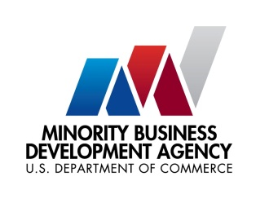

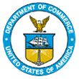
UNITED STATES DEPARTMENT OF

COMMERCE

NEWS
WASHINGTON, D.C. 20230

MBDA Media Contact Information:
Mr. Gabriel Cushing, Public Affairs
Email Address: mbdapublicaffairs@mbda.gov
Website(s): http://www.mbda.gov/

The Minority Business Development Agency to Announce Historic Collaboration with Divine Nine Sororities and National Women’s Leadership Organizations
WASHINGTON, DC, March 8, 2024 – Yesterday, the U.S. Department of Commerce Minority Business Development Agency (MBDA) hosted the Divine Nine Sororities, The National Council of Negro Women, The Links Incorporated, The Black Women’s Agenda, and The National Coalition of 100 Black Women at the White House. During this event, MBDA memorialized Memorandums of Understanding (MOU) with each organization to collaborate on advancing the growth of women business enterprises.
“The Minority Business Development Agency is excited to collaborate with these women-led organizations to break down barriers and expand opportunities for Black women,” said Eric Morissette, performing the delegated duties of the Under Secretary of Commerce for Minority Business Development. “As the fastest growing demographic of entrepreneurs, women of color continue to be a driving force for the nation’s economy. The Biden-Harris Administration, the Department of Commerce, and MBDA are committed to matching their drive with the resources and opportunities they need and deserve.”

The event featured a roundtable discussion with each organization’s leadership that examined the challenges women entrepreneurs face related to access to capital, starting and scaling businesses, and access to contracts and networks. MBDA’s alliance with these organizations aims to provide solutions, resources, and opportunities for economic empowerment.

The Department of Commerce’s mission is “to create the conditions for economic growth and opportunity for all communities.” Through this historic collaboration with the Divine Nine sororities and other national women’s leadership organizations, the MBDA continues to ensure economic prosperity for all American business enterprises.

About the U.S. Minority Business Development Agency (MBDA):
The Minority Business Development Agency is the only Federal agency dedicated to the growth and competitiveness of U.S. minority business enterprises. For more than 50 years, MBDA’s programs and services have better equipped MBEs to create jobs, build scale and capacity, increase revenues, and expand regionally, nationally, and internationally.

###

