**FOR IMMEDIATE RELEASE**

Abraham Lincoln Capital Airport™ Wins Prestigious 2024 Airports Going Green Award™ for Sustainability Leadership

**Springfield, IL – November 20, 2024** – Abraham Lincoln Capital Airport™ (SPI) has been awarded the prestigious 2024 Airports Going Green (AGG) Award, presented during the annual AGG Conference hosted by the American Association of Airport Executives (AAAE) in partnership with the Chicago Department of Aviation, O’Hare, and Midway International Airports. This award recognizes the airport’s outstanding commitment to sustainability, innovative practices, and leadership in green energy initiatives.

The Airports Going Green Awards™, introduced in 2010, celebrate leadership in sustainability. SPI was honored in the **Outstanding Sustainability Infrastructure Development** category, recognizing the airport's sustainable design and construction project. The award highlights SPI’s innovative and leadership-driven approach to sustainability within the aviation industry, specifically for its **Energy Savings Project**, a significant achievement in reducing environmental impact.

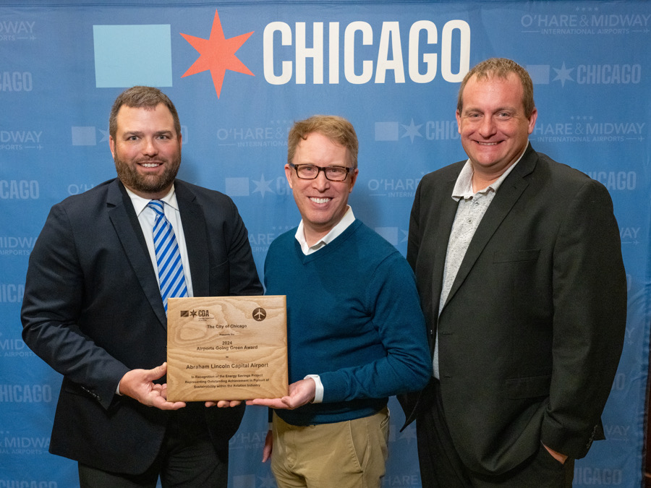

(Pictured Above - Mark Hanna, Springfield Airport, Aaron Frame, Chicago Department of Aviation, and Corey Harper, Veregy)

**Project Highlights:**

* A 2.88 MW Solar Array project featuring ground and roof-mounted installations.
* A $6 million investment, supported by significant funding from the Illinois SREC program and third-party financing through Balance Solar.
* Expected 20-year savings of $6.7 million, with a 30-year projection of revenue and savings of

$14.1 million.

* An impactful reduction in carbon footprint, equivalent to significant environmental savings annually.

This honor adds to the airport's growing list of industry recognitions, cementing its role as a leader in sustainable aviation practices. In 2023, SPI received the **IPAA First Ever Sustainability Award**, marking the beginning of its efforts in environmental responsibility. That same year, the airport also won the **AAAE GL Airfield Project of the Year Award** for its exceptional contributions to airfield modernization.

Additionally, SPI was featured in **Airport Improvement Magazine** in 2023 for its solar project, recognized for best practices in solar implementation and economics. More recently, SPI was named **2024 Sustainability Project of the Year by Airport Business Magazine** for its ongoing initiatives to reduce its carbon footprint and promote renewable energy.

The airport's solar project, constructed by Veregy, played a key role in SPI's sustainability achievements. This project significantly reduced the airport's reliance on non-renewable energy sources, serving as a model for airports globally. The collaboration between Mark Hanna at Abraham Lincoln Capital Airport™ and the Veregy team was crucial in realizing this vision, showcasing best practices in solar energy deployment and economic efficiency.

“We are incredibly honored to receive the 2024 Airports Going Green Award,” said **Mark Hanna**, SPI Executive Director. “This award is a testament to our continuous effort to lead the way in sustainability and environmental stewardship in the aviation industry. Our team and partners like Veregy have worked diligently to implement innovative solutions that align with our long-term sustainability goals.”

The 2024 Airports Going Green Award underscores Abraham Lincoln Capital Airport's™ dedication to reducing environmental impact, enhancing energy efficiency, and setting new standards for sustainability within the aviation sector.

For more information about Abraham Lincoln Capital Airport’s™ sustainability initiatives, please visit [www.flyspi.com](http://www.flyspi.com).

**Springfield Airport**

Abraham Lincoln Capital Airport™ was named the 2020 Primary Airport of the Year by the Illinois Department of Transportation. In 2021 IDOT released an Economic Impact study indicating Abraham Lincoln Capital Airport™ generates $370.8 million in total economic output annually for the local economy impacting 2,630 jobs. The airport is home to many major tenants that include the Illinois Air National Guard’s 183rd Wing, StandardAero MRO, IDOT’s Division of Aeronautics, Lincoln Land Community College’s LRS Aviation Maintenance Training Center, Illinois Army National Guard and Stellar Aviation. The airport’s main passenger terminal is also home to the Passenger Service Center and Sky Club, a membership-based club offering added benefits for frequent travelers. Commercial passenger air service offerings feature daily service to Chicago O’Hare International Airport on American Airlines, flights to Ft. Myers/Punta Gorda Florida on Allegiant and flights to Orlando Florida on Breeze Airways. More information can be found at [www.FlySPI.com](http://www.flyspi.com/) or by calling the Passenger Service Center at 217-788-9200.

**Veregy**

Veregy is an award-winning NAESCO-accredited decarbonization company focusing on accelerating and simplifying the Energy Transition. We provide turnkey engineering and construction services designed to reduce our clients’ energy and operating costs by implementing energy efficiency and infrastructure upgrades, smart building technology, fleet EV infrastructure, clean energy generation, and sustainability.

**####**

**Media Contacts:**  
Vince Esparza

VP of Marketing and Communications

Veregy

[vesparza@veregy.com](mailto:vesparza@veregy.com)

602.452.8746

www.veregy.com

Mark E. Hanna, A.A.E.

Executive Director

Springfield Airport Authority/Abraham Lincoln Capital Airport

217.788.1060

[www.flyspi.com](http://www.flyspi.com)

American Association of Airport Executives

<https://aaae.org/>

