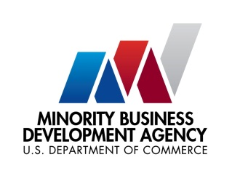

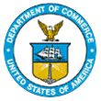
UNITED STATES DEPARTMENT OF

COMMERCE

NEWS
WASHINGTON, D.C. 20230

MBDA Media Contact Information:
Mr. Gabriel Cushing, Public Affairs
Email Address: gcushing@mbda.gov
Website(s): http://www.mbda.gov/

MBDA Hosts its First Capital Readiness Program (CRP) Implementation Meeting with CRP Awardees

WASHINGTON, D.C. (May 10, 2024) – MBDA hosted 43 Capital Readiness Program (CRP) awardees from across the nation for its first implementation meeting at the U.S. Department of Commerce. The two-day program convened awardee administrators and directors for an opportunity to meet Department of Commerce and MBDA staff, network within their cohort, and receive valuable program information.

The CRP is a $125 million technical assistance program to help underserved entrepreneurs grow and scale their businesses. CRP awardees operate business incubators or accelerators designed to prepare underserved entrepreneurs to secure capital from the historic $10 billion State Small Business Credit Initiative (SSBCI) and other capital sources.

“Entrepreneurship is a premier pathway to the American Dream. With the Capital Readiness Program, we are building on MBDA’s track record of success and ensuring that more minority business enterprises and underserved entrepreneurs have the tools they need to thrive,” said U.S. Secretary of Commerce Gina Raimondo. "Thanks to President Biden’s Investing In America agenda, MBDA is leading the charge to jumpstart the next generation of diverse entrepreneurs, spur innovation, and build a more resilient economy for all communities."

“This summit is important because MBDA is a community-based Agency and our mission is guided by the work done in the communities our awardees serve,” said Acting Under Secretary Eric Morrisette. “They understand what is working and what isn’t and bringing them together is valuable because CRP’s impact comes from its strength as part MBDA’s network and the greater Department of Commerce family.”

These 43 CRP awardees join MBDA’s robust National Network of business and specialty centers that provide technical assistance and business support to minority business enterprises, giving the Agency and the Department of Commerce greater reach and influence in helping create an economy that works for all businesses.
Last August, Vice President Kamala Harris announced CRP awardees marking the launch of the program --- a monumental milestone for MBDA, following the Agency’s enactment as a permanent Federal Agency in November 2021 as part of President Biden’s Bipartisan Infrastructure Law.

MBDA’s CRP is funded by the Department of Treasury’s State Small Business Credit Initiative (SSBCI) and was reauthorized under the American Rescue Plan Act of 2021. SSBCI is a nearly $10 billion fund designed to drive new investment and capital to small businesses across America. SSBCI provides funding to states, the District of Columbia, territories, and Tribal governments to promote entrepreneurship, increase access to capital, and help businesses grow—especially in traditionally underserved communities.

About the Minority Business Development Agency (MBDA)
The U.S. Department of Commerce, Minority Business Development Agency is the only Federal agency dedicated to the growth and global competitiveness of U.S. minority business enterprises (MBEs). For more than 50 years, MBDA’s programs and services have better equipped MBEs to create jobs, build scale and capacity, increase revenues, and expand regionally, nationally, and internationally.

###

