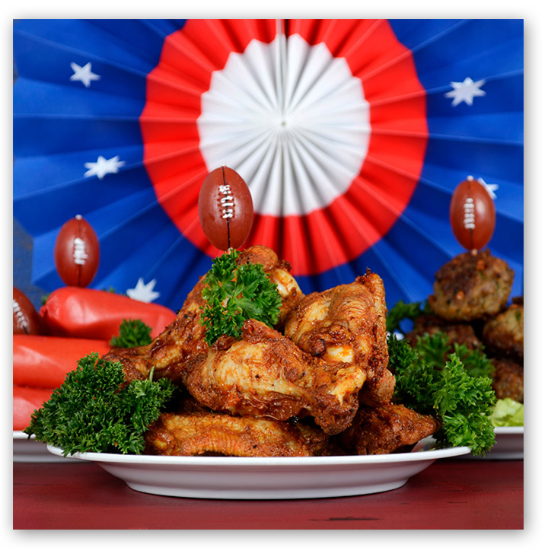
Don’t Let Delivery and Takeout Foods Fumble Your Super Bowl

WASHINGTON, Jan. 31, 2023 —February 12 marks Super Bowl LVII and Americans from coast to coast will gather with friends and family to cheer on their team, enjoy the halftime show and partake in traditional football foods. While foods prepared at home remain a popular option, delivery and takeout options are convenient alternatives. Since this event can last up to four hours, harmful bacteria have ample time to develop in your favorite dishes, which increases the possibility of foodborne illness.

The U.S. Department of Agriculture’s (USDA) Food Safety and Inspection Service (FSIS) wants to keep you in the game with some tips on how not to get benched by foodborne illness.
“Many Americans enjoy delivery and takeout foods during the Super Bowl for convenience, but food safety precautions are the same as food prepared at home,” said USDA Under Secretary for Food Safety Dr. Emilio Esteban. “To prevent foodborne illness, food should not be left out for over two hours without proper heating or cooling and should be placed out in small amounts and replenished as needed to keep your family and friends safe.”

Follow some tips from the food safety playbook to tackle foodborne illness head on throughout the game:

Play 1: Boost your Food Safety Defense Strategy with Four Simple Steps for Preparing Foods
You can't see, smell or taste harmful bacteria that may cause illness. When preparing food, follow the four guidelines below to keep food safe:

- Clean — When handling raw meat and poultry, wash your hands for at least 20 seconds and clean and sanitize surfaces often with soap, water and a sanitizer.
- Separate — Don't cross-contaminate. Use separate cutting boards, plates and utensils to avoid cross-contamination between raw meat or poultry and foods that are ready-to-eat.
- Cook — Cook to proper internal temperatures, checking with a food thermometer.
- Chill — Refrigerate promptly and do not leave food out at room temperature for over two hours.

Play 2: Block Foodborne Illness and Bacteria by Staying out of the Danger Zone

Leaving takeout and delivered foods out too long at room temperature is not safe. Dangerous bacteria can grow most rapidly in the range of temperatures between 40 F and 140 F (the Danger Zone), doubling in number in as little as 20 minutes.

- If you order food and it’s delivered or picked up in advance of the big game, divide the food into smaller portions or pieces, place in shallow containers and refrigerate until ready to reheat and serve. You can also keep the food warm (above 140 F) in a preheated oven, warming tray, chafing dish or slow cooker.
- Perishable foods, such as chicken wings, deli wraps and meatball appetizers, should be discarded if left out for longer than two hours without something keeping them hot or cold. To prevent food waste, refrigerate or freeze perishable items within two hours.
- Leftovers should be reheated to an internal temperature of 165 F as measured with a food thermometer. If using a microwave to reheat, cover and rotate the food for even heating. Food should be placed evenly in a covered microwave safe glass or ceramic dish with the lid or wrap vented to let the steam escape.

Play 3: Get in the End Zone – Store Your Leftovers Safely
- To prevent bacterial growth, it's important to cool food rapidly so it reaches a safe temperature of 40 F or below as fast as possible. Divide large amounts of food into shallow containers and cut large items of food into smaller portions to cool.
- Place leftovers into airtight containers to help keep bacteria out and retain moisture.
- Leftovers can be kept in the refrigerator for 3 to 4 days or frozen for 3 to 4 months. Although safe indefinitely, frozen leftovers can lose moisture and flavor when stored for longer times in the freezer.

Stay food safe year-round with our free magnet with safe internal temperatures, available in English and Spanish. Contact the FSIS Outreach team at FSIS.Outreach@usda.gov to order yours today!
If you have food safety questions, call the USDA Meat and Poultry Hotline at 1-888-MPHotline (1-888-674-6854), email MPHotline@usda.gov or chat live at ask.usda.gov from 10 a.m. to 6 p.m. Eastern Time, Monday through Friday.

Access news releases and other information at FSIS’ website at www.fsis.usda.gov/newsroom. Follow FSIS on Twitter at twitter.com/usdafoodsafety or in Spanish at: twitter.com/usdafoodsafe_es.

USDA touches the lives of all Americans each day in so many positive ways. In the Biden-Harris Administration, USDA is transforming America’s food system with a greater focus on more resilient local and regional food production, fairer markets for all producers, ensuring access to safe, healthy and nutritious food in all communities, building new markets and streams of income for farmers and producers using climate smart food and forestry practices, making historic investments in infrastructure and clean energy capabilities in rural America, and committing to equity across the Department by removing systemic barriers and building a workforce more representative of America. To learn more, visit www.usda.gov.

#

USDA is an equal opportunity provider, employer and lender.

