Single Stocks Are Driving the Tape – Direxion Launches Four 2X Bull ETFs



New York, New York, March 25th, 2026, NewsDirect

2X Exposure to ADBE, PYPL, TXN, and UNH for Catalyst-Driven Trades
Direxion, a leading provider of Single Stock Leveraged & Inverse ETFs, today announced the launch of four new ETFs offering 2X daily exposure to Adobe Inc. (ADBE), PayPal Holdings Inc. (PYPL), Texas Instruments Inc. (TXN) and UnitedHealth Group Inc. (UNH). As trading activity increasingly centers on company-specific catalysts – from earnings and guidance to sector and macro developments – individual stocks are driving a growing share of short-term market moves. These ETFs are designed to provide targeted tools for expressing bullish views on four widely followed names across software, digital payments, semiconductors and healthcare.
“Direxion’s Active Trader Report points to growing interest in single stock ETFs as trading activity becomes increasingly concentrated in individual names,” said Mo Sparks, Chief Product Officer of Direxion. “We’re seeing traders use those names more tactically, focusing on specific opportunities rather than broad market exposure. These ETFs provide targeted ways to express short-term views, and we see the next phase of single stock ETFs extending beyond today’s opportunity set.”
Fund Summary:
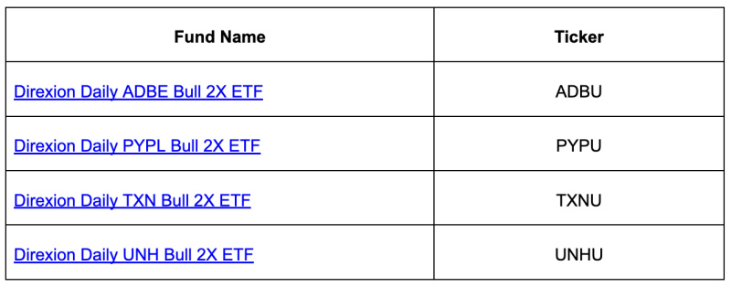All Direxion Leveraged and Inverse ETFs are intended only for investors with an in-depth understanding of the risks associated with seeking leveraged investment results, and who plan to actively monitor and manage their positions. There is no guarantee these ETFs will meet their objective. Please visit the Direxion Leveraged and Inverse ETF Education Center, where you will find educational brochures, videos, and a self-paced online course to help you understand if Leveraged and Inverse ETFs – including Single Stock Daily LETFs – are right for you.
About Direxion:
Direxion equips investors who are driven by conviction with ETF solutions built for purpose and fine-tuned for precision. These solutions are available for a broad spectrum of investors, whether executing short-term tactical trades, or investing in thematic strategies. Direxion’s reputation is founded on developing products that precisely express market perspectives and allow investors to manage their risk exposure. Founded in 1997, the company has approximately $54.8 billion in assets under management as of December 31, 2025. For more information, please visit www.direxion.com.
There is no guarantee that the Funds will achieve their investment objectives.
For more information on all Direxion Shares ETFs, go to www.direxion.com, or call us at 866.301.9214.
An investor should carefully consider a Fund’s investment objective, risks, charges, and expenses before investing. A Fund’s prospectus and summary prospectus contain this and other information about the Direxion Shares. To obtain a prospectus and summary prospectus call 866.476.7523 or visit our website at direxion.com. A Fund’s prospectus and summary prospectus should be read carefully before investing.
Investing in the funds involves a high degree of risk. Unlike traditional ETFs, or even other leveraged and/or inverse ETFs, these leveraged and/or inverse single-stock ETFs track the price of a single stock rather than an index, eliminating the benefits of diversification. Leveraged and inverse ETFs pursue daily leveraged investment objectives, which means they are riskier than alternatives which do not use leverage. They seek daily goals and should not be expected to track the underlying stock's performance over periods longer than one day. They are not suitable for all investors and should be utilized only by investors who understand leverage risk and who actively manage their investments. The Funds will lose money if the underlying stock's performance is flat, and it is possible that the Bull Fund will lose money even if the underlying stock's performance increases, and the Bear Fund will lose money even if the underlying stock's performance decreases, over a period longer than a single day. Investing in the Funds is not equivalent to investing directly in the underlying stock.
Direxion Shares Risks – An investment in the ETFs involves risk, including the possible loss of principal. The ETFs are non-diversified and include risks associated with concentration that results from an ETF’s investments in a particular industry, sector or company, which can increase volatility. The use of derivatives such as futures contracts and swaps are subject to market risks that may cause their price to fluctuate over time. The ETFs do not attempt to, and should not be expected to, provide returns which are a multiple of the return of their respective index or underlying security for periods other than a single day. For other risks including leverage, correlation, daily compounding, market volatility and risks specific to an industry, sector or company, please read the prospectus.
Distributor: ALPS Distributors, Inc.

Contact
Associate Vice President
Danielle Black
Ditto Public Relations
direxion@dittopr.co

