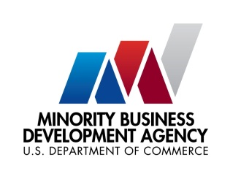

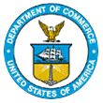
UNITED STATES DEPARTMENT OF

COMMERCE

NEWS
WASHINGTON, D.C. 20230

MBDA Media Contact Information:
Mr. Gabriel Cushing, Public Affairs
Email Address: mbdapublicaffairs@mbda.gov
Website(s): http://www.mbda.gov/

U.S. Minority Business Development Agency Convenes Panel for Southern Florida’s Minority Business Communities

MIAMI (June 7, 2024) – On Wednesday, Acting Under Secretary of Commerce for Minority Business Development Eric Morrissette convened a panel in Miami, Florida for minority business enterprises, as an addition to the Minority Business Development Agency’s (MBDA) National Training Conference (NTC).

Entitled Investing in Our Communities: Minority Business Development Agency Panel, the Acting Under Secretary’s panel included a briefing and discussion which brought senior government officials, industry leaders, and minority business enterprises together to discuss five major issues: contract opportunities and resources available through the federal government, investing in our communities, access to capital, access to contracts, and U.S. global competitiveness.

“At MBDA, our priority is to create economic opportunity for minority business enterprises in communities across the country, including Miami. These minority business enterprises are essential players in South Florida’s economic prosperity, and the community dialogues we’ve had will be crucial to providing pathways to capital, contracts, and new global markets,” said Acting Under Secretary Eric Morrissette. “These are things all businesses and entrepreneurs need to succeed, and I look forward to continuing work with our partners, centers and programs to advance this work.”

The topics discussed in the roundtable include tips and best practices for securing federal government contracts; navigating the complexities of working with the federal government; advancing public policies that provide pathways to scaling the growth and global competitiveness of MBEs, job creation, and more.

MBDA’s National Training Conference serves as a vehicle to train operators of MBDA-funded technical assistance programs on new and innovative programs; new and existing policies; procedures for the management of grant awards and compliance; and new initiatives as they relate to the President’s agenda, the Department of Commerce, and MBDA. The NTC also serves as a forum for the exchange of information on minority business enterprise development through general sessions, workshops and general networking activities.

About the U.S. Minority Business Development Agency (MBDA):
The U.S. Department of Commerce, Minority Business Development Agency is the only Federal agency dedicated to the growth and global competitiveness of U.S. minority business enterprises (MBEs). For more than 50 years, MBDA’s programs and services have better equipped MBEs to create jobs, build scale and capacity, increase revenues, and expand regionally, nationally, and internationally.

###

