ManageCasa announces Minii AI, a Powerful AI Assistant for Property Managers and Residents

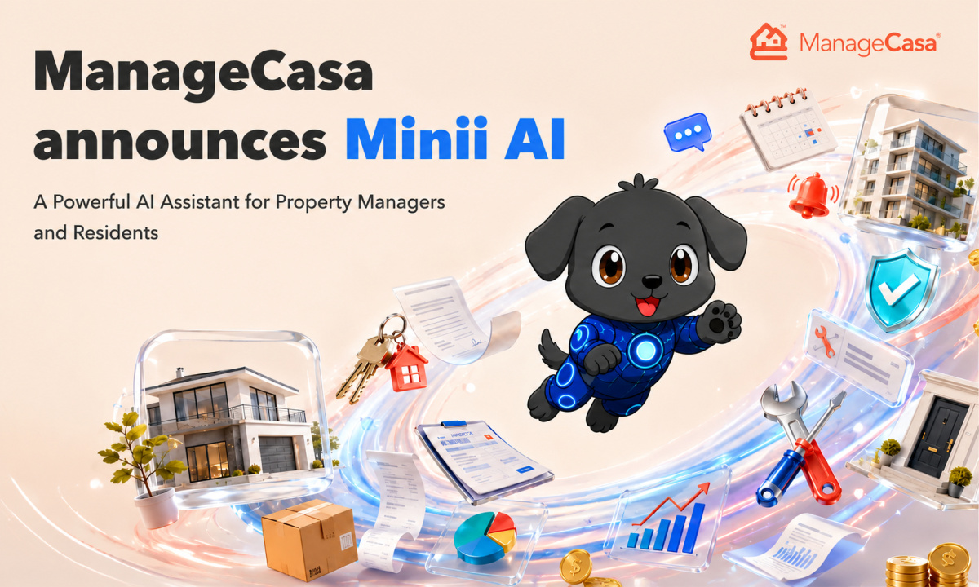

SAN FRANCISCO, USA, August 5th, 2026, FinanceWire

ManageCasa, a leading property management software for rental properties and homeowners associations (HOAs), announced the expansion of Minii AI and its powerful AI capabilities.
Built into the core of the platform, Minii AI is an intuitive AI assistant for property managers. Minii AI automates maintenance, answers resident questions, searches leases and governing documents, and streamlines daily operations.
AI is rapidly transforming the property management industry. Per a 2025 CAI survey, 71% of Community Managers said they currently use AI in their work. As property managers face increasing workloads and rising resident expectations, AI tools like ManageCasa’s Minii reduce repetitive administrative tasks while improving response times.
"Property managers shouldn't spend their day stuck answering the same question or sifting through maintenance emails," said Peter Koch, Founder and CEO of ManageCasa. "Minii AI acts as an intelligent assistant built directly into ManageCasa. With Minii, property managers can automate admin tasks, saving time for both themselves and residents."
AI Property Management Software Built for Every Day Managers
Unlike typical AI chatbots, Minii AI is built directly into the ManageCasa platform, designed specifically for property management tasks. Managers can complete real property management tasks without switching between systems, while residents can quickly get answers and support.
New AI capabilities include:
- AI Maintenance Management that helps triage maintenance requests. Users can upload photos, assign vendors, update residents, and monitor repairs through completion. Common workflows (like plumbing) can be automated so that a vendor is notified automatically when a certain maintenance issue comes up. Residents can easily report maintenance issues, upload photos of the problem, and check the status of their request 24/7 (meaning no more long email chains or a feeling of being ignored).
- AI Document Search that provides total clarity on governing documents, leases, and more. The AI transforms HOA policy, CC&Rs, bylaws, leases, policies, and community documents into a searchable knowledge base, allowing managers and residents to receive instant, accurate answers to nearly any question (some of which the board might not even have known!).
- 24/7 AI Resident Q&A. Minii can act as a property management chatbot that answers common questions about community rules, payments, amenities, maintenance, violations, and property information, reducing incoming phone calls and email volume.
- AI Violation Management helps managers handle violations in seconds. The AI property management software can streamline the process of documenting violations, identifying relevant community rules, preparing violation notices, and more. This allows HOA and community association teams to enforce policies more efficiently and consistently… While keeping residents informed.
- AI Architectural Review simplifies the architectural request process for managers and residents. Minii the property management chatbot can help review requests against governing documents and community guidelines, surface relevant requirements, and make it easier for managers and boards to evaluate submissions without manually searching through policies and CC&Rs.
- Coming Soon: AI-Powered Invoicing. Minii AI will make invoice processing faster by allowing managers to upload or scan an invoice and use AI to capture the relevant information, reducing manual data entry and helping teams process invoices in seconds.
Property Management AI That Works Alongside Management Teams
ManageCasa designed Minii AI to eliminate repetitive administrative work–so teams can focus on higher-impact responsibilities that move the needle, like improving resident satisfaction.
Property managers maintain complete control over which documents are available to AI, when residents can access AI-powered features, and how workflows are managed within ManageCasa.
Expanding Into Property Management Invoicing
ManageCasa also announced that Minii AI will soon support invoicing. The AI powered property management will allow users to simply take a photo (or scan) of an invoice to quickly upload it to the system. This will allow users to handle invoicing in seconds using a simple AI chatbot.
Built for Modern HOA and Rental Property Management
ManageCasa’s AI property management software was built specifically with community associations and rental portfolios in mind, incorporating their real-time feedback and needs into the platform. And what’s more unique is that unlike many platforms, ManageCasa supports a wide variety of portfolio types. Their new property management AI serves homeowners associations, community associations, landlords, residential property managers, and more. With Minii AI, all of the above can reduce admin work, improve response times, automate routine processes, and provide better experiences for both residents and property owners.
To learn more about Minii AI and ManageCasa, visit ManageCasa.com.
About ManageCasa
ManageCasa is a cloud-based AI property management software built for a variety of portfolio types, from community associations to rental portfolios. The platform combines accounting, maintenance management, communications, online payments, document management, resident portals, and artificial intelligence into a single solution that helps property management companies operate more efficiently while delivering exceptional service.

Contact
ManageCasa Marketing Team
ManageCasa
info@managecasa.com
+1 (800) 998-6627

