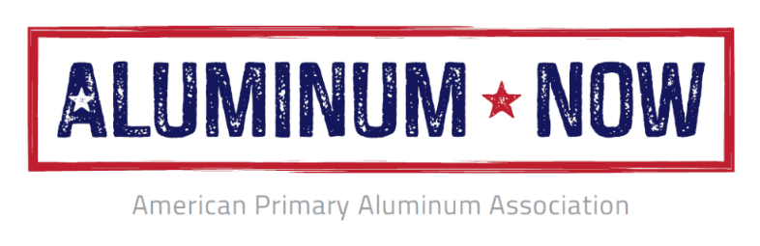
APAA Supports Well-Crafted Tariff-Rate Quota for the EU to Protect and Create Thousands of American Aluminum Jobs
Washington, DC; September 30, 2021 – Following on from yesterday’s U.S.-E.U. Trade and Tech Council in Pittsburgh between U.S. and European Union officials, Mark Duffy, CEO of the American Primary Aluminum Association, released the following statement:

“The domestic primary aluminum industry supports a well-crafted tariff-rate quota (TRQ) for the European Union to preserve the effectiveness of the Section 232 program. The Section 232 program is working and helping America make progress in preserving our ability to produce primary aluminum, protecting and creating thousands of American aluminum jobs and leading to over $6 billion in new domestic capital investments (in primary and downstream production).
U.S. policymakers should be wary of special interest groups seeking to benefit foreign producers or their own “European affiliates” rather than investing in American manufacturing and American workers. We strongly support efforts by the Biden Administration to protect and create more family sustaining U.S. manufacturing jobs, as we work together to Build Back Better.”

About the American Primary Aluminum Association:

The American Primary Aluminum Association advances the interests of America’s primary aluminum industry and its workers through the Aluminum Now campaign. APAA is registered and incorporated in Washington, DC and operates as a non-profit trade association. For more, please visit: www.aluminumnow.org

