Award Photos and Captions

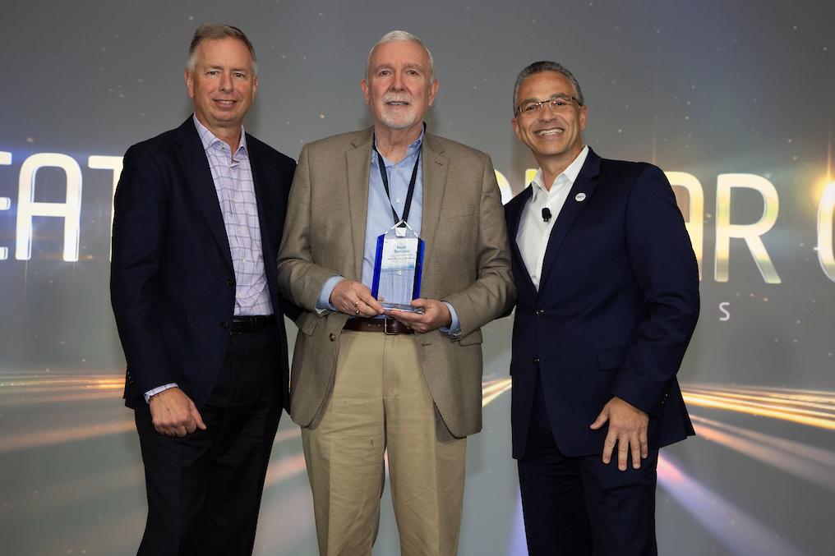
Associated Food Stores, Inc. – Greatest Dollar Growth, All Programs
From left: Randy Skoda, President & CEO, Topco Associates; Neal Berube, President & CEO, Associated Food Stores; Marc Kurkiewicz, VP Member Development, Topco Associates

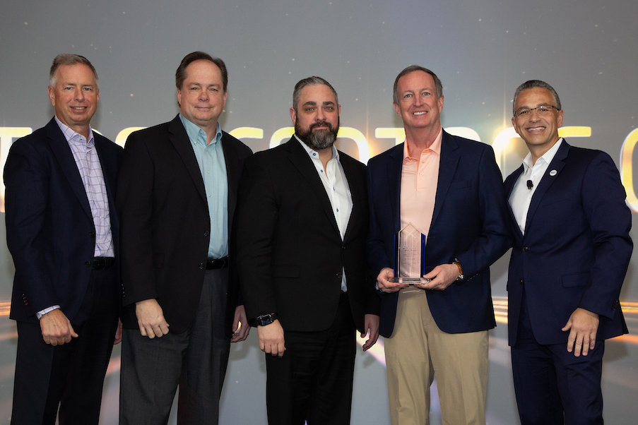
Schnuck Markets, Inc. – Greatest Percentage Growth, All Programs
From left: Randy Skoda, President & CEO, Topco Associates; Steve Mayer, Chief Merchant, Schnuck Markets; Jason Ulichnie, Vice President Own Brands, Schnuck Markets; Todd Schnuck, Chairman & CEO, Schnuck Markets; Marc Kurkiewicz, VP Member Development, Topco Associates

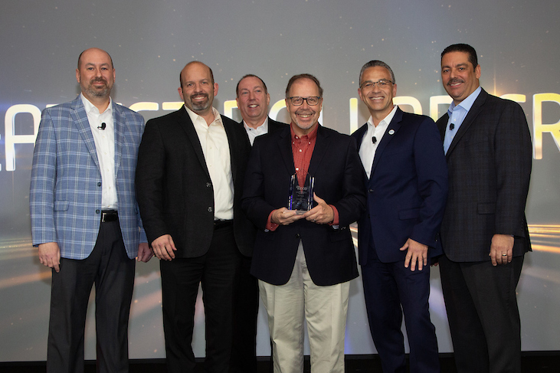
Big Y Foods, Inc. – Greatest Dollar Growth, Fresh
From left: Mike Ferguson, VP Produce & Floral, Topco Associates; Michael D’Amour, EVP & COO, Big Y Foods; Scott Caro, SVP Fresh, Topco Associates; Charlie D’Amour, President & CEO, Big Y Foods; Marc Kurkiewicz, VP Member Development, Topco Associates; Dave Negron, VP Meat Programs, Topco Associates

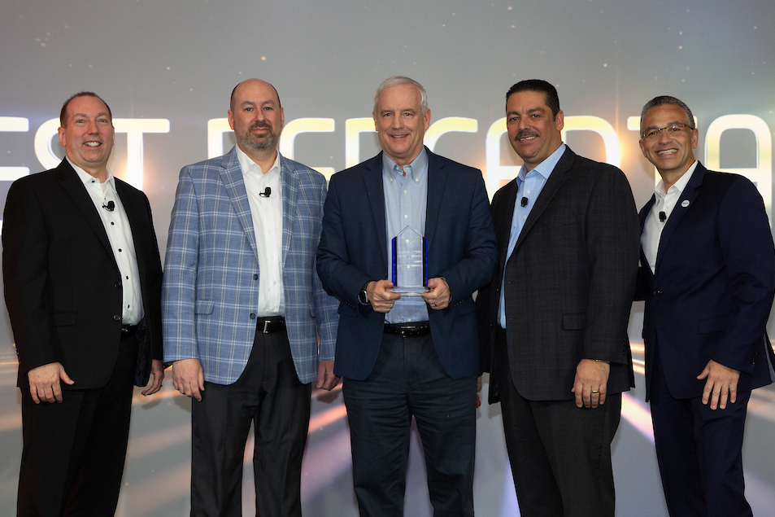
Brookshire Holdings, Inc. – Greatest Percentage Growth, Fresh
From left: Scott Caro, SVP Fresh, Topco Associates; Mike Ferguson, VP Produce & Floral, Topco Associates; Brad Brookshire, Chairman & CEO, Brookshire Holdings; Dave Negron, VP Meat Programs, Topco Associates; Marc Kurkiewicz, VP Member Development, Topco Associates

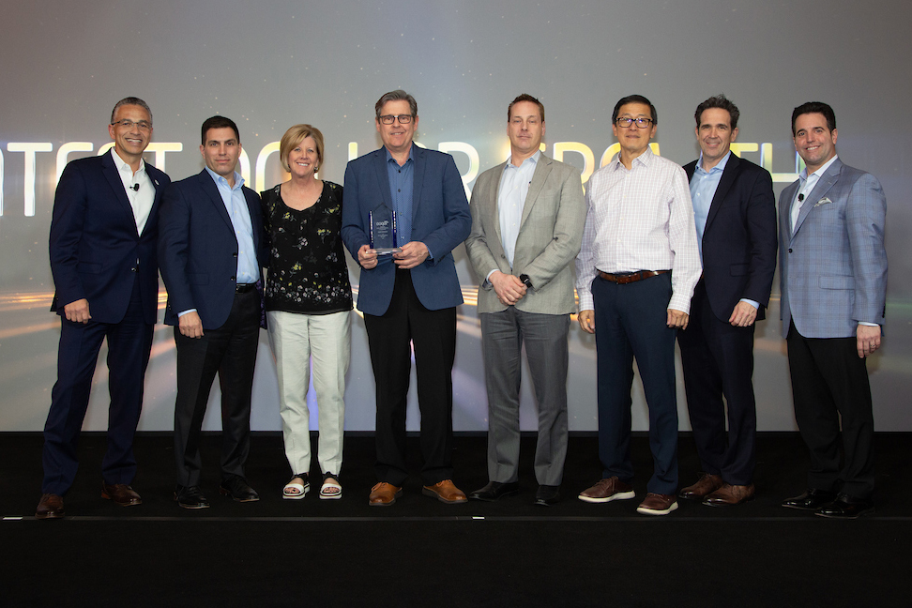
SpartanNash Company – Greatest Dollar Growth, Value-Add
From left: Marc Kurkiewicz, VP Member Development, Topco Associates; Rich Minio, Senior Director Indirect Spend, Topco Associates; Lori Raya, EVP & Chief Merchandising and Marketing Officer, SpartanNash; John Paul, Vice President, Private Brands, SpartanNash; Joe McQuesten, SVP Merchandising, SpartanNash; Francis Wong, VP Operations Finance, SpartanNash; Tom Frey, EVP & CFO, Topco Associates; Tom Rousonelos, SVP Health & Wellness, Topco Associates

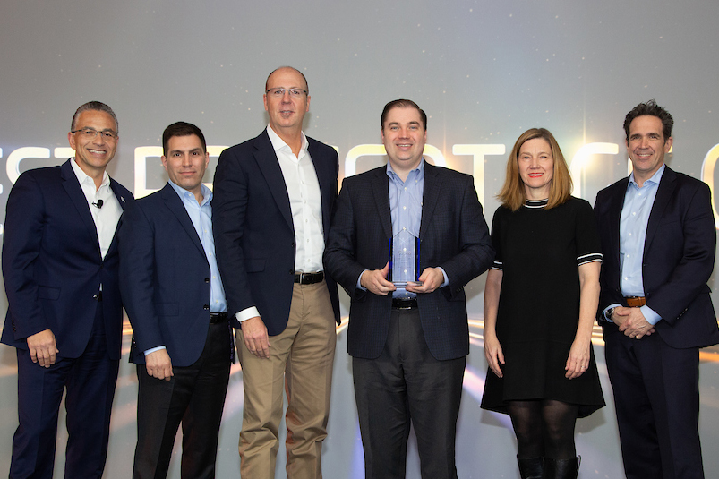
Alex Lee, Inc. – Greatest Percentage Growth, Value-Add
From left: Marc Kurkiewicz, VP Member Development, Topco Associates; Rich Minio, Senior Director Indirect Spend, Topco Associates; Tim Lowe, President, Alex Lee Inc./Lowes Foods, LLC; Brian George, President & CEO, Alex Lee, Inc.; Michelle Azar, President, Alex Lee Inc./MDI; Tom Frey, EVP & CFO, Topco Associates

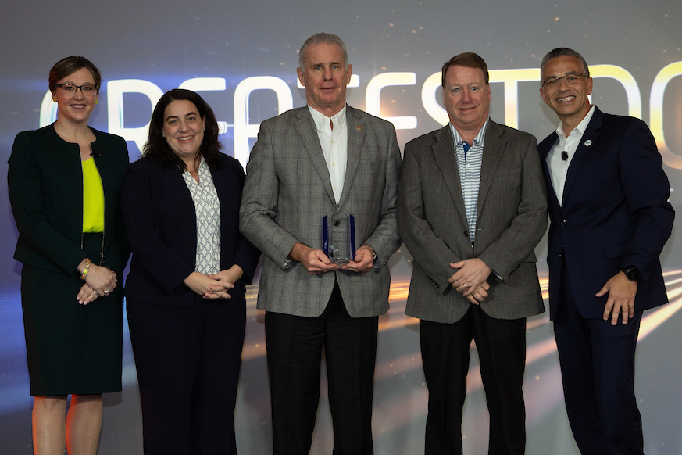
URM Stores, Inc. – Greatest Dollar Growth, Center Store
From left: Katie Waeltz, VP Category Management & Market Insights, Topco Associates; Christine Heffernan, SVP Center Store, Topco Associates; Ray Sprinkle, President & CEO, URM Stores; Michael McShane, VP Procurement, URM Stores; Marc Kurkiewicz, VP Member Development, Topco Associates

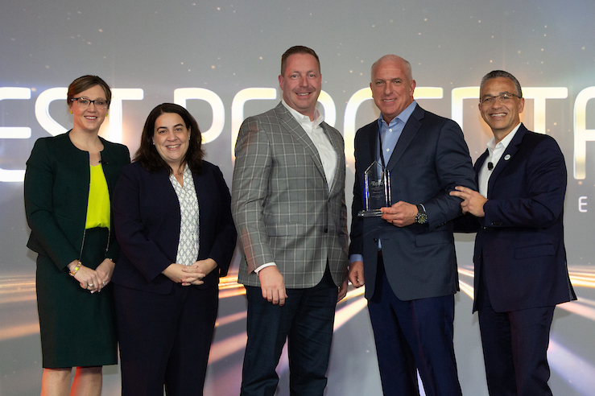
Affiliated Foods, Inc. – Greatest Percentage Growth, Center Store
From left: Katie Waeltz, VP Category Management & Market Insights, Topco Associates; Christine Heffernan, SVP Center Store, Topco Associates; Brian Piancino, COO, Affiliated Foods; Randy Arceneaux, President & CEO, Affiliated Foods; Marc Kurkiewicz, VP Member Development, Topco Associates

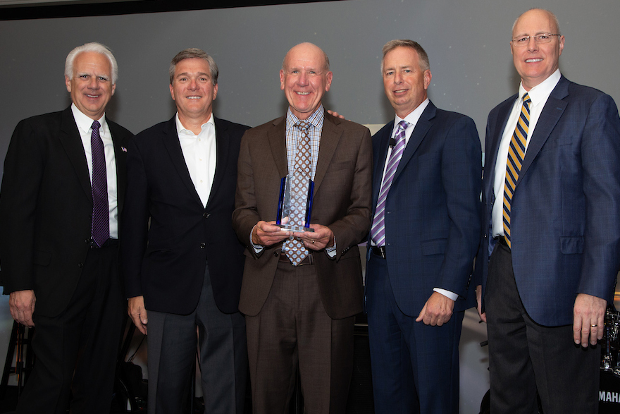
K-VA-T Food Stores, Inc. – Greatest Overall Purchase Penetration
From left: Pete Van Helden, Topco Chairman of the Board and Stater Bros. Chief Executive Officer; Dan Glei, EVP Merchandising & Marketing, K-VA-T Food Stores; Steve Smith, President & CEO, K-VA-T Food Stores; Randy Skoda, President & CEO, Topco Associates; Greg Sparks, COO, K-VA-T Food Stores

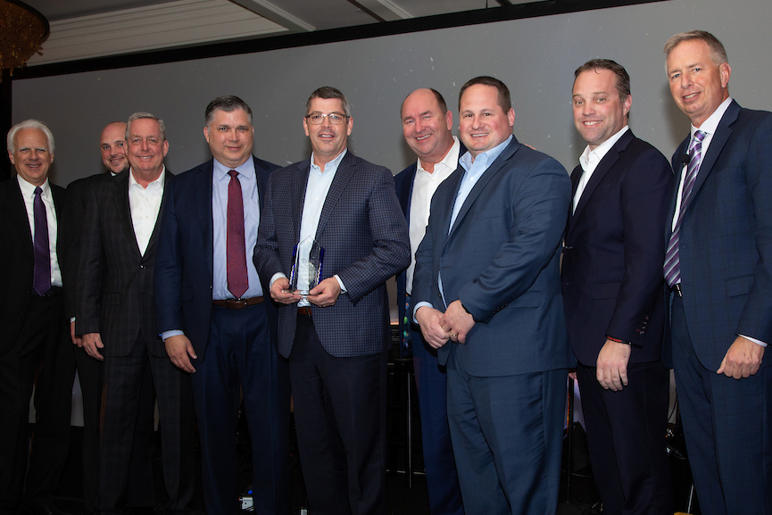
Hy-Vee, Inc. – Greatest Overall Purchase Volume
From left: Pete Van Helden, Topco Chairman of the Board and Stater Bros. Chief Executive Officer; Isaac Wiese, VP Procurement, Hy-Vee; Mike Terry, SVP Merchandising, Hy-Vee; Darren Baty, EVP & Chief Merchandising Officer, Hy-Vee; Jay Marshall, Vice Chairman, President Hy-Vee Supply Chain, Subsidiaries; Randy Edeker, Chairman, CEO & President, Hy-Vee, Inc.; Dan Gubbins, Group VP Merchandising & Private Brands, Hy-Vee; Joel Allen, SVP Marketing, Hy-Vee; Randy Skoda, President & CEO, Topco Associates

