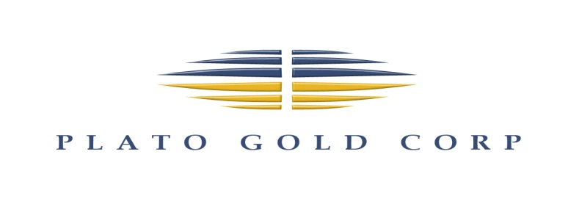
For Immediate Release

Plato Gold Corp. Announces $150,000
Non-Brokered Private Placement

/ NOT FOR DISTRIBUTION TO UNITED STATES NEWS WIRE SERVICES OR FOR DISSEMINATION IN THE UNITED STATES /

Toronto, December 1, 2021 – Plato Gold Corp. (TSX-V: PGC; Frankfurt: 4Y7 or WKN: A0M2QX) (“Plato” or the “Company”) is pleased to announce that it intends to complete a non-brokered private placement (the “Offering”) for gross proceeds of up to $150,000. Closing of the Offering is expected to occur on or about December 22, 2021.

The Offering shall be composed of 3,000,000 Common Shares (“Common Share”) at a price of $0.05 per Common Share for gross proceeds of up to $150,000

Completion of the Offering is subject to certain conditions including, but not limited to, the receipt of all necessary approvals, including the approval of the TSX Venture Exchange (the “Exchange”) and applicable securities regulatory authorities. The securities issued and issuable pursuant to the Offering will be subject to a four month and one day statutory hold period. In connection with the Offering, the Company may pay commissions to eligible persons in accordance with the policies of the Exchange.

The proceeds raised from the sale of the Common Shares will be used for exploration expenses and general working capital purposes on the Company’s properties.

This press release does not constitute an offer to sell or a solicitation of an offer to buy any of the securities in the United States. The securities have not been and will not be registered under the United States Securities Act of 1933, as amended, (the “U.S. Securities Act”) or any state securities laws and may not be offered or sold within the United States or to or for the account or benefit of a U.S. person (as defined in Regulation S under the U.S. Securities Act) unless registered under the U.S. Securities Act and applicable state securities laws or an exemption from such registration is available.

About Plato Gold Corp.

Plato Gold Corp. is a Canadian exploration company listed on the TSX Venture Exchange and Frankfurt Exchange with projects in Timmins, Ontario, Marathon, Ontario and Santa Cruz, Argentina.

The Timmins, Ontario project includes 4 properties: Guibord, Harker, Holloway and Marriott in the Harker/Holloway gold camp located east of Timmins, Ontario with a focus on gold.

In Argentina, Plato owns a 95% interest in Winnipeg Minerals S.A. (“WMSA”), an Argentina incorporated company that holds a number of contiguous mineral rights totalling 9,672 hectares with potential for gold and silver.

The Good Hope Niobium Project consists of approximately 5,146 hectares in Killala Lake Area and Cairngorm Lake Area Townships, near Marathon, Ontario with the primary target being niobium.

The Pic River Platinum Group Metals (PGM) Project consists of 2,247 hectares in Foxtrap Lake and Grain Township, near Marathon, Ontario of which 19 claims are contiguous to the western boundary of Generation Mining’s Marathon PGM project and is located on strike to Generation Mining’s Sally deposit.

For additional company information, please visit: www.platogold.com.

NEITHER THE TSX VENTURE EXCHANGE NOR ITS REGULATION PROVIDER (AS THAT TERM IS DEFINED IN THE POLICIES OF THE TSX VENTURE EXCHANGE) ACCEPTS RESPONSIBILITY FOR THE ADEQUACY OF THIS RELEASE.

For further information, please contact:

Anthony Cohen
President and CEO
Plato Gold Corp.
T: 416-968-0608
F: 416-968-3339
info@platogold.com
www.platogold.com

Forward Looking Statements

This news release contains “forward-looking statements”, within the meaning of applicable securities laws. These statements include, but are not limited to, completion of the Offering, statements regarding the potential mineralization and resources, exploration results, concentrations of pay minerals may offset operating costs and future plans and objectives. Forward-looking statements may be identified by such terms as “believes”, “anticipates”, “expects”, “estimates”, “may”, “could”, “would”, “will”, or “plan”. Since forward-looking statements are based on assumptions and address future events and conditions, by their very nature they involve inherent risks and uncertainties. Although these statements are based on information currently available to the Company, the Company provides no assurance that actual results will meet management’s expectations. These forward-looking statements are subject to a variety of risks and uncertainties and other factors that could cause actual events or results to differ materially from those projected in the forward-looking information. Risks that could change or prevent these statements from coming to fruition include but are not limited to: changing costs for mining and processing; increased capital costs; the timing and content of upcoming work programs; geological interpretations based on drilling that may change with more detailed information; potential process methods and mineral recoveries assumption based on limited test work and by comparison to what are considered analogous deposits that with further test work may not be comparable; testing of our process may not prove successful and even it tests are successful, the economic and other outcomes may not be as expected; the availability of labour, equipment and markets for the products produced; conditions changing such that the minerals on our property cannot be economically mined, or that the required permits cannot be obtained; and an inability to predict and counteract the effects of COVID-19 on the business of the Company, including but not limited to the effects of COVID-19 on the price of commodities, capital market conditions, restrictions on labour and international travel and supply chains. Although management of Plato has attempted to identify important factors that could cause actual results to differ materially from those contained in forward-looking statements, there may be other factors that cause results not to be as anticipated, estimated or intended. There can be no assurance that such statements will prove to be accurate, as actual results and future events could differ materially from those anticipated in such statements. Accordingly, readers should not place undue reliance on forward-looking statements. The forward-looking information contained herein is given as of the date hereof and the Company assumes no responsibility to update or revise such information to reflect new events or circumstances, except as required by law.

