Accessory Technologies Corporation Expands Capabilities by Opening a Dynamic New Facility in Long Island NY, USA
In an ongoing effort to provide cutting-edge aviation repair services, Accessory Technologies Corporation, a Wencor Group Company, now provides High Flow-High Heat Pneumatic Valve and Pneumatic Starter repair capabilities.
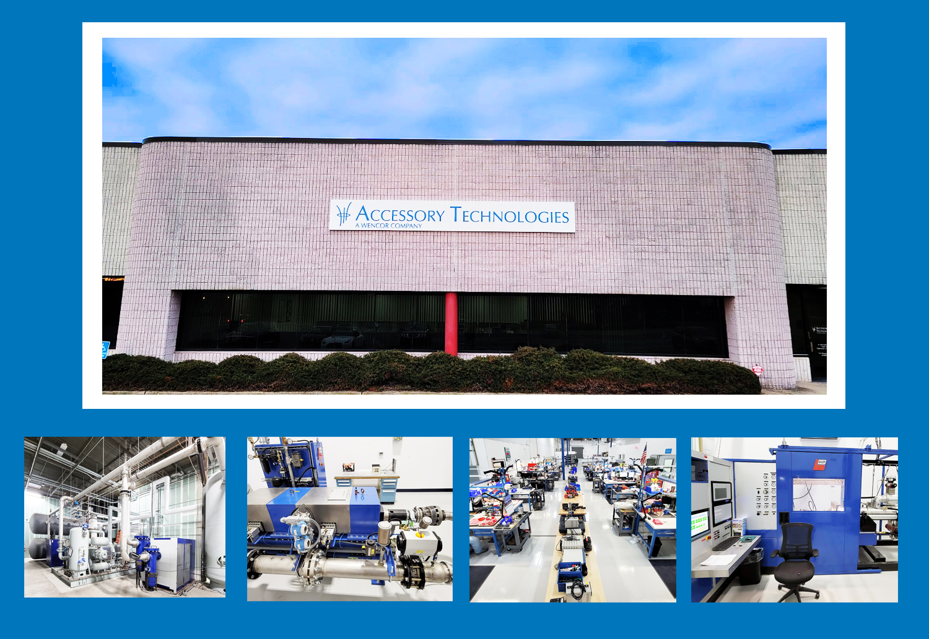
Edgewood NY, Jan 27th, 2021. In response to consistent customer demand, Wencor Group’s Accessory Technologies Corporation recently completed their transition into a state-of-the-art pneumatics facility, including the addition of High Flow-High Heat Pneumatic Valve and Pneumatic Starter capabilities. The facility move has reaffirmed Wencor Group’s position as a global leader within the aerospace industry and is a part of their ongoing commitment to providing best-in-class MRO support. At over 30,000 square feet, the new Edgewood, New York facility will help consistently enhance Wencor’s ARC (Availability, Reliability, Cost) value proposition through reduced turnaround times, reduced costs, and continued top-tier MRO support.
“By investing in High Flow-High Heat Pneumatic Valve and Pneumatic Starter repair capabilities in a world class facility, Wencor and Accessory Technologies continue to demonstrate a commitment to lean manufacturing principles and alternate build specifications using DER’s and PMA’s, helping us to lower the cost per flight hour for our customers,” said Matt Mazzilli, Accessory Technologies Vice President.
“For decades, Accessory Technologies has showcased its dedication to customers through detailed, cost-effective services. The recent expansion reaffirms Wencor’s commitment to growth, driving costs down while propelling performance to an all-time high,” said Pat McCarty, Wencor MRO President.
About Accessory Technologies Corporation
With over 2 decades of trusted service, Accessory Technologies Corporation’s dedication to some of the world’s largest airlines and logistics providers has stood the test of time. By offering PMA parts, DERs, USM-integrated repairs, and now High Flow - High Heat pneumatics, Accessory Technologies drives lower costs per flight hour while accelerating aircraft performance worldwide. Based in Edgewood, New York, their new 30,000 square foot facility bolsters their ability to service starters, valves, turbines, fans, actuators, and beyond. Known as a Center of Excellence for Pneumatics, Accessory Technologies has proven repair solutions to keep your fleet Ready to Fly!
About Wencor Group
Wencor has been a trusted partner in aerospace for over 60 years, offering CMM and DER repairs, PMA, and an extensive network of distribution solutions to make flights safer and more cost-effective. We support most of the commercial airlines, repair stations, and OEMs worldwide through our corporate affiliates Wencor, Soundair Aviation Services, PHS/MWA Aviation Services, Absolute Aviation Services, Aerospace Coatings International, Flight Line Products, Accessory Technologies Corporation, Fortner Engineering, Silver Wings Aerospace, and Kitco Defense. Wencor Group is headquartered in the Atlanta, Georgia area with additional offices in Utah, Miami, Seattle, California, Alabama, New York, Amsterdam, Singapore, Shanghai, and Istanbul. For more information, please visit wencor.com, follow @Wencor_Official on Twitter, and join Wencor on LinkedIn.

For more information, please visit https://www.wencor.com

